MESHWERKS, INC. v. TOYOTA MOTOR SALES U.S.A.
____________________________

United States Court of Appeals for the Tenth Circuit, 2008

528 F.3d 1258
GORSUCH, Circuit Judge.

This case calls on us to apply copyright principles to a relatively new technology: digital modeling. Meshwerks insists that, contrary to the district court's summary judgment determination, its digital models of Toyota cars and trucks are sufficiently original to warrant copyright protection. Meshwerks' models, which form the base layers of computerized substitutes for product photographs in advertising, are unadorned, digital wire-frames of Toyota's vehicles. While fully appreciating that digital media present new frontiers for copyrightable creative expression, in this particular case the uncontested facts reveal that Meshwerks' models owe their designs and origins to Toyota and deliberately do not include anything original of their own; accordingly, we hold that Meshwerks' models are not protected by copyright and affirm.

I

A

In 2003, and in conjunction with Saatchi & Saatchi, its advertising agency, Toyota began work on its model-year 2004 advertising campaign. Saatchi and Toyota agreed that the campaign would involve, among other things, digital models of Toyota's vehicles for use on Toyota's website and in various other media. These digital models have substantial advantages over the product photographs for which they substitute. With a few clicks of a computer mouse, the advertiser can change the color of the car, its surroundings, and even edit its physical dimensions to portray changes in vehicle styling; before this innovation, advertisers had to conduct new photo shoots of whole fleets of vehicles each time the manufacturer made even a small design change to a car or truck.

To supply these digital models, Saatchi and Toyota hired Grace & Wild, Inc. ("G&W"). In turn, G&W subcontracted with Meshwerks to assist with two initial aspects of the project--digitization and modeling. Digitizing involves collecting physical data points from the object to be portrayed. In the case of Toyota's vehicles, Meshwerks took copious measurements of Toyota's vehicles by covering each car, truck, and van with a grid of tape and running an articulated arm tethered to a computer over the vehicle to measure all points of intersection in the grid. Based on these measurements, modeling software then generated a digital image resembling a wire-frame model. In other words, the vehicles' data points (measurements) were mapped onto a computerized grid and the modeling software connected the dots to create a "wire frame" of each vehicle.

At this point, however, the on-screen image remained far from perfect and manual "modeling" was necessary. Meshwerks personnel fine-tuned or, as the company prefers it, "sculpted," the lines on screen to resemble each vehicle as closely as possible. Approximately 90 percent of the data points contained in each final model, Meshwerks represents, were the result not of the first-step measurement process, but of the skill and effort its digital sculptors manually expended at the second step. For example, some areas of detail, such as wheels, headlights, door handles, and the Toyota emblem, could not be accurately measured using current technology; those features had to be added at the second "sculpting" stage, and Meshwerks had to recreate those features as realistically as possible by hand, based on photographs. Even for areas that were measured, Meshwerks faced the challenge of converting measurements taken of a three-dimensional car into a two-dimensional computer representation; to achieve this, its modelers had to sculpt, or move, data points to achieve a visually convincing result. The purpose and product of these processes, after nearly 80 to 100 hours of effort per vehicle, were two-dimensional wire-frame depictions of Toyota's vehicles that appeared three-dimensional on screen, but were utterly unadorned--lacking color, shading, and other details. Attached to this opinion as Appendix A are sample screen-prints of one of Meshwerks' digital wire-frame models.

With Meshwerks' wire-frame products in hand, G&W then manipulated the computerized models by, first, adding detail, the result of which appeared on screen as a "tightening" of the wire frames, as though significantly more wires had been added to the frames, or as though they were made of a finer mesh. Next, G&W digitally applied color, texture, lighting, and animation for use in Toyota's advertisements. An example of G&W's work product is attached as Appendix B to this opinion. G&W's digital models were then sent to Saatchi to be employed in a number of advertisements prepared by Saatchi and Toyota in various print, online, and television media.

B

This dispute arose because, according to Meshwerks, it contracted with G&W for only a single use of its models--as part of one Toyota television commercial--and neither Toyota nor any other defendant was allowed to use the digital models created from Meshwerks' wire-frames in other advertisements. Thus, Meshwerks contends defendants improperly--in violation of copyright laws as well as the parties' agreement--reused and redistributed the models created by Meshwerks in a host of other media. In support of the allegations that defendants misappropriated its intellectual property, Meshwerks points to the fact that it sought and received copyright registration on its wire-frame models.

In due course, defendants moved for summary judgment on the theory that Meshwerks' wire-frame models lacked sufficient originality to be protected by copyright. Specifically, defendants argued that any original expression found in Meshwerks' products was attributable to the Toyota designers who conceived of the vehicle designs in the first place; accordingly, defendants' use of the models could not give rise to a claim for copyright infringement.

The district court agreed. It found that the wire-frame models were merely copies of Toyota's products, not sufficiently original to warrant copyright protection, and stressed that Meshwerks' "intent was to replicate, as exactly as possible, the image of certain Toyota vehicles." D. Ct. Op. at 8. Because there was no valid copyright, there could be no infringement, and, having granted summary judgment on the federal copyright claim, the district court declined to exercise supplemental jurisdiction over Meshwerks' state-law contract claim. Today, Meshwerks asks us to reverse and hold its digital, wire-frame models sufficiently original to warrant copyright protection.

II

To make a case for copyright infringement, Meshwerks must show (1) it owns a valid copyright, and (2) defendants copied constituent elements of the work that are original to Meshwerks. Autoskill Inc. v. Nat'l Educ. Support Sys., Inc., 994 F.2d 1476, 1487 (10th Cir. 1993). Our inquiry in this case focuses on the first of these tests--that is, on the question whether Meshwerks held a valid copyright in its digital wire-frame models. Because Meshwerks obtained registration certificates for its models from the Copyright Office, we presume that it holds a valid copyright. See 17 U.S.C. § 410(c); Palladium Music, Inc. v. EatSleepMusic, Inc., 398 F.3d 1193, 1196 (10th Cir. 2005). At the same time, defendants may overcome this presumption by presenting evidence and legal argument sufficient to establish that the works in question were not entitled to copyright protection. Palladium Music, Inc., 398 F.3d at 1196. Because this case comes to us on summary judgment, we review the question whether Meshwerks holds a valid copyright de novo and will affirm the district court's judgment only if, viewing all of the facts in the light most favorable to Meshwerks, we are able to conclude that "there is no genuine issue as to any material fact and that [defendants are] entitled to judgment as a matter of law." Fed. R. Civ. P. 56(c).

A

The Constitution authorizes Congress "[t]o promote the Progress of Science and useful Arts, by securing for limited Times to Authors and Inventors the exclusive Right to their respective Writings and Discoveries." U.S. Const. art. I, § 8, cl. 8. The Supreme Court has emphasized that the power afforded by this provision--namely, to give an author exclusive authority over a work--rests in part on a "presuppos[ition]" that the work contains "a degree of originality." Feist Pub'lns, Inc. v. Rural Tel. Serv. Co., 499 U.S. 340, 346, 111 S. Ct. 1282, 113 L. Ed. 2d 358 (1991). Congress has recognized this same point, extending copyright protection only to "original works of authorship . . . ." 17 U.S.C. § 102 (emphasis added). Originality, thus, is said to be "[t]he sine qua non of copyright." Feist, 499 U.S. at 345. That is, not every work of authorship, let alone every aspect of every work of authorship, is protectable in copyright; only original expressions are protected. This constitutional and statutory principle seeks to strike a delicate balance--rewarding (and thus encouraging) those who contribute something new to society, while also allowing (and thus stimulating) others to build upon, add to, and develop those creations. The copyright power is said to exist primarily "not to reward the labor of authors, but to promote the progress of science and the useful arts. . . . To this end, copyright assures authors the right to their original expression, but encourages others to build freely upon the ideas and information conveyed by a work." Id. at 349-50 (internal quotation and citations omitted).

What exactly does it mean for a work to qualify as "original"? In Feist, the Supreme Court clarified that the work must be "independently created by the author (as opposed to copied from other works)." Id. at 345; see also Burrow-Giles Lithographic Co. v. Sarony, 111 U.S. 53, 58, 4 S. Ct. 279, 28 L. Ed. 349, 1884 Dec. Comm'r Pat. 186 (1884) (the work for which copyright protection is sought must "owe[] its origin" to the putative copyright holder) (internal quotation omitted). In addition, the work must "possesses at least some minimal degree of creativity," Feist, 499 U.S. at 345; see also William F. Patry, Patry on Copyright § 3:27 ("both independent creation and a minimal degree of creativity are required"), though this is not to say that to count as containing a minimal degree of creativity a work must have aesthetic merit in the minds of judges (arguably not always the most artistically discerning lot). As the Court explained through Justice Holmes, even "a very modest grade of art has in it something irreducible, which is one man's alone. That something he may copyright . . . ." Bleistein v. Donaldson Lithographing Co., 188 U.S. 239, 250, 23 S. Ct. 298, 47 L. Ed. 460, 1903 Dec. Comm'r Pat. 650 (1903); see also Feist, 499 U.S. at 345 (all that's needed is some creative spark, "no matter how crude, humble, or obvious").

The parties focus most of their energy in this case on the question whether Meshwerks' models qualify as independent creations, as opposed to copies of Toyota's handiwork. But what can be said, at least based on received copyright doctrine, to distinguish an independent creation from a copy? And how might that doctrine apply in an age of virtual worlds and digital media that seek to mimic the "real" world, but often do so in ways that undoubtedly qualify as (highly) original? While there is little authority explaining how our received principles of copyright law apply to the relatively new digital medium before us, some lessons may be discerned from how the law coped in an earlier time with a previous revolution in technology: photography.

As Judge Pauley admirably recounted in SHL Imaging, Inc. v. Artisan House, Inc., photography was initially met by critics with a degree of skepticism: a photograph, some said, "copies everything and explains nothing," and it was debated whether a camera could do anything more than merely record the physical world. 117 F. Supp. 2d 301, 307 (S.D.N.Y 2000) (internal quotation omitted). These largely aesthetic debates migrated into legal territory when Oscar Wilde toured the United States in the 1880s and sought out Napoleon Sarony for a series of publicity photographs to promote the event. Burrow-Giles, a lithography firm, quickly copied one of Sarony's photos and sold 85,000 prints without the photographer's permission. Burrow-Giles defended its conduct on the ground that the photograph was a "mere mechanical reproduction of the physical features" of Wilde and thus not copyrightable. Burrow-Giles, 111 U.S. at 59. Recognizing that Oscar Wilde's inimitable visage does not belong, or "owe its origins" to any photographer, the Supreme Court noted that photographs may well sometimes lack originality and are thus not per se copyrightable. Id. ("the ordinary production of a photograph" may involve "no protection" in copyright). At the same time, the Court held, a copyright may be had to the extent a photograph involves "posing the said Oscar Wilde in front of the camera, selecting and arranging the costume, draperies, and other various accessories in said photograph, arranging the subject so as to present graceful outlines, arranging and disposing the light and shade, suggesting and evoking the desired expression . . . ." Id. at 60. Accordingly, the Court indicated, photographs are copyrightable, if only to the extent of their original depiction of the subject. Wilde's image is not copyrightable; but to the extent a photograph reflects the photographer's decisions regarding pose, positioning, background, lighting, shading, and the like, those elements can be said to "owe their origins" to the photographer, making the photograph copyrightable, at least to that extent.

As the Court more recently explained in Feist, the operative distinction is between, on the one hand, ideas or facts in the world, items that cannot be copyrighted, and a particular expression of that idea or fact, that can be. "This principle, known as the idea/expression or fact/expression dichotomy, applies to all works of authorship. As applied to a factual compilation," the particular matter at issue in Feist, "assuming the absence of original written expression, only the compiler's selection and arrangement may be protected; the raw facts may be copied at will. This result is neither unfair nor unfortunate. It is the means by which copyright advances the progress of science and art." Feist, 499 U.S. at 350; see also id. at 351 ("In no event may copyright extend to the facts themselves."). So, in the case of photographs, for which Meshwerks' digital models were designed to serve as practically advantageous substitutes, authors are entitled to copyright protection only for the "incremental contribution," SHL Imaging, Inc., 117 F. Supp. 2d at 311 (internal quotation omitted), represented by their interpretation or expression of the objects of their attention.

B

Applying these principles, evolved in the realm of photography, to the new medium that has come to supplement and even in some ways to supplant it, we think Meshwerks' models are not so much independent creations as (very good) copies of Toyota's vehicles. In reaching this conclusion we rely on (1) an objective assessment of the particular models before us and (2) the parties' purpose in creating them. All the same, we do not doubt for an instant that the digital medium before us, like photography before it, can be employed to create vivid new expressions fully protectable in copyright.

1

Key to our evaluation of this case is the fact that Meshwerks' digital wire-frame computer models depict Toyota's vehicles without any individualizing features: they are untouched by a digital paintbrush; they are not depicted in front of a palm tree, whizzing down the open road, or climbing up a mountainside. Put another way, Meshwerks' models depict nothing more than unadorned Toyota vehicles--the car as car. See Appendix A. And the unequivocal lesson from Feist is that works are not copyrightable to the extent they do not involve any expression apart from the raw facts in the world. As Professor Nimmer has commented in connection with the predecessor technology of photography, "[a]s applied to a photograph of a pre-existing product, that bedrock principle [of originality] means that the photographer manifestly cannot claim to have originated the matter depicted therein . . . . The upshot is that the photographer is entitled to copyright solely based on lighting, angle, perspective, and the other ingredients that traditionally apply to that art-form." Nimmer on Copyright § 3.03[C][3]. It seems to us that exactly the same holds true with the digital medium now before us: the facts in this case unambiguously show that Meshwerks did not make any decisions regarding lighting, shading, the background in front of which a vehicle would be posed, the angle at which to pose it, or the like--in short, its models reflect none of the decisions that can make depictions of things or facts in the world, whether Oscar Wilde or a Toyota Camry, new expressions subject to copyright protection.

The primary case on which Meshwerks asks us to rely actually reinforces this conclusion. In Ets-Hokin v. Skyy Spirits, Inc., 225 F.3d 1068 (9th Cir. 2000) (Skyy I), the Ninth Circuit was faced with a suit brought by a plaintiff photographer who alleged that the defendant had infringed on his commercial photographs of a Skyy-brand vodka bottle. The court held that the vodka bottle, as a "utilitarian object," a fact in the world, was not itself (at least usually) copyrightable. Id. at 1080 (citing 17 U.S.C. § 101). At the same time, the court recognized that plaintiff's photos reflected decisions regarding "lighting, shading, angle, background, and so forth," id. at 1078, and to the extent plaintiff's photographs reflected such original contributions the court held they could be copyrighted. In so holding, the Ninth Circuit reversed a district court's dismissal of the case and remanded the matter for further proceedings, and Meshwerks argues this analysis controls the outcome of its case.

But Skyy I tells only half the story. The case soon returned to the court of appeals, and the court held that the defendant's photos, which differed in terms of angle, lighting, shadow, reflection, and background, did not infringe on the plaintiff's copyrights. Ets-Hokin v. Skyy Spirits, Inc., 323 F.3d 763, 765 (9th Cir. 2003) (Skyy II). Why? The only constant between the plaintiff's photographs and the defendant's photographs was the bottle itself, id. at 766, and an accurate portrayal of the unadorned bottle could not be copyrighted. Facts and ideas are the public's domain and open to exploitation to ensure the progress of science and the useful arts. Only original expressions of those facts or ideas are copyrightable, leaving the plaintiff in the Skyy case with an admittedly "thin" copyright offering protection perhaps only from exact duplication by others. Id.; see also SHL Imaging, Inc., 117 F. Supp. 2d at 311 ("Practically, the plaintiffs [photos] are only protected from verbatim copying.").

The teaching of Skyy I and II, then, is that the vodka bottle, because it did not owe its origins to the photographers, had to be filtered out to determine what copyrightable expression remained. And, by analogy--though not perhaps the one Meshwerks had in mind--we hold that the unadorned images of Toyota's vehicles cannot be copyrighted by Meshwerks and likewise must be filtered out. To the extent that Meshwerks' digital wire-frame models depict only those unadorned vehicles, having stripped away all lighting, angle, perspective, and "other ingredients" associated with an original expression, we conclude that they have left no copyrightable matter.

Confirming this conclusion as well is the peculiar place where Meshwerks stood in the model-creation pecking order. On the one hand, Meshwerks had nothing to do with designing the appearance of Toyota's vehicles, distinguishing them from any other cars, trucks, or vans in the world. That expressive creation took place before Meshwerks happened along, and was the result of work done by Toyota and its designers; indeed, at least six of the eight vehicles at issue are still covered by design patents belonging to Toyota and protecting the appearances of the objects for which they are issued. See 35 U.S.C. § 171; Gorham Mfg. Co. v. White, 81 U.S. 511, 525, 20 L. Ed. 731 (1871) ("It is the appearance itself, no matter by what agency caused, that constitutes mainly, if not entirely, the contribution to the public which the law deems worthy of recompense."). On the other hand, how the models Meshwerks created were to be deployed in advertising--including the backgrounds, lighting, angles, and colors--were all matters left to those (G&W, Saatchi, and 3D Recon) who came after Meshwerks left the scene. See infra Section II.C. Meshwerks thus played a narrow, if pivotal, role in the process by simply, if effectively, copying Toyota's vehicles into a digital medium so they could be expressively manipulated by others.

Were we to afford copyright protection in this case, we would run aground on one of the bedrock principles of copyright law--namely, that originality, "as the term is used in copyright, means only that the work was independently created by the author (as opposed to copied from other works)." Feist, 499 U.S. at 345 (emphasis added). Because our copyright laws protect only "original" expression, the reason for refusing copyright protection to copies is clear, "since obviously a copier is not a creator, much less an 'independent' creator." Patry on Copyright § 3:28; see also id. ("The key is whether original matter in which protection is claimed is the result of plaintiff's ingenuity rather than appropriation of another's material."). As it happens, many other courts before us have denied copyright protection in analogous cases, involving copies of facts in the world, as well as copies of prior works of art. So, for example, in Sparaco v. Lawler, Matusky, Skelly, Engineers LLP, 303 F.3d 460, 467 (2d Cir. 2002), our sister circuit, relying on Feist, denied copyright protection to that portion of an architectural drawing setting forth "the existing physical characteristics of the site, including its shape and dimensions, the grade contours, and the location of existing elements, [as] it sets forth facts; copyright does not bar the copying of such facts." Much the same might be said here. See also ATC Distr. Group, Inc. v. Whatever It Takes Transmissions & Parts, Inc., 402 F.3d 700, 712 (6th Cir. 2005) (denying copyright protection to catalog illustrations of transmission parts "copied from photographs cut out of competitors' catalogs"); Bridgeman Art Library, Ltd. v. Corel Corp., 36 F. Supp. 2d 191, 197 (S.D.N.Y. 1999) (denying copyright protection to photographs that were "'slavish copies' of public domain works of art"); Mary Campbell Wojcik, The Antithesis of Originality: Bridgeman, Image Licensors, and the Public Domain, 30 Hastings Comm. & Ent. L. J. 257, 267 (2008) ("[T]he law is becoming increasingly clear: one possesses no copyright interest in reproductions . . . when these reproductions do nothing more than accurately convey the underlying image.").

It is certainly true that what Meshwerks accomplished was a peculiar kind of copying. It did not seek to recreate Toyota vehicles outright--steel, rubber, and all; instead, it sought to depict Toyota's three-dimensional physical objects in a two-dimensional digital medium. But we hold, as many before us have already suggested, that, standing alone, "[t]he fact that a work in one medium has been copied from a work in another medium does not render it any the less a 'copy.'" Nimmer on Copyright § 8.01[B]; see also Durham Indus., Inc. v. Tomy Corp., 630 F.2d 905, 910 (2d Cir. 1980) (holding that "the mere reproduction of the Disney characters in plastic . . . does not constitute originality as this Court has defined the term"); Entm't Research Group, Inc. v. Genesis Creative Group, Inc., 122 F.3d 1211, 1221-24 (9th Cir. 1997) (denying copyright protection to 3-D costumes based on 2-D cartoon characters). After all, the putative creator who merely shifts the medium in which another's creation is expressed has not necessarily added anything beyond the expression contained in the original. See Bridgeman Art Library, Ltd., 36 F. Supp. 2d at 199 (noting that "a copy in a new medium is copyrightable only where, as often but not always is the case, the copier makes some identifiable original contribution").

In reaching this conclusion, we do not for a moment seek to downplay the considerable amount of time, effort, and skill that went into making Meshwerks' digital wire-frame models. But, in assessing the originality of a work for which copyright protection is sought, we look only at the final product, not the process, and the fact that intensive, skillful, and even creative labor is invested in the process of creating a product does not guarantee its copyrightability. See Feist, 499 U.S. at 359-60; Howard B. Abrams, Law of Copyright § 2:8 ("Even if the process is both expensive and intricate, an exact or near-exact duplicate of an original should not qualify for copyright.") (emphasis added); Wojcik, supra, 30 Hastings Comm. & Ent. L. J. at 267 ("This is not to say that [accurately reproducing an underlying image] requires no skill or effort; it simply means that such skill and effort does not suffice to invoke the highly advantageous legal monopoly granted under the Copyright Act."). In the case before us, there is no doubt that transposing the physical appearances of Toyota's vehicles from three dimensions to two, such that computer-screen images accurately reflect Toyota's products, was labor intensive and required a great amount of skill. But because the end-results were unadorned images of Toyota's vehicles, the appearances of which do not owe their origins to Meshwerks, we are unable to reward that skill, effort, and labor with copyright protection.

2

Meshwerks' intent in making its wire-frame models provides additional support for our conclusion. "In theory, the originality requirement tests the putative author's state of mind: Did he have an earlier work in mind when he created his own?" Paul Goldstein, Goldstein on Copyright § 2.2.1.1. If an artist affirmatively sets out to be unoriginal--to make a copy of someone else's creation, rather than to create an original work--it is far more likely that the resultant product will, in fact, be unoriginal. See Russ VerSteeg, Intent, Originality, Creativity and Joint Authorship, 68 Brook. L. Rev. 123, 133 (2002) ("[A] person's intent to copy . . . should be considered strong evidence that what that person has produced is not copyrightable."). Of course, this is not to say that the accidental or spontaneous artist will be denied copyright protection for not intending to produce art; it is only to say that authorial intent sometimes can shed light on the question of whether a particular work qualifies as an independent creation or only a copy.

In this case, the undisputed evidence before us leaves no question that Meshwerks set out to copy Toyota's vehicles, rather than to create, or even to add, any original expression. The purchase order signed by G&W asked Meshwerks to "digitize and model" Toyota's vehicles, and Meshwerks' invoice submitted to G&W for payment reflects that this is exactly the service Meshwerks performed. Aplt's App. at 113, 115. Meshwerks itself has consistently described digitization and modeling as an attempt accurately to depict real-world, three-dimensional objects as digital images viewable on a computer screen. See, e.g., id. at 369 ("the graphic sculptor is not intending to 'redesign' the product, he or she is attempting to depict that object in the most realistic way"); id. at 370 (goal is "to create a realistic depiction on the computer screen"); id. at 378 ("Meshwerks' graphic sculptors [] create realistic-looking depictions of complicated real-world objects on a two dimensional screen . . . a digital representation of the real object"); id. at 455 (Meshwerks "basically draws a three dimensional rendering of that object in the computer . . . it closely resembles the original"). The parties thus intended to have Meshwerks create base-layer digital models to which the original and creative elements viewers would see in actual advertisements could be added by others in subsequent processes.

Other courts before us have examined and relied on a putative copyright holder's intent in holding that the resultant work was not original and thus subject to copyright protection. The Sixth Circuit, for example, held that a series of catalog illustrations depicting auto transmission parts were not independently copyrightable. ATC Distrib. Group, Inc, 402 F.3d at 712. The drawings had been copied by hand from photographs in a competitor's catalog. Id. In denying copyright protection, the court emphasized that "[t]he illustrations were intended to be as accurate as possible in reproducing the parts shown in the photographs on which they were based, a form of slavish copying that is the antithesis of originality." Id. (emphasis added). In Bridgeman Art Library, the court examined whether color transparencies of public domain works of art were sufficiently original for copyright protection, ultimately holding that, as "exact photographic copies of public domain works of art," they were not. 36 F. Supp. 2d at 195. In support of its holding, the court looked to the plaintiff's intent in creating the transparencies: where "the point of the exercise was to reproduce the underlying works with absolute fidelity," the "spark of originality" necessary for copyright protection was absent. Id. at 197 (emphasis added). Precisely the same holds true here, where, by design, all that was left in Meshwerks' digital wire-frame models were the designs of Toyota's vehicles.

C

Although we hold that Meshwerks' digital, wire-frame models are insufficiently original to warrant copyright protection, we do not turn a blind eye to the fact that digital imaging is a relatively new and evolving technology and that Congress extended copyright protection to "original works of authorship fixed in any tangible medium of expression, now known or later developed." 17 U.S.C. § 102(a) (emphasis added). A Luddite might make the mistake of suggesting that digital modeling, as was once said of photography, allows for nothing more than "mechanical reproduction of the physical features or outlines of some object . . . and involves no originality of thought or any novelty in the intellectual operation connected with its visible reproduction in [the] shape of a picture." Burrow-Giles, 111 U.S. at 59. Clearly, this is not so.

Digital modeling can be, surely is being, and no doubt increasingly will be used to create copyrightable expressions. Yet, just as photographs can be, but are not per se, copyrightable, the same holds true for digital models. There's little question that digital models can be devised of Toyota cars with copyrightable features, whether by virtue of unique shading, lighting, angle, background scene, or other choices. The problem for Meshwerks in this particular case is simply that the uncontested facts reveal that it wasn't involved in any such process, and indeed contracted to provide completely unadorned digital replicas of Toyota vehicles in a two-dimensional space. For this reason, we do not envision any "chilling effect" on creative expression based on our holding today, and instead see it as applying to digital modeling the same legal principles that have come, in the fullness of time and with an enlightened eye, to apply to photographs and other media.

* * *

Originality is the sine qua non of copyright. If the basic design reflected in a work of art does not owe its origin to the putative copyright holder, then that person must add something original to that design, and then only the original addition may be copyrighted. In this case, Meshwerks copied Toyota's designs in creating digital, wire-frame models of Toyota's vehicles. But the models reflect, that is, "express," no more than the depiction of the vehicles as vehicles. The designs of the vehicles, however, owe their origins to Toyota, not to Meshwerks, and so we are unable to reward Meshwerks' digital wire-frame models, no doubt the product of significant labor, skill, and judgment, with copyright protection. The judgment of the district court is affirmed, and defendants' request for attorneys' fees is denied.

So ordered.

APPENDIX A
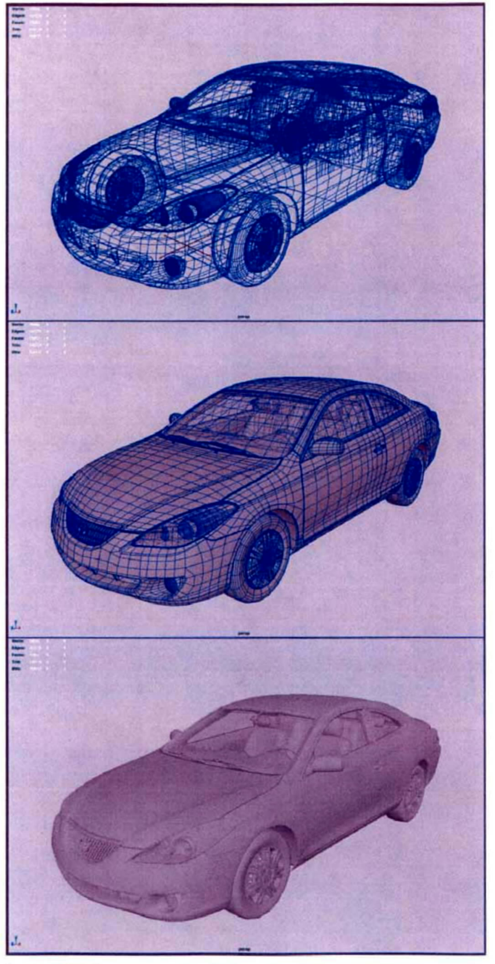

APPENDIX B

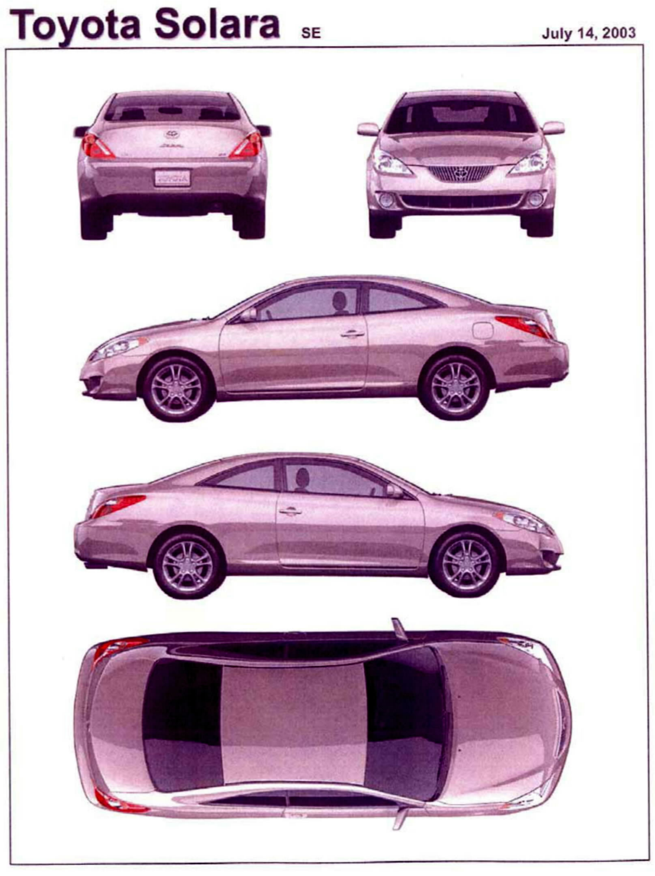

G&W also shared one of Meshwerks' original wire-frames with defendant 3D Recon, one of Meshwerks' competitors hired to work on a subsequent phase of Toyota's advertising campaign.
An initial suit for copyright infringement was dismissed without prejudice because Meshwerks had not obtained registrations for all of the copyrights it claimed defendants infringed. Meshwerks subsequently registered the copyrights at issue and filed this suit.
On appeal, we have not been asked to address Meshwerks' contract claim, though if the holding on its federal claim were to be reversed, the existence of supplemental jurisdiction to review the contract claim of course would have to be reconsidered.
There is some debate over whether the question of copyrightability is a pure question of law and thus one for the court, or a mixed question of law and fact and thus one involving potential jury questions in the presence of materially disputed facts. See Gaiman v. McFarlane, 360 F.3d 644, 648-49 (7th Cir. 2004) (discussing the dispute). Our court has not spoken on the matter, but neither do we have need to do so today as this case comes to us on summary judgment, and we cannot, of course, grant such a motion if we discern any material dispute of fact in the record before us.
The two pertinent concepts--independent creation and minimal creativity--are intertwined and overlap, at least to some degree: After all, if something qualifies as an independent creation (that is, it is more than a copy) won't it also usually betray some minimal degree of creativity? Still, though the independent test imputed by the creativity requirement is low, it does exist. Feist, 499 U.S. at 345, 362. It is thus not the case, as some interpreted Judge Learned Hand to say when he observed that "'no photograph, however simple, can be unaffected by the personal influence of the author, and no two will be absolutely alike,'" that photographs (or any other works, for that matter) are per se protectable. See SHL Imaging, Inc. v. Artisan House, Inc., 117 F. Supp. 2d 301, 309 (S.D.N.Y. 2000) (quoting Jewelers' Circular Pub. Co. v. Keystone Pub. Co., 274 F. 932, 934 (S.D.N.Y. 1921) (Hand, J.)).
The tour brought Wilde within what is now our territorial jurisdiction in 1882, including to the bustling silver mining town of Leadville, Colorado, where Wilde descended into Horace Tabor's Matchless Mine and later claimed, "I read [assembled miners] passages from the autobiography of Benvenuto Cellini and they seemed much delighted. I was reproved by my hearers for not having brought him with me. I explained that he had been dead for some little time which elicited the enquiry 'Who shot him?'" Oscar Wilde, Impressions of America 31 (Keystone Press 1906).
The Skyy I panel also faulted the district court for analyzing the photographs as "derivative works," requiring (a) non-trivial differences between the photos and bottle and (b) that copyright in the photo would not interfere with Skyy's ability to use its own bottle. See Skyy I, 225 F.3d at 1073. A derivative work is based on a pre-existing copyrighted work and seeks to recast, transform, or adapt that original work. 17 U.S.C. § 101. Meshwerks argues that the originality requirement is "higher" for derivative works, that the district court erroneously applied this standard here, and that cases analyzing originality in derivative works are generally inapposite. In our de novo review, however, we have simply applied the Supreme Court's originality directives set out in Feist. And it appears to us that the courts in derivative works cases, see, e.g., ATC Distr. Group, Inc. v. Whatever It Takes Transmissions & Parts, Inc., 402 F.3d 700, 712 (6th Cir. 2005); L. Batlin & Son, Inc. v. Snyder, 536 F.2d 486, 490-92 (2d Cir. 1976), just like the court in Skyy II, also had to separate out that which owed its origin to the putative copyright holder from that which did not, holding only the former copyrightable. In then examining the elements that are original to the author, the originality analysis ought to be the same. Patry on Copyright § 3:50 ("[T]he standard of originality for derivative works is no different than for nonderivative works."); id. § 3:55 ("Under the Supreme Court's Feist opinion, there is a single test for originality applicable to all works, derivative and nonderivative alike.").
We are not called upon to, and do not, express any view on the copyrightability of the work products produced by those who employed and adorned Meshwerks' models.
We are not convinced that the single case to which we are pointed where copyright was awarded for a "slavish copy" remains good law after Feist. In Alva Studios, Inc. v. Winninger, 177 F. Supp. 265 (S.D.N.Y. 1959), the court held that a miniature reproduction of Rodin's "Hand of God" was copyrightable because of the great skill it took accurately to replicate Rodin's masterpiece. Feist, however, rejected the notion that skill and hard work suffice for copyright protection, 499 U.S. at 359-60, undermining the very foundation for the holding in Alva Studios. See Patry on Copyright § 3:56 ("Alva appears to have protected labor--albeit labor by a skilled artisan--but still only labor, not judgment. Alva is inconsistent with the Supreme Court's opinion in Feist.").
The single case Meshwerks cites to us as suggesting that a medium shift alone is sufficient to warrant copyright protection does not alter our conclusion on this score. There, a series of three-dimensional works of art translated from two-dimensional sketches were held copyrightable based on the artist's "creative effort." W. Goebel Porzellanfabrik v. Action Indus., Inc., 589 F. Supp. 763, 767 (S.D.N.Y. 1984). This case pre-dated Feist, and it is unclear whether it remains good law. In Feist, the Supreme Court specifically eschewed the notion that effort alone was enough to make the resultant work "original" and therefore the proper subject of copyright protection. See Feist, 499 U.S. at 359-60; see also supra note 9. Moreover, and as discussed in greater detail below, creative decision-making in the process is insufficient to render the product original. Cf. Nimmer on Copyright § 3.03[C][2] (stating that a district court erred in another case "in holding that the mere act of converting a public domain Santa Claus figure into a three-dimensional plastic form constituted sufficient originality").
Defendants' request for the costs and attorneys fees associated with this appeal is denied. See 17 U.S.C. § 505 (allowing reasonable fees and costs at the court's discretion). Non-exclusive factors that may guide a court's exercise of its discretion include the "frivolousness, motivation, objective unreasonableness (both in the factual and in the legal components of the case) and the need in particular circumstances to advance considerations of compensation and deterrence." Fogerty v. Fantasy, Inc., 510 U.S. 517, 534 n.19, 114 S. Ct. 1023, 127 L. Ed. 2d 455 (1994). Far from being frivolous, this suit presents a novel and consequential question focused on the copyrightability of images in a relatively new technological medium. Neither are we presented with evidence suggesting that Meshwerks' motivation in filing this suit was anything other than sincere.

