ANDY WARHOL FOUNDATION FOR THE VISUAL ARTS, INC. v. GOLDSMITH
___________________________________________

Supreme Court of the United States
598 U.S. 508 (2023)
Justice SOTOMAYOR delivered the opinion of the Court.
This copyright case involves not one, but two artists. The first, Andy Warhol, is well known. His images of products like Campbell's soup cans and of celebrities like Marilyn Monroe appear in museums around the world. Warhol's contribution to contemporary art is undeniable.

The second, Lynn Goldsmith, is less well known. But she too was a trailblazer. Goldsmith began a career in rock-and-roll photography when there were few women in the genre. Her award-winning concert and portrait images, however, shot to the top. Goldsmith's work appeared in Life, Time, Rolling Stone, and People magazines, not to mention the National Portrait Gallery and the Museum of Modern Art. She captured some of the 20th century's greatest rock stars: Bob Dylan, Mick Jagger, Patti Smith, Bruce Springsteen, and, as relevant here, Prince.

In 1984, Vanity Fair sought to license one of Goldsmith's Prince photographs for use as an “artist reference.” The magazine wanted the photograph to help illustrate a story about the musician. Goldsmith agreed, on the condition that the use of her photo be for “one time” only. 1 App. 85. The artist Vanity Fair hired was Andy Warhol. Warhol made a silkscreen using Goldsmith's photo, and Vanity Fair published the resulting image alongside an article about Prince. The magazine credited Goldsmith for the “source photograph,” and it paid her $400. 2 id., at 323, 325–326.

Warhol, however, did not stop there. From Goldsmith's photograph, he derived 15 additional works. Later, the Andy Warhol Foundation for the Visual Arts, Inc. (AWF) licensed one of those works to Condé Nast, again for the purpose of illustrating a magazine story about Prince. AWF came away with $10,000. Goldsmith received nothing.

When Goldsmith informed AWF that she believed its use of her photograph infringed her copyright, AWF sued her. The District Court granted summary judgment for AWF on its assertion of “fair use,” 17 U.S.C. § 107, but the Court of Appeals for the Second Circuit reversed. In this Court, the sole question presented is whether the first fair use factor, “the purpose and character of the use, including whether such use is of a commercial nature or is for nonprofit educational purposes,” § 107(1), weighs in favor of AWF's recent commercial licensing to Condé Nast. On that narrow issue, and limited to the challenged use, the Court agrees with the Second Circuit: The first factor favors Goldsmith, not AWF.

I
Lynn Goldsmith is a professional photographer. Her specialty is concert and portrait photography of musicians. At age 16, Goldsmith got one of her first shots: an image of the Beatles’ “trendy boots” before the band performed live on The Ed Sullivan Show. S. Michel, Rock Portraits, N. Y. Times, Dec. 2, 2007, p. G64. Within 10 years, Goldsmith had photographed everyone from Led Zeppelin to James Brown (the latter in concert in Kinshasa, no less). At that time, Goldsmith “had few female peers.” Ibid. But she was a self-starter. She quickly became “a leading rock photographer” in an era “when women on the scene were largely dismissed as groupies.” Ibid.

In 1981, Goldsmith convinced Newsweek magazine to hire her to photograph Prince Rogers Nelson, then an “up and coming” and “hot young musician.” 2 App. 315. Newsweek agreed, and Goldsmith took photos of Prince in concert at the Palladium in New York City and in her studio on West 36th Street. Newsweek ran one of the concert photos, together with an article titled “ ‘The Naughty Prince of Rock.’ ” Id., at 320. Goldsmith retained the other photos. She holds copyright in all of them.

One of Goldsmith's studio photographs, a black and white portrait of Prince, is the original copyrighted work at issue in this case. See fig. 1, infra.

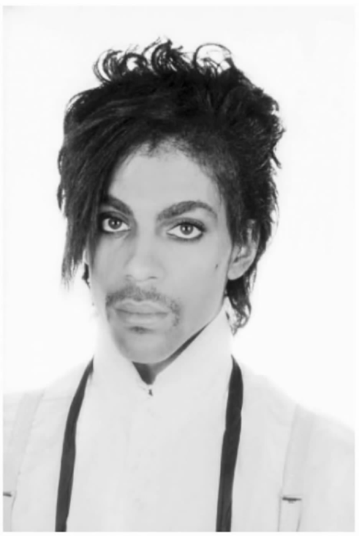​
Figure 1. A black and white portrait photograph of Prince taken in 1981 by Lynn Goldsmith.

In 1984, Goldsmith, through her agency, licensed that photograph to Vanity Fair to serve as an “artist reference for an illustration” in the magazine. 1 App. 85. The terms of the license were that the illustration was “to be published in Vanity Fair November 1984 issue. It can appear one time full page and one time under one quarter page. No other usage right granted.” Ibid. Goldsmith was to receive $400 and a source credit.

To make the illustration, Vanity Fair hired pop artist Andy Warhol. Warhol was already a major figure in American art, known among other things for his silkscreen portraits of celebrities. From Goldsmith's photograph, Warhol created a silkscreen portrait of Prince, which appeared alongside an article about Prince in the November 1984 issue of Vanity Fair. See fig. 2, infra. The article, titled “Purple Fame,” is primarily about the “sexual style” of the new celebrity and his music. Vanity Fair, Nov. 1984, p. 66. Goldsmith received her $400 fee, and Vanity Fair credited her for the “source photograph.” 2 App. 323, 325–326. Warhol received an unspecified amount.

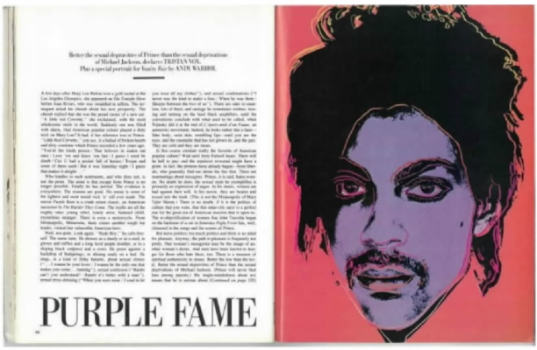​
Figure 2. A purple silkscreen portrait of Prince created in 1984 by Andy Warhol to illustrate an article in Vanity Fair

In addition to the single illustration authorized by the Vanity Fair license, Warhol created 15 other works based on Goldsmith's photograph: 13 silkscreen prints and two pencil drawings. The works are collectively referred to as the “Prince Series.” See Appendix, infra. Goldsmith did not know about the Prince Series until 2016, when she saw the image of an orange silkscreen portrait of Prince (“Orange Prince”) on the cover of a magazine published by Vanity Fair's parent company, Condé Nast. See fig. 3, infra.

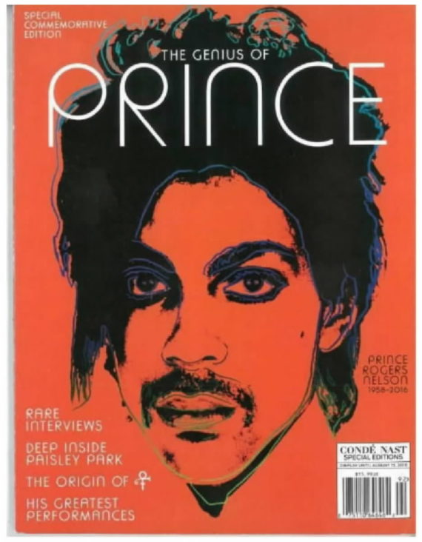​
Figure 3. An orange silkscreen portrait of Prince on the cover of a special edition magazine published in 2016 by Condé Nast.

By that time, Warhol had died, and the Prince Series had passed to the Andy Warhol Foundation for the Visual Arts, Inc. AWF no longer possesses the works, but it asserts copyright in them. It has licensed images of the works for commercial and editorial uses. In particular, after Prince died in 2016, Condé Nast contacted AWF about the possibility of reusing the 1984 Vanity Fair image for a special edition magazine that would commemorate Prince. Once AWF informed Condé Nast about the other Prince Series images, however, Condé Nast obtained a license to publish Orange Prince instead. The magazine, titled “The Genius of Prince,” is a tribute to “Prince Rogers Nelson, 1958–2016.” It is “devoted to Prince.” 2 App. 352. Condé Nast paid AWF $10,000 for the license. Goldsmith received neither a fee nor a source credit.

Remember that Goldsmith, too, had licensed her Prince images to magazines such as Newsweek, to accompany a story about the musician, and Vanity Fair, to serve as an artist reference. But that was not all. Between 1981 and 2016, Goldsmith's photos of Prince appeared on or between the covers of People, Readers Digest, Guitar World, and Musician magazines. See, e.g., fig. 4, infra.

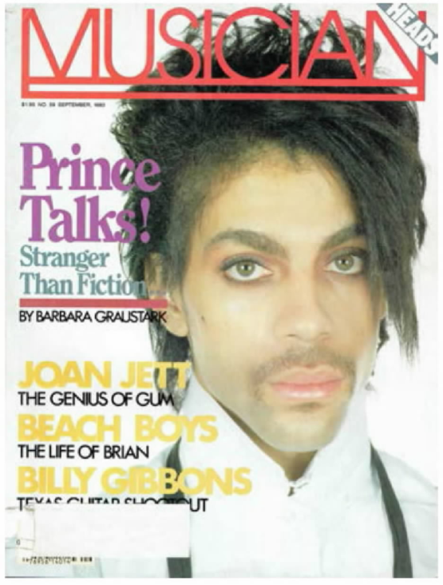​
Figure 4. One of Lynn Goldsmith's photographs of Prince on the cover of Musician magazine.

People magazine, in fact, paid Goldsmith $1,000 to use one of her copyrighted photographs in a special collector's edition, “Celebrating Prince: 1958–2016,” just after Prince died. People's tribute, like Condé Nast's, honors the life and music of Prince. Other magazines, including Rolling Stone and Time, also released special editions. See fig. 5, infra. All of them depicted Prince on the cover. All of them used a copyrighted photograph in service of that object. And all of them (except Condé Nast) credited the photographer.

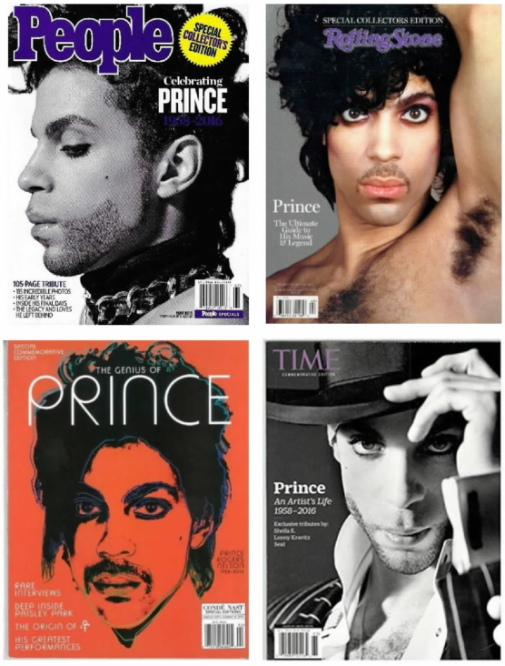​
Figure 5. Four special edition magazines commemorating Prince after he died in 2016.

When Goldsmith saw Orange Prince on the cover of Condé Nast's special edition magazine, she recognized her work. “It's the photograph,” she later testified. 1 App. 290. Orange Prince crops, flattens, traces, and colors the photo but otherwise does not alter it. See fig. 6, infra.

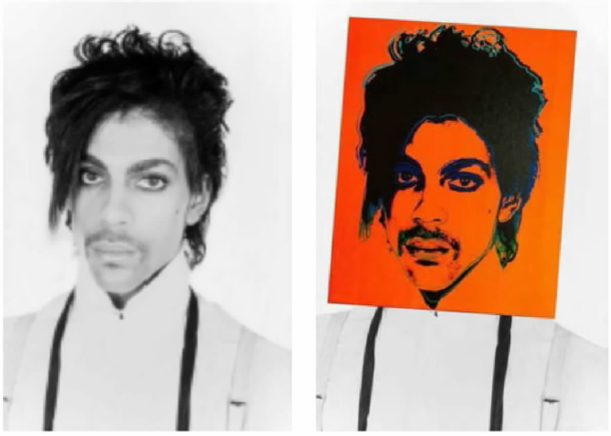​
Figure 6. Warhol's orange silkscreen portrait of Prince superimposed on Goldsmith's portrait photograph.

Goldsmith notified AWF of her belief that it had infringed her copyright. AWF then sued Goldsmith and her agency for a declaratory judgment of noninfringement or, in the alternative, fair use. Goldsmith counterclaimed for infringement.

The District Court granted summary judgment for AWF. 382 F.Supp.3d 312, 316 (S.D.N.Y. 2019). The court considered the four fair use factors enumerated in 17 U.S.C. § 107 and held that the Prince Series works made fair use of Goldsmith's photograph. As to the first factor, the works were “transformative” because, looking at them and the photograph “side-by-side,” they “have a different character, give Goldsmith's photograph a new expression, and employ new aesthetics with creative and communicative results distinct from Goldsmith's.” 382 F.Supp.3d at 325–326 (internal quotation marks and alterations omitted). In particular, the works “can reasonably be perceived to have transformed Prince from a vulnerable, uncomfortable person to an iconic, larger-than-life figure,” such that “each Prince Series work is immediately recognizable as a ‘Warhol’ rather than as a photograph of Prince.” Id., at 326. Although the second factor, the nature of Goldsmith's copyrighted work (creative and unpublished), “would ordinarily weigh in [her] favor ... , this factor [was] of limited importance because the Prince Series works are transformative.” Id., at 327. The third factor, the amount and substantiality of the portion used in relation to the copyrighted work, favored AWF because, according to the District Court, “Warhol removed nearly all the photograph's protectible elements in creating the Prince Series.” Id., at 330. Finally, the fourth factor likewise favored AWF because “the Prince Series works are not market substitutes that have harmed—or have the potential to harm—Goldsmith.” Id., at 331.

The Court of Appeals for the Second Circuit reversed and remanded. 11 F.4th 26, 54 (2021). It held that all four fair use factors favored Goldsmith. On the first factor, “the purpose and character of the use,” § 107(1), the Court of Appeals rejected the notion that “any secondary work that adds a new aesthetic or new expression to its source material is necessarily transformative.” Id., at 38–39. The question was, instead, “whether the secondary work's use of its source material is in service of a fundamentally different and new artistic purpose and character.” Id., at 42 (internal quotation marks omitted). Such “transformative purpose and character must, at bare minimum, comprise something more than the imposition of another artist's style on the primary work.” Ibid. Here, however, “the overarching purpose and function of the two works at issue ... is identical, not merely in the broad sense that they are created as works of visual art, but also in the narrow but essential sense that they are portraits of the same person.” Ibid. (footnote omitted). The Court of Appeals also rejected the District Court's logic that “ ‘each Prince Series work’ ” is transformative because it “ ‘is immediately recognizable as a “Warhol,” ’ ” which the Court of Appeals believed would “create a celebrity-plagiarist privilege.” Id., at 43; see also ibid. (“[T]he fact that Martin Scorsese's recent film The Irishman is recognizably ‘a Scorsese’ does not absolve him of the obligation to license the original book” (some internal quotation marks and alterations omitted)).

On the other three factors, the Court of Appeals found that the creative and unpublished nature of Goldsmith's photograph favored her, id., at 45; that the amount and substantiality of the portion taken (here, “the ‘essence’ ” of the photograph) was not reasonable in relation to the purpose of the use, id., at 45–47; and that AWF's commercial licensing encroached on Goldsmith's protected market to license her photograph “to publications for editorial purposes and to other artists to create derivative works,” id., at 48–51. The court noted that there was “no material dispute that both Goldsmith and AWF have sought to license (and indeed have successfully licensed) their respective depictions of Prince to popular print magazines to accompany articles about him.” Id., at 49 (footnote omitted).

Finally, although the District Court had not reached the issue, the Court of Appeals rejected AWF's argument that the Prince Series works were not substantially similar to Goldsmith's photograph. See id., at 52–54.

Judge Jacobs concurred. He stressed that the Court of Appeals’ holding “d[id] not consider, let alone decide, whether the infringement here encumbers the original Prince Series works.” Id., at 54. Instead, “the only use at issue” was “the Foundation's commercial licensing” of images of the Prince Series. Id., at 55.
II
AWF does not challenge the Court of Appeals’ holding that Goldsmith's photograph and the Prince Series works are substantially similar. The question here is whether AWF can defend against a claim of copyright infringement because it made “fair use” of Goldsmith's photograph. 17 U.S.C. § 107.

Although the Court of Appeals analyzed each fair use factor, the only question before this Court is whether the court below correctly held that the first factor, “the purpose and character of the use, including whether such use is of a commercial nature or is for nonprofit educational purposes,” § 107(1), weighs in Goldsmith's favor. AWF contends that the Prince Series works are “transformative,” and that the first factor therefore weighs in its favor, because the works convey a different meaning or message than the photograph. Brief for Petitioner 33. The Court of Appeals erred, according to AWF, by not considering that new expression. Id., at 47–48.

But the first fair use factor instead focuses on whether an allegedly infringing use has a further purpose or different character, which is a matter of degree, and the degree of difference must be weighed against other considerations, like commercialism. Campbell v. Acuff-Rose Music, Inc., 510 U.S. 569, 579 (1994). Although new expression may be relevant to whether a copying use has a sufficiently distinct purpose or character, it is not, without more, dispositive of the first factor.

Here, the specific use of Goldsmith's photograph alleged to infringe her copyright is AWF's licensing of Orange Prince to Condé Nast. As portraits of Prince used to depict Prince in magazine stories about Prince, the original photograph and AWF's copying use of it share substantially the same purpose. Moreover, the copying use is of a commercial nature. Even though Orange Prince adds new expression to Goldsmith's photograph, as the District Court found, this Court agrees with the Court of Appeals that, in the context of the challenged use, the first fair use factor still favors Goldsmith.
A
The Copyright Act encourages creativity by granting to the author of an original work “a bundle of exclusive rights.” Harper & Row, Publishers, Inc. v. Nation Enterprises, 471 U.S. 539, 546 (1985); see U. S. Const., Art. I, § 8, cl. 8 (“The Congress shall have Power ... To Promote the Progress of Science and useful Arts, by securing for limited Times to Authors and Inventors the exclusive Right to their respective Writings and Discoveries”). That bundle includes the rights to reproduce the copyrighted work, to prepare derivative works, and, in the case of pictorial or graphic works, to display the copyrighted work publicly. 17 U.S.C. § 106.

The Act, however, “reflects a balance of competing claims upon the public interest: Creative work is to be encouraged and rewarded, but private motivation must ultimately serve the cause of promoting broad public availability of literature, music, and the other arts.” Twentieth Century Music Corp. v. Aiken, 422 U.S. 151, 156 (1975). Copyright thus trades off the benefits of incentives to create against the costs of restrictions on copying. The Act, for example, limits the duration of copyright, §§ 302–305, as required by the Constitution; makes facts and ideas uncopyrightable, § 102; and limits the scope of copyright owners’ exclusive rights, §§ 107–122.

This balancing act between creativity and availability (including for use in new works) is reflected in one such limitation, the defense of “fair use.” In 1976, Congress codified the common-law doctrine of fair use in § 107, which provides: “[T]he fair use of a copyrighted work, ... for purposes such as criticism, comment, news reporting, teaching ... , scholarship, or research, is not an infringement of copyright.” To determine whether a particular use is “fair,” the statute sets out four factors to be considered:
“(1) the purpose and character of the use, including whether such use is of a commercial nature or is for nonprofit educational purposes;
“(2) the nature of the copyrighted work;
“(3) the amount and substantiality of the portion used in relation to the copyrighted work as a whole; and
“(4) the effect of the use upon the potential market for or value of the copyrighted work.”

The fair use doctrine “permits courts to avoid rigid application of the copyright statute when, on occasion, it would stifle the very creativity which that law is designed to foster.” Stewart v. Abend, 495 U.S. 207, 236 (1990) (internal quotation marks omitted). The Act's fair use provision, in turn, “set[s] forth general principles, the application of which requires judicial balancing, depending upon relevant circumstances.” Google LLC v. Oracle America, Inc., 593 U. S. –––, –––, 141 S.Ct. 1183, 1197 (2021). Because those principles apply across a wide range of copyrightable material, from books to photographs to software, fair use is a “flexible” concept, and “its application may well vary depending on context.” Id., at –––, 141 S.Ct. at 1197. For example, in applying the fair use provision, “copyright's protection may be stronger where the copyrighted material ... serves an artistic rather than a utilitarian function.” Ibid.
1
The first fair use factor is “the purpose and character of the use, including whether such use is of a commercial nature or is for nonprofit educational purposes.” § 107(1). This factor considers the reasons for, and nature of, the copier's use of an original work. The “central” question it asks is “whether the new work merely ‘supersede[s] the objects’ of the original creation ... (‘supplanting’ the original), or instead adds something new, with a further purpose or different character.” Campbell, 510 U.S. at 579 (quoting Folsom v. Marsh, 9 F.Cas. 342, 348 (No. 4,901) (C.C.D. Mass. 1841) (Story, J.), and Harper & Row, 471 U.S. at 562). In that way, the first factor relates to the problem of substitution—copyright's bête noire. The use of an original work to achieve a purpose that is the same as, or highly similar to, that of the original work is more likely to substitute for, or “ ‘supplan[t],’ ” the work, ibid.

Consider the “purposes” listed in the preamble paragraph of § 107: “criticism, comment, news reporting, teaching ..., scholarship, or research.” Although the examples given are “ ‘illustrative and not limitative,’ ” they reflect “the sorts of copying that courts and Congress most commonly ha[ve] found to be fair uses,” and so may guide the first factor inquiry. Campbell, 510 U.S. at 577–578 (quoting § 101). As the Court of Appeals observed, the “examples are easily understood,” as they contemplate the use of an original work to “serv[e] a manifestly different purpose from the [work] itself.” 11 F.4th at 37. Criticism of a work, for instance, ordinarily does not supersede the objects of, or supplant, the work. Rather, it uses the work to serve a distinct end.

Not every instance will be clear cut, however. Whether a use shares the purpose or character of an original work, or instead has a further purpose or different character, is a matter of degree. Most copying has some further purpose, in the sense that copying is socially useful ex post. Many secondary works add something new. That alone does not render such uses fair. Rather, the first factor (which is just one factor in a larger analysis) asks “whether and to what extent” the use at issue has a purpose or character different from the original. Campbell, 510 U.S. at 579 (emphasis added). The larger the difference, the more likely the first factor weighs in favor of fair use. The smaller the difference, the less likely.

A use that has a further purpose or different character is said to be “ ‘transformative.’ ” Ibid. (quoting P. Leval, Toward a Fair Use Standard, 103 Harv. L. Rev. 1105, 1111 (1990) (hereinafter Leval)). As before, “transformativeness” is a matter of degree. See Campbell, 510 U.S. at 579. That is important because the word “transform,” though not included in § 107, appears elsewhere in the Copyright Act. The statute defines derivative works, which the copyright owner has “the exclusive righ[t]” to prepare, § 106(2), to include “any other form in which a work may be recast, transformed, or adapted,” § 101. In other words, the owner has a right to derivative transformations of her work. Such transformations may be substantial, like the adaptation of a book into a movie. To be sure, this right is “[s]ubject to” fair use. § 106; see also § 107. The two are not mutually exclusive. But an overbroad concept of transformative use, one that includes any further purpose, or any different character, would narrow the copyright owner's exclusive right to create derivative works. To preserve that right, the degree of transformation required to make “transformative” use of an original must go beyond that required to qualify as a derivative.

For example, this Court in Campbell considered whether parody may be fair use. In holding that it may, the Court explained that “parody has an obvious claim to transformative value” because “it can provide social benefit, by shedding light on an earlier work, and, in the process, creating a new one.” 510 U.S. at 579. The use at issue in Campbell was 2 Live Crew's copying of certain lyrics and musical elements from Roy Orbison's song, “Oh, Pretty Woman,” to create a rap derivative titled “Pretty Woman.” Without a doubt, 2 Live Crew transformed Orbison's song by adding new lyrics and musical elements, such that “Pretty Woman” had a new message and different aesthetic than “Oh, Pretty Woman.” Indeed, the whole genre of music changed from rock ballad to rap. That was not enough for the first factor to weigh in favor of fair use, however. The Court found it necessary to determine whether 2 Live Crew's transformation of Orbison's song rose to the level of parody, a distinct purpose of commenting on the original or criticizing it. See id., at 580–583.

Distinguishing between parody (which targets an author or work for humor or ridicule) and satire (which ridicules society but does not necessarily target an author or work), the Court further explained that “[p]arody needs to mimic an original to make its point, and so has some claim to use the creation of its victim's (or collective victims’) imagination, whereas satire can stand on its own two feet and so requires justification for the very act of borrowing.” Id., at 580–581. More generally, when “commentary has no critical bearing on the substance or style of the original composition, ... the claim to fairness in borrowing from another's work diminishes accordingly (if it does not vanish), and other factors, like the extent of its commerciality, loom larger.” Id., at 580; see also id., at 597 (Kennedy, J., concurring).

This discussion illustrates two important points: First, the fact that a use is commercial as opposed to nonprofit is an additional “element of the first factor.” Id., at 584. The commercial nature of the use is not dispositive. Ibid.; Google, 593 U. S., at –––. But it is relevant. As the Court explained in Campbell, it is to be weighed against the degree to which the use has a further purpose or different character. See 510 U.S. at 579 (“[T]he more transformative the new work, the less will be the significance of other factors, like commercialism, that may weigh against a finding of fair use”); see also id., at 580, 585.

Second, the first factor also relates to the justification for the use. In a broad sense, a use that has a distinct purpose is justified because it furthers the goal of copyright, namely, to promote the progress of science and the arts, without diminishing the incentive to create. See id., at 579; Authors Guild v. Google, Inc., 804 F.3d 202, 214 (C.A.2 2015) (Leval, J.) (“The more the appropriator is using the copied material for new, transformative purposes, the more it serves copyright's goal of enriching public knowledge and the less likely it is that the appropriation will serve as a substitute for the original or its plausible derivatives, shrinking the protected market opportunities of the copyrighted work”). A use that shares the purpose of a copyrighted work, by contrast, is more likely to provide “the public with a substantial substitute for matter protected by the [copyright owner's] interests in the original wor[k] or derivatives of [it],” id., at 207, which undermines the goal of copyright.

In a narrower sense, a use may be justified because copying is reasonably necessary to achieve the user's new purpose. Parody, for example, “needs to mimic an original to make its point.” Campbell, 510 U.S. at 580–581. Similarly, other commentary or criticism that targets an original work may have compelling reason to “ ‘conjure up’ ” the original by borrowing from it. Id., at 588. An independent justification like this is particularly relevant to assessing fair use where an original work and copying use share the same or highly similar purposes, or where wide dissemination of a secondary work would otherwise run the risk of substitution for the original or licensed derivatives of it. See id., at 580; Harper & Row, 471 U.S. at 557. Once again, the question of justification is one of degree. See Leval 1111 (“[I]t is not sufficient simply to conclude whether or not justification exists. The question remains how powerful, or persuasive, is the justification, because the court must weigh the strength of the secondary user's justification against factors favoring the copyright owner”).

In sum, the first fair use factor considers whether the use of a copyrighted work has a further purpose or different character, which is a matter of degree, and the degree of difference must be balanced against the commercial nature of the use. If an original work and a secondary use share the same or highly similar purposes, and the secondary use is of a commercial nature, the first factor is likely to weigh against fair use, absent some other justification for copying.
2
The fair use provision, and the first factor in particular, requires an analysis of the specific “use” of a copyrighted work that is alleged to be “an infringement.” § 107. The same copying may be fair when used for one purpose but not another. See Campbell, 510 U.S. at 585 (contrasting the use of a copyrighted work “to advertise a product, even in a parody,” with “the sale of a parody for its own sake, let alone one performed a single time by students in school”); Sony Corp. of America v. Universal City Studios, Inc., 464 U.S. 417, 449–451 (1984) (contrasting the recording of TV “for a commercial or profit-making purpose” with “private home use”).

Here, Goldsmith's copyrighted photograph has been used in multiple ways: After Goldsmith licensed the photograph to Vanity Fair to serve as an artist reference, Warhol used the photograph to create the Vanity Fair illustration and the other Prince Series works. Vanity Fair then used the photograph, pursuant to the license, when it published Warhol's illustration in 1984. Finally, AWF used the photograph when it licensed an image of Warhol's Orange Prince to Condé Nast in 2016. Only that last use, however, AWF's commercial licensing of Orange Prince to Condé Nast, is alleged to be infringing. We limit our analysis accordingly. In particular, the Court expresses no opinion as to the creation, display, or sale of any of the original Prince Series works.

A typical use of a celebrity photograph is to accompany stories about the celebrity, often in magazines. For example, Goldsmith licensed her photographs of Prince to illustrate stories about Prince in magazines such as Newsweek, Vanity Fair, and People. Supra, at 1266 – 1269. She even licensed her photographs for that purpose after Prince died in 2016. Supra, at 1269. A photographer may also license her creative work to serve as a reference for an artist, like Goldsmith did in 1984 when Vanity Fair wanted an image of Prince created by Warhol to illustrate an article about Prince. As noted by the Court of Appeals, Goldsmith introduced “uncontroverted” evidence “that photographers generally license others to create stylized derivatives of their work in the vein of the Prince Series.” 11 F.4th at 50; see 2 App. 291–299. In fact, Warhol himself paid to license photographs for some of his artistic renditions. Such licenses, for photographs or derivatives of them, are how photographers like Goldsmith make a living. They provide an economic incentive to create original works, which is the goal of copyright.

In 2016, AWF licensed an image of Orange Prince to Condé Nast to appear on the cover of a commemorative edition magazine about Prince. The edition, titled “The Genius of Prince,” celebrates the life and work of “Prince Rogers Nelson, 1958–2016.” It is undisputed here that the edition is “devoted to Prince.” 2 App. 352. In addition to AWF's image on the cover, the magazine contains numerous concert and studio photographs of Prince. In that context, the purpose of the image is substantially the same as that of Goldsmith's photograph. Both are portraits of Prince used in magazines to illustrate stories about Prince.¹¹ Such “environment[s]” are not “distinct and different.” Google, 593 U. S., at –––, 141 S.Ct. at 1203. AWF's licensing of the Orange Prince image thus “ ‘supersede[d] the objects,’ ” Campbell, 510 U.S. at 579, i.e., shared the objectives, of Goldsmith's photograph, even if the two were not perfect substitutes.

The use also “is of a commercial nature.” § 107(1). Just as Goldsmith licensed her photograph to Vanity Fair for $400, AWF licensed Orange Prince to Condé Nast for $10,000. The undisputed commercial character of AWF's use, though not dispositive, “tends to weigh against a finding of fair use.” Harper & Row, 471 U.S. at 562.

Taken together, these two elements—that Goldsmith's photograph and AWF's 2016 licensing of Orange Prince share substantially the same purpose, and that AWF's use of Goldsmith's photo was of a commercial nature—counsel against fair use, absent some other justification for copying. That is, although a use's transformativeness may outweigh its commercial character, here, both elements point in the same direction.

The foregoing does not mean, however, that derivative works borrowing heavily from an original cannot be fair uses. In Google, the Court suggested that “[a]n ‘artistic painting’ might, for example, fall within the scope of fair use even though it precisely replicates a copyrighted ‘advertising logo to make a comment about consumerism.’ ” 593 U. S., at ––– – –––, 141 S.Ct. at 1203 (quoting 4 M. Nimmer & D. Nimmer, Copyright § 13.05[A][1][b] (2019), in turn quoting N. Netanel, Making Sense of Fair Use, 15 Lewis & Clark L. Rev. 715, 746 (2011) (some internal quotation marks omitted)). That suggestion refers to Warhol's works that incorporate advertising logos, such as the Campbell's Soup Cans series. See fig. 7, infra.

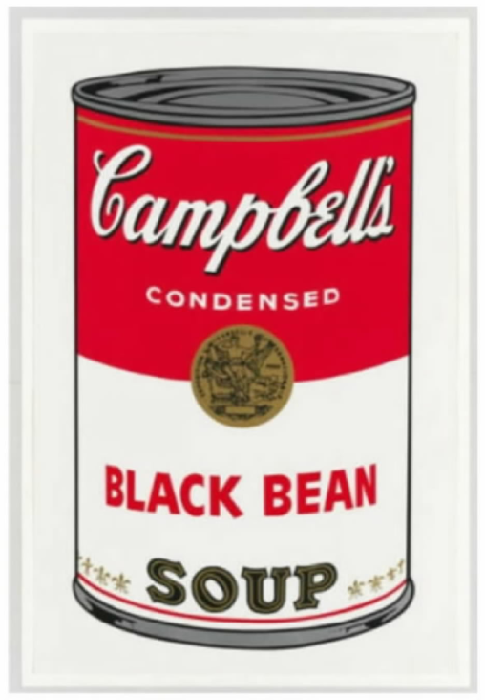​
Figure 7. A print based on the Campbell's soup can, one of Warhol's works that replicates a copyrighted advertising logo.

Yet not all of Warhol's works, nor all uses of them, give rise to the same fair use analysis. In fact, Soup Cans well illustrates the distinction drawn here. The purpose of Campbell's logo is to advertise soup. Warhol's canvases do not share that purpose. Rather, the Soup Cans series uses Campbell's copyrighted work for an artistic commentary on consumerism, a purpose that is orthogonal to advertising soup. The use therefore does not supersede the objects of the advertising logo.

Moreover, a further justification for Warhol's use of Campbell's logo is apparent. His Soup Cans series targets the logo. That is, the original copyrighted work is, at least in part, the object of Warhol's commentary. It is the very nature of Campbell's copyrighted logo—well known to the public, designed to be reproduced, and a symbol of an everyday item for mass consumption—that enables the commentary. Hence, the use of the copyrighted work not only serves a completely different purpose, to comment on consumerism rather than to advertise soup, it also “conjures up” the original work to “she[d] light” on the work itself, not just the subject of the work. Campbell, 510 U.S. at 579, 588. Here, by contrast, AWF's use of Goldsmith's photograph does not target the photograph, nor has AWF offered another compelling justification for the use. See infra, at 1285 – 1286, and nn. 20–21.
B
AWF contends, however, that the purpose and character of its use of Goldsmith's photograph weighs in favor of fair use because Warhol's silkscreen image of the photograph, like the Campbell's Soup Cans series, has a new meaning or message. The District Court, for example, understood the Prince Series works to portray Prince as “an iconic, larger-than-life figure.” 382 F.Supp.3d at 326. AWF also asserts that the works are a comment on celebrity. In particular, “Warhol's Prince Series conveys the dehumanizing nature of celebrity.” Brief for Petitioner 44. According to AWF, that new meaning or message, which the Court of Appeals ignored, makes the use “transformative” in the fair use sense. See id., at 44–48. We disagree.
1
Campbell did describe a transformative use as one that “alter[s] the first [work] with new expression, meaning, or message.” 510 U.S. at 579; see also Google, 593 U. S., at –––, 141 S.Ct. at 1202-1203. That description paraphrased Judge Leval's law review article, which referred to “new information, new aesthetics, new insights and understandings.” Leval 1111. (Judge Leval contrasted such additions with secondary uses that “merely repackag[e]” the original. Ibid.) But Campbell cannot be read to mean that § 107(1) weighs in favor of any use that adds some new expression, meaning, or message.

Otherwise, “transformative use” would swallow the copyright owner's exclusive right to prepare derivative works. Many derivative works, including musical arrangements, film and stage adaptions, sequels, spinoffs, and others that “recast, transfor[m] or adap[t]” the original, § 101, add new expression, meaning or message, or provide new information, new aesthetics, new insights and understandings. That is an intractable problem for AWF's interpretation of transformative use. The first fair use factor would not weigh in favor of a commercial remix of Prince's “Purple Rain” just because the remix added new expression or had a different aesthetic. A film or musical adaptation, like that of Alice Walker's The Color Purple, might win awards for its “significant creative contribution”; alter the meaning of a classic novel; and add “important new expression,” such as images, performances, original music, and lyrics. Post, at 1297 – 1298, 1304 (KAGAN, J., dissenting) (internal quotation marks omitted). But that does not in itself dispense with the need for licensing.

Campbell is again instructive. 2 Live Crew's version of Orbison's song easily conveyed a new meaning or message. It also had a different aesthetic. Yet the Court went further, examining whether and to what extent 2 Live Crew's song had the parodic purpose of “commenting on the original or criticizing it.” 510 U.S. at 583. Parody is, of course, a kind of message. Moreover, the Court considered what the words of the songs might have meant to determine whether parody “reasonably could be perceived.” Ibid. But new meaning or message was not sufficient. If it had been, the Court could have made quick work of the first fair use factor. Instead, meaning or message was simply relevant to whether the new use served a purpose distinct from the original, or instead superseded its objects. That was, and is, the “central” question under the first factor. Id., at 579.

The dissent commits the same interpretive error as AWF: It focuses on Campbell’s paraphrase, yet ignores the rest of that decision's careful reasoning. Indeed, upon reading the dissent, someone might be surprised to learn that Campbell was about parody at all. Had expert testimony confirmed the obvious fact that 2 Live Crew's “Pretty Woman” differed in aesthetics and meaning from Orbison's original, that would have been the end of the dissent's analysis. See post, at 1299 – 1301 (opinion of KAGAN, J.). Not the Court's, however. Campbell was the culmination of a long line of cases and scholarship about parody's claim to fairness in borrowing. “For purposes of copyright law,” the Court explained, “the heart of any parodist's claim to quote from existing material is the use of some elements of a prior author's composition to create a new one that, at least in part, comments on that author's works.” 510 U.S. at 580. Campbell thus drew a nuanced distinction between parody and satire: While parody cannot function unless it conjures up the original, “satire can stand on its own two feet and so requires justification for ... borrowing.” Id., at 580–581. The objective meaning or message of 2 Live Crew's song was relevant to this inquiry into the reasons for copying, but any “new expression, meaning, or message” was not the test.

What role meaning or message played in the Court of Appeals’ analysis here is not entirely clear. The court correctly rejected the idea “that any secondary work that adds a new aesthetic or new expression to its source material is necessarily transformative.” 11 F.4th at 38–39. It also appeared correctly to accept that meaning or message is relevant to, but not dispositive of, purpose. See id., at 41 (“[T]he secondary work itself must reasonably be perceived as embodying a distinct artistic purpose, one that conveys a new meaning or message separate from its source material”); id., at 42 (“[T]he judge must examine whether the secondary work's use of its source material is in service of a fundamentally different and new artistic purpose and character, [which] must, at a bare minimum, comprise something more than the imposition of another artist's style on the primary work ... ” (internal quotation marks omitted)).

Elsewhere, however, the Court of Appeals stated that “the district judge should not assume the role of art critic and seek to ascertain the intent behind or meaning of the works at issue.” Id., at 41. That statement is correct in part. A court should not attempt to evaluate the artistic significance of a particular work. See Bleistein v. Donaldson Lithographing Co., 188 U.S. 239, 251 (1903) (Holmes, J.) (“It would be a dangerous undertaking for persons trained only to the law to constitute themselves final judges of the worth of [a work], outside of the narrowest and most obvious limits”). Nor does the subjective intent of the user (or the subjective interpretation of a court) determine the purpose of the use. But the meaning of a secondary work, as reasonably can be perceived, should be considered to the extent necessary to determine whether the purpose of the use is distinct from the original, for instance, because the use comments on, criticizes, or provides otherwise unavailable information about the original, see, e.g., Authors Guild, 804 F.3d at 215–216.
2
The District Court determined that “[t]he Prince Series works can reasonably be perceived to have transformed Prince from a vulnerable, uncomfortable person to an iconic, larger-than-life figure.” 382 F.Supp.3d at 326. To make that determination, the District Court relied, in part, on testimony by Goldsmith that her photographs of Prince show that he “is ‘not a comfortable person’ and that he is ‘a vulnerable human being.’ ” Ibid. An expert on Warhol, meanwhile, testified that the Prince Series works depict “Prince as a kind of icon or totem of something,” a “mask-like simulacrum of his actual existence.” 1 App. 249, 257.

The Court of Appeals noted, correctly, that “whether a work is transformative cannot turn merely on the stated or perceived intent of the artist or the meaning or impression that a critic—or for that matter, a judge—draws from the work.” 11 F.4th at 41. “[O]therwise, the law may well ‘recogniz[e] any alteration as transformative.’ ” Ibid. (quoting 4 Nimmer, Copyright § 13.05[B][6]). Whether the purpose and character of a use weighs in favor of fair use is, instead, an objective inquiry into what use was made, i.e., what the user does with the original work.

Granting the District Court's conclusion that Orange Prince reasonably can be perceived to portray Prince as iconic, whereas Goldsmith's portrayal is photorealistic, that difference must be evaluated in the context of the specific use at issue. The use is AWF's commercial licensing of Orange Prince to appear on the cover of Condé Nast's special commemorative edition. The purpose of that use is, still, to illustrate a magazine about Prince with a portrait of Prince. Although the purpose could be more specifically described as illustrating a magazine about Prince with a portrait of Prince, one that portrays Prince somewhat differently from Goldsmith's photograph (yet has no critical bearing on her photograph), that degree of difference is not enough for the first factor to favor AWF, given the specific context of the use.

To hold otherwise would potentially authorize a range of commercial copying of photographs, to be used for purposes that are substantially the same as those of the originals. As long as the user somehow portrays the subject of the photograph differently, he could make modest alterations to the original, sell it to an outlet to accompany a story about the subject, and claim transformative use. Many photographs will be open to various interpretations. A subject as open to interpretation as the human face, for example, reasonably can be perceived as conveying several possible meanings. The application of an artist's characteristic style to bring out a particular meaning that was available in the photograph is less likely to constitute a “further purpose” as Campbell used the term. 510 U.S. at 579.

AWF asserts another, albeit related, purpose, which is to comment on the “dehumanizing nature” and “effects” of celebrity. Brief for Petitioner 44, 51. No doubt, many of Warhol's works, and particularly his uses of repeated images, can be perceived as depicting celebrities as commodities. But again, even if such commentary is perceptible on the cover of Condé Nast's tribute to “Prince Rogers Nelson, 1958–2016,” on the occasion of the man's death, AWF has a problem: The asserted commentary is at Campbell’s lowest ebb. Because it “has no critical bearing on” Goldsmith's photograph, the commentary's “claim to fairness in borrowing from” her work “diminishes accordingly (if it does not vanish).” 510 U.S. at 580. The commercial nature of the use, on the other hand, “loom[s] larger.” Ibid.

Here, the circumstances of AWF's 2016 licensing outweigh its diminished claim to fairness in copying under the first factor. Like satire that does not target an original work, AWF's asserted commentary “can stand on its own two feet and so requires justification for the very act of borrowing.” Id., at 581. Moreover, because AWF's commercial use of Goldsmith's photograph to illustrate a magazine about Prince is so similar to the photograph's typical use, a particularly compelling justification is needed. Yet AWF offers no independent justification, let alone a compelling one, for copying the photograph, other than to convey a new meaning or message. As explained, that alone is not enough for the first factor to favor fair use.

Copying might have been helpful to convey a new meaning or message. It often is. But that does not suffice under the first factor. Nor does it distinguish AWF from a long list of would-be fair users: a musician who finds it helpful to sample another artist's song to make his own, a playwright who finds it helpful to adapt a novel, or a filmmaker who would prefer to create a sequel or spinoff, to name just a few. As Judge Leval has explained, “[a] secondary author is not necessarily at liberty to make wholesale takings of the original author's expression merely because of how well the original author's expression would convey the secondary author's different message.” Authors Guild, 804 F.3d at 215.

3
The dissent would rather not debate these finer points. See post, at 1293, n. 2 (opinion of KAGAN, J.). It offers no theory of the relationship between transformative uses of original works and derivative works that transform originals. No reason why AWF was justified in using Goldsmith's original work in this specific instance. And no limiting principle for its apparent position that any use that is creative prevails under the first fair use factor. Instead, the dissent makes the simple (and obvious) point that restrictions on copying can inhibit follow-on works. “ ‘Nothing comes from nothing,’ ” the dissent observes, “ ‘nothing ever could.’ ” Post, at 1297. So somewhere in the copyright statute, there must be an “escape valve” to create something good. Post, at 1298. If AWF must pay Goldsmith to use her creation, the dissent claims, this will “stifle creativity of every sort,” “thwart the expression of new ideas and the attainment of new knowledge,” and “make our world poorer.” Post, at 1312.

These claims will not age well. It will not impoverish our world to require AWF to pay Goldsmith a fraction of the proceeds from its reuse of her copyrighted work. Recall, payments like these are incentives for artists to create original works in the first place. Nor will the Court's decision, which is consistent with longstanding principles of fair use, snuff out the light of Western civilization, returning us to the Dark Ages of a world without Titian, Shakespeare, or Richard Rodgers. The dissent goes on at length about the basic premise that copyright (like other forms of intellectual property) involves a tradeoff between stimulating innovative activity, on the one hand, and allowing follow-on innovation, on the other. See post, at 1297 – 1298, and n. 4, 1304 – 1312. This theme will be familiar to any student of copyright law. In tracing the history of Renaissance painting, however, the dissent loses sight of the statute and this Court's cases. The Lives of the Artists undoubtedly makes for livelier reading than the U. S. Code or the U. S. Reports, but as a court, we do not have that luxury.

The dissent thus misses the forest for a tree. Its single-minded focus on the value of copying ignores the value of original works. It ignores the statute's focus on the specific use alleged to be infringing. See n. 10, supra. It waves away the statute's concern for derivative works. Supra, at 1281 – 1283, and n. 17. It fails to appreciate Campbell’s nuance. Supra, at 1282 – 1283, 1285, n. 21. And it disregards this Court's repeated emphasis on justification. Supra, at 1282 – 1283, and n. 18, 1285, n. 21.

The result of these omissions is an account of fair use that is unbalanced in theory and, perhaps relatedly, in tone. The dissent's conclusion—that whenever a use adds new meaning or message, or constitutes creative progress in the opinion of a critic or judge, the first fair use factor weighs in its favor—does not follow from its basic premise. Fair use instead strikes a balance between original works and secondary uses based in part on objective indicia of the use's purpose and character, including whether the use is commercial and, importantly, the reasons for copying.

Finally, copyright law is replete with escape valves: the idea–expression distinction; the general rule that facts may not receive protection; the requirement of originality; the legal standard for actionable copying; the limited duration of copyright; and, yes, the defense of fair use, including all its factors, such as whether the amount taken is reasonable in relation to the purpose of the use. These doctrines (and others) provide ample space for artists and other creators to use existing materials to make valuable new works. They account for most, if not all, of the examples given by the dissent, as well as the dissent's own copying (and the Court's, too). If the last century of American art, literature, music, and film is any indication, the existing copyright law, of which today's opinion is a continuation, is a powerful engine of creativity.
III
Lynn Goldsmith's original works, like those of other photographers, are entitled to copyright protection, even against famous artists. Such protection includes the right to prepare derivative works that transform the original. The use of a copyrighted work may nevertheless be fair if, among other things, the use has a purpose and character that is sufficiently distinct from the original. In this case, however, Goldsmith's original photograph of Prince, and AWF's copying use of that photograph in an image licensed to a special edition magazine devoted to Prince, share substantially the same purpose, and the use is of a commercial nature. AWF has offered no other persuasive justification for its unauthorized use of the photograph. Therefore, the “purpose and character of the use, including whether such use is of a commercial nature or is for nonprofit educational purposes,” § 107(1), weighs in Goldsmith's favor.

The Court has cautioned that the four statutory fair use factors may not “be treated in isolation, one from another. All are to be explored, and the results weighed together, in light of the purposes of copyright.” Campbell, 510 U.S. at 578. AWF does not challenge the Court of Appeals’ determinations that the second factor, “the nature of the copyrighted work,” § 107(2); third factor, “the amount and substantiality of the portion used in relation to the copyrighted work as a whole,” § 107(3); and fourth factor, “the effect of the use upon the potential market for or value of the copyrighted work,” all favor Goldsmith. See 11 F.4th at 45–51. Because this Court agrees with the Court of Appeals that the first factor likewise favors her, the judgment of the Court of Appeals is

Affirmed.
APPENDIX
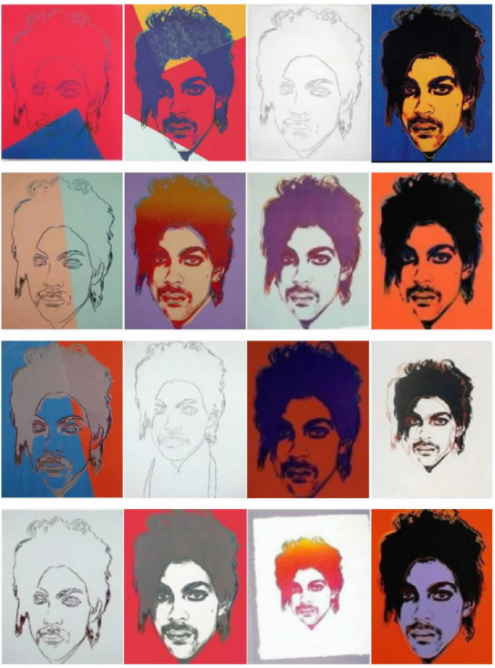​
Andy Warhol created 16 works based on Lynn Goldsmith's photograph: 14 silkscreen prints and two pencil drawings. The works are collectively known as the Prince Series.
CONCURRING OPINION of Justice GORSUCH and Justice JACKSON OMITTED
Justice KAGAN, with whom THE CHIEF JUSTICE joins, dissenting.

Today, the Court declares that Andy Warhol's eye-popping silkscreen of Prince—a work based on but dramatically altering an existing photograph—is (in copyright lingo) not “transformative.” Still more, the Court decides that even if Warhol's portrait were transformative—even if its expression and meaning were worlds away from the photo—that fact would not matter. For in the majority's view, copyright law's first fair-use factor—addressing “the purpose and character” of “the use made of a work”—is uninterested in the distinctiveness and newness of Warhol's portrait. 17 U.S.C. § 107. What matters under that factor, the majority says, is instead a marketing decision: In the majority's view, Warhol's licensing of the silkscreen to a magazine precludes fair use.1

You've probably heard of Andy Warhol; you've probably seen his art. You know that he reframed and reformulated—in a word, transformed—images created first by others. Campbell's soup cans and Brillo boxes. Photos of celebrity icons: Marilyn, Elvis, Jackie, Liz—and, as most relevant here, Prince. That's how Warhol earned his conspicuous place in every college's Art History 101. So it may come as a surprise to see the majority describe the Prince silkscreen as a “modest alteration[ ]” of Lynn Goldsmith's photograph—the result of some “crop[ping]” and “flatten[ing]”—with the same “essential nature.” Ante, at 1270, 1280, n. 14, 1284 – 1285 (emphasis deleted). Or more generally, to observe the majority's lack of appreciation for the way his works differ in both aesthetics and message from the original templates. In a recent decision, this Court used Warhol paintings as the perfect exemplar of a “copying use that adds something new and important”—of a use that is “transformative,” and thus points toward a finding of fair use. Google LLC v. Oracle America, Inc., 593 U. S. –––, ––– – –––, 141 S.Ct. 1183, 1202-1203 (2021). That Court would have told this one to go back to school.

What is worse, that refresher course would apparently be insufficient. For it is not just that the majority does not realize how much Warhol added; it is that the majority does not care. In adopting that posture of indifference, the majority does something novel (though in law, unlike in art, it is rarely a good thing to be transformative). Before today, we assessed “the purpose and character” of a copier's use by asking the following question: Does the work “add[ ] something new, with a further purpose or different character, altering the [original] with new expression, meaning, or message”? Campbell v. Acuff-Rose Music, Inc., 510 U.S. 569, 579 (1994); see Google, 593 U. S., at –––, 141 S.Ct. at 1202-1203. When it did so to a significant degree, we called the work “transformative” and held that the fair-use test's first factor favored the copier (though other factors could outweigh that one). But today's decision—all the majority's protestations notwithstanding—leaves our first-factor inquiry in shambles. The majority holds that because Warhol licensed his work to a magazine—as Goldsmith sometimes also did—the first factor goes against him. See, e.g., ante, at 1285 – 1286. It does not matter how different the Warhol is from the original photo—how much “new expression, meaning, or message” he added. It does not matter that the silkscreen and the photo do not have the same aesthetic characteristics and do not convey the same meaning. It does not matter that because of those dissimilarities, the magazine publisher did not view the one as a substitute for the other. All that matters is that Warhol and the publisher entered into a licensing transaction, similar to one Goldsmith might have done. Because the artist had such a commercial purpose, all the creativity in the world could not save him.

That doctrinal shift ill serves copyright's core purpose. The law does not grant artists (and authors and composers and so on) exclusive rights—that is, monopolies—for their own sake. It does so to foster creativity—“[t]o promote the [p]rogress” of both arts and science. U. S. Const., Art. I, § 8, cl. 8. And for that same reason, the law also protects the fair use of copyrighted material. Both Congress and the courts have long recognized that an overly stringent copyright regime actually “stifle[s]” creativity by preventing artists from building on the work of others. Stewart v. Abend, 495 U.S. 207, 236 (1990) (internal quotation marks omitted); see Campbell, 510 U.S. at 578–579. For, let's be honest, artists don't create all on their own; they cannot do what they do without borrowing from or otherwise making use of the work of others. That is the way artistry of all kinds—visual, musical, literary—happens (as it is the way knowledge and invention generally develop). The fair-use test's first factor responds to that truth: As understood in our precedent, it provides “breathing space” for artists to use existing materials to make fundamentally new works, for the public's enjoyment and benefit. Id., at 579. In now remaking that factor, and thus constricting fair use's boundaries, the majority hampers creative progress and undermines creative freedom. I respectfully dissent.2

I

A
Andy Warhol is the avatar of transformative copying. Cf. Google, 593 U. S., at ––– – –––, 141 S.Ct. at 1202-1203 (selecting Warhol, from the universe of creators, to illustrate what transformative copying is). In his early career, Warhol worked as a commercial illustrator and became experienced in varied techniques of reproduction. By night, he used those techniques—in particular, the silkscreen—to create his own art. His own—even though in one sense not. The silkscreen enabled him to make brilliantly novel art out of existing “images carefully selected from popular culture.” D. De Salvo, God Is in the Details, in Andy Warhol Prints 22 (4th rev. ed. 2003). The works he produced, connecting traditions of fine art with mass culture, depended on “appropriation[s]”: The use of “elements of an extant image[ ] is Warhol's entire modus operandi.” B. Gopnik, Artistic Appropriation vs. Copyright Law, N. Y. Times, Apr. 6, 2021, p. C4 (internal quotation marks omitted). And with that m.o., he changed modern art; his appropriations and his originality were flipsides of each other. To a public accustomed to thinking of art as formal works “belong[ing] in gold frames”—disconnected from the everyday world of products and personalities—Warhol's paintings landed like a thunderclap. A. Danto, Andy Warhol 36 (2009). Think Soup Cans or, in another vein, think Elvis. Warhol had created “something very new”—“shockingly important, transformative art.” B. Gopnik, Warhol 138 (2020); Gopnik, Artistic Appropriation.

To see the method in action, consider one of Warhol's pre-Prince celebrity silkscreens—this one, of Marilyn Monroe. He began with a publicity photograph of the actress. And then he went to work. He reframed the image, zooming in on Monroe's face to “produc[e] the disembodied effect of a cinematic close-up.” 1 App. 161 (expert declaration).

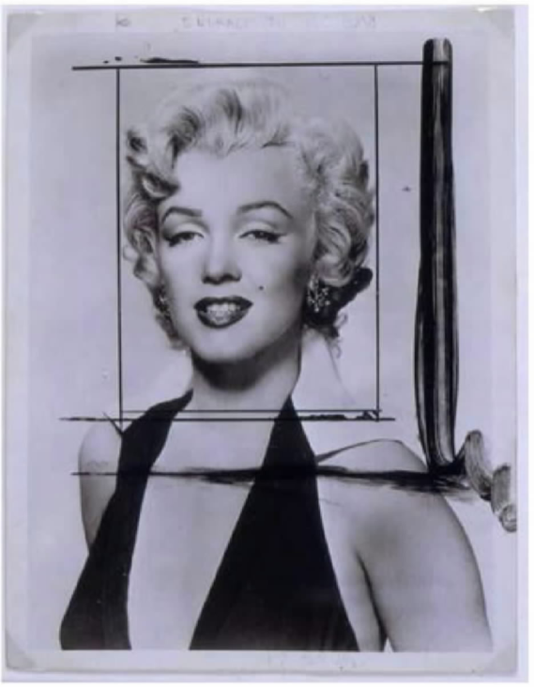​
At that point, he produced a high-contrast, flattened image on a sheet of clear acetate. He used that image to trace an outline on the canvas. And he painted on top—applying exotic colors with “a flat, even consistency and an industrial appearance.” Id., at 165. The same high-contrast image was then reproduced in negative on a silkscreen, designed to function as a selectively porous mesh. Warhol would “place the screen face down on the canvas, pour ink onto the back of the mesh, and use a squeegee to pull the ink through the weave and onto the canvas.” Id., at 164. On some of his Marilyns (there are many), he reordered the process—first ink, then color, then (perhaps) ink again. See id., at 165–166. The result—see for yourself—is miles away from a literal copy of the publicity photo.
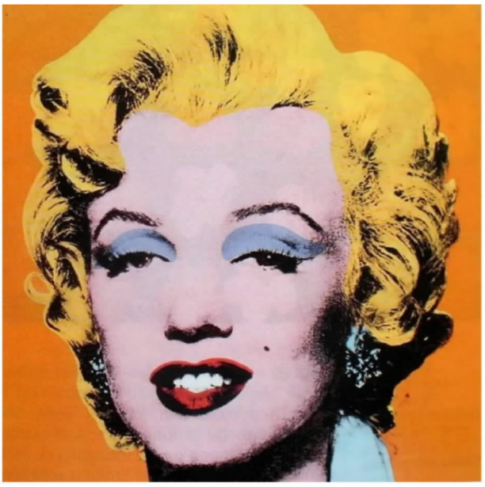​
Andy Warhol, Marilyn, 1964, acrylic and silkscreen ink on linen

And the meaning is different from any the photo had. Of course, meaning in great art is contestable and contested (as is the premise that an artwork is great). But note what some experts say about the complex message(s) Warhol's Marilyns convey. On one level, those vivid, larger-than-life paintings are celebrity iconography, making a “secular, profane subject[ ]” “transcendent” and “eternal.” Id., at 209 (internal quotation marks omitted). But they also function as a biting critique of the cult of celebrity, and the role it plays in American life. With misaligned, “Day-Glo” colors suggesting “artificiality and industrial production,” Warhol portrayed the actress as a “consumer product.” The Metropolitan Museum of Art Guide 233 (2012); The Metropolitan Museum of Art, Marilyn (2023) (online source archived at https://www.supremecourt.gov). And in so doing, he “exposed the deficiencies” of a “mass-media culture” in which “such superficial icons loom so large.” 1 App. 208, 210 (internal quotation marks omitted). Out of a publicity photo came both memorable portraiture and pointed social commentary.

As with Marilyn, similarly with Prince. In 1984, Vanity Fair commissioned Warhol to create a portrait based on a black-and-white photograph taken by noted photographer Lynn Goldsmith:

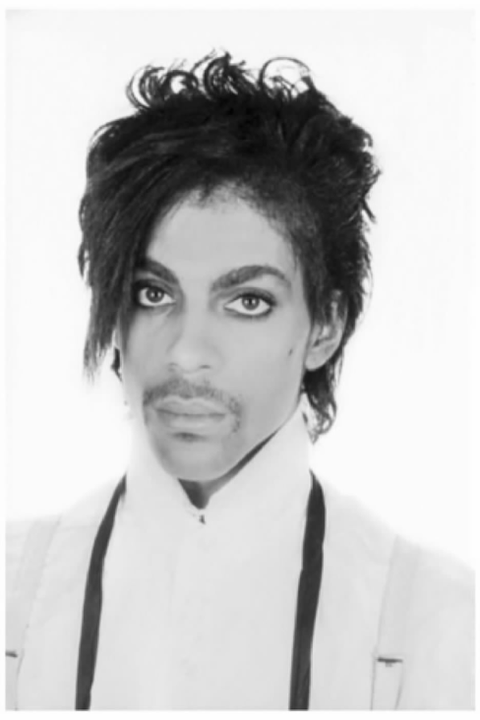​
As he did in the Marilyn series, Warhol cropped the photo, so that Prince's head fills the whole frame: It thus becomes “disembodied,” as if “magically suspended in space.” Id., at 174. And as before, Warhol converted the cropped photo into a higher-contrast image, incorporated into a silkscreen. That image isolated and exaggerated the darkest details of Prince's head; it also reduced his “natural, angled position,” presenting him in a more face-forward way. Id., at 223. Warhol traced, painted, and inked, as earlier described. See supra, at 1293 – 1294. He also made a second silkscreen, based on his tracings; the ink he passed through that screen left differently colored, out-of-kilter lines around Prince's face and hair (a bit hard to see in the reproduction below—more pronounced in the original). Altogether, Warhol made 14 prints and two drawings—the Prince series—in a range of unnatural, lurid hues. See Appendix, ante, at 1288. Vanity Fair chose the Purple Prince to accompany an article on the musician. Thirty-two years later, just after Prince died, Condé Nast paid Warhol (now actually his foundation, see supra, at 1292, n. 1) to use the Orange Prince on the cover of a special commemorative magazine. A picture (or two), as the saying goes, is worth a thousand words, so here is what those magazines published:

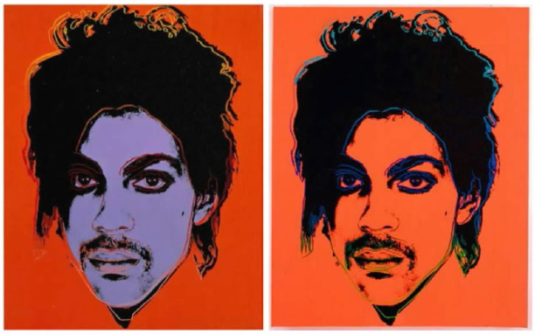​
Andy Warhol, Prince, 1984, synthetic paint and silkscreen ink on canvas

It does not take an art expert to see a transformation—but in any event, all those offering testimony in this case agreed there was one. The experts explained, in far greater detail than I have, the laborious and painstaking work that Warhol put into these and other portraits. See 1 App. 160–185, 212–216, 222–224. They described, in ways I have tried to suggest, the resulting visual differences between the photo and the silkscreen. As one summarized the matter: The two works are “materially distinct” in “their composition, presentation, color palette, and media”—i.e., in pretty much all their aesthetic traits. Id., at 227.3³ And with the change in form came an undisputed change in meaning. Goldsmith's focus—seen in what one expert called the “corporeality and luminosity” of her depiction—was on Prince's “unique human identity.” Id., at 176, 227. Warhol's focus was more nearly the opposite. His subject was “not the private person but the public image.” Id., at 159. The artist's “flattened, cropped, exotically colored, and unnatural depiction of Prince's disembodied head” sought to “communicate a message about the impact of celebrity” in contemporary life. Id., at 227. On Warhol's canvas, Prince emerged as “spectral, dark, [and] uncanny”—less a real person than a “mask-like simulacrum.” Id., at 187, 249. He was reframed as a “larger than life” “icon or totem.” Id., at 257. Yet he was also reduced: He became the product of a “publicity machine” that “packages and disseminates commoditized images.” Id., at 160. He manifested, in short, the dehumanizing culture of celebrity in America. The message could not have been more different.

A thought experiment may pound the point home. Suppose you were the editor of Vanity Fair or Condé Nast, publishing an article about Prince. You need, of course, some kind of picture. An employee comes to you with two options: the Goldsmith photo, the Warhol portrait. Would you say that you don't really care? That the employee is free to flip a coin? In the majority's view, you apparently would. Its opinion, as further discussed below, is built on the idea that both are just “portraits of Prince” that may equivalently be “used to depict Prince in magazine stories about Prince.” Ante, at 1273; see ante, at 1278 – 1279, and n. 11, 1281, n. 15, 1284 – 1285, 1285 – 1286. All I can say is that it's a good thing the majority isn't in the magazine business. Of course you would care! You would be drawn aesthetically to one, or instead to the other. You would want to convey the message of one, or instead of the other. The point here is not that one is better and the other worse. The point is that they are fundamentally different. You would see them not as “substitute[s],” but as divergent ways to (in the majority's mantra) “illustrate a magazine about Prince with a portrait of Prince.” Ante, at 1274 – 1275, 1284; see ante, at 1278 – 1279, and n. 11, 1281, n. 15, 1285 – 1286. Or else you (like the majority) would not have much of a future in magazine publishing.

In any event, the editors of Vanity Fair and Condé Nast understood the difference—the gulf in both aesthetics and meaning—between the Goldsmith photo and the Warhol portrait. They knew about the photo; but they wanted the portrait. They saw that as between the two works, Warhol had effected a transformation.

B
The question in this case is whether that transformation should matter in assessing whether Warhol made “fair use” of Goldsmith's copyrighted photo. The answer is yes—it should push toward (although not dictate) a finding of fair use. That answer comports with the copyright statute, its underlying policy, and our precedent concerning the two. Under established copyright law (until today), Warhol's addition of important “new expression, meaning, [and] message” counts in his favor in the fair-use inquiry. Campbell, 510 U.S. at 579.

Start by asking a broader question: Why do we have “fair use” anyway? The majority responds that while copyrights encourage the making of creative works, fair use promotes their “public availability.” Ante, at 1273 (internal quotation marks omitted). But that description sells fair use far short. Beyond promoting “availability,” fair use itself advances creativity and artistic progress. See Campbell, 510 U.S. at 575, 579 (fair use is “necessary to fulfill copyright's very purpose”—to “promote science and the arts”). That is because creative work does not happen in a vacuum. “Nothing comes from nothing, nothing ever could,” said songwriter Richard Rodgers, maybe thinking not only about love and marriage but also about how the Great American Songbook arose from vaudeville, ragtime, the blues, and jazz.4 This Court has long understood the point—has gotten how new art, new invention, and new knowledge arise from existing works. Our seminal opinion on fair use quoted the illustrious Justice Story:
“In truth, in literature, in science and in art, there are, and can be, few, if any, things, which ... are strictly new and original throughout. Every book in literature, science and art, borrows, and must necessarily borrow, and use much which was well known and used before.” Id., at 575 (quoting Emerson v. Davies, 8 F.Cas. 615, 619 (No. 4,436) (C.C.D. Mass. 1845)).
Because that is so, a copyright regime with no escape valves would “stifle the very creativity which [the] law is designed to foster.” Stewart, 495 U.S. at 236. Fair use is such an escape valve. It “allow[s] others to build upon” copyrighted material, so as not to “put manacles upon” creative progress. Campbell, 510 U.S. at 575 (internal quotation marks omitted). In short, copyright's core value—promoting creativity—sometimes demands a pass for copying.

To identify when that is so, the courts developed and Congress later codified a multi-factored inquiry. As the majority describes, see ante, at 1273 – 1274, the current statute sets out four non-exclusive considerations to guide courts. They are: (1) “the purpose and character of the use” made of the copyrighted work, “including whether such use is of a commercial nature”; (2) “the nature of the copyrighted work”; (3) “the amount and substantiality of the portion used in relation to the copyrighted work as a whole”; and (4) “the effect of the use upon the potential market for or value of the copyrighted work.” 17 U.S.C. § 107. Those factors sometimes point in different directions; if so, a court must weigh them against each other. In doing so, we have stated, courts should view the fourth factor—which focuses on the copyright holder's economic interests—as the “most important.” See Harper & Row, Publishers, Inc. v. Nation Enterprises, 471 U.S. 539, 566 (1985).5 But the overall balance cannot come out right unless each factor is assessed correctly. This case, of course, is about (and only about) the first.

And that factor is distinctive: It is the only one that focuses on what the copier's use of the original work accomplishes. The first factor asks about the “character” of that use—its “main or essential nature[,] esp[ecially] as strongly marked and serving to distinguish.” Webster's Third New International Dictionary 376 (1976). And the first factor asks about the “purpose” of the use—the “object, effect, or result aimed at, intended, or attained.” Id., at 1847. In that way, the first factor gives the copier a chance to make his case. See P. Leval, Toward a Fair Use Standard, 103 Harv. L. Rev. 1105, 1116 (1990) (describing factor 1 as “the soul of” the “fair use defense”). Look, the copier can say, at how I altered the original, and what I achieved in so doing. Look at how (as Judge Leval's seminal article put the point) the original was “used as raw material” and was “transformed in the creation of new information, new aesthetics, new insights.” Id., at 1111. That is hardly the end of the fair-use inquiry (commercialism, too, may bear on the first factor, and anyway there are three factors to go), but it matters profoundly. Because when a transformation of the original work has occurred, the user of the work has made the kind of creative contribution that copyright law has as its object.

Don't take it from me (or Judge Leval): The above is exactly what this Court has held about how to apply factor 1. In Campbell, our primary case on the topic, we stated that the first factor's purpose-and-character test “central[ly]” concerns “whether and to what extent the new work is ‘transformative.’ ” 510 U.S. at 579 (quoting Leval 1111). That makes sense, we explained, because “the goal of copyright, to promote science and the arts, is generally furthered by the creation of transformative works.” 510 U.S. at 579. We then expounded on when such a transformation happens. Harking back to Justice Story, we explained that a “new work” might “merely ‘supersede[ ] the objects’ of the original creation”—meaning, that it does no more, and for no other end, than the first work had. Ibid. (quoting Folsom v. Marsh, 9 F.Cas. 342, 348 (No. 4,901) (C.C.D. Mass. 1841)). But alternatively, the new work could “add[ ] something new, with a further purpose or different character, altering the first with new expression, meaning, or message.” 510 U.S. at 579. Forgive me, but given the majority's stance (see, e.g., ante, at 1284 – 1285), that bears repeating: The critical factor 1 inquiry, we held, is whether a new work alters the first with “new expression, meaning, or message.” The more it does so, the more transformative the new work. And (here is the final takeaway) “the more transformative the new work, the less will be the significance of other factors, like commercialism, that may weigh against a finding of fair use.” 510 U.S. at 579. Under that approach, the Campbell Court held, the rap group 2 Live Crew's “transformative” copying of Roy Orbison's “Pretty Woman” counted in favor of fair use. Id., at 583. And that was so even though the rap song was, as everyone agreed, recorded and later sold for profit. See id., at 573.

Just two Terms ago, in Google, we made all the same points. We quoted Campbell in explaining that the factor 1 inquiry is “whether the copier's use ‘adds something new, with a further purpose or different character, altering’ the copyrighted work ‘with new expression, meaning, or message.’ ” 593 U. S., at –––, 141 S.Ct. at 1219. We again described “a copying use that adds something new and important” as “transformative.” Ibid. We reiterated that protecting transformative uses “stimulate[s] creativity” and thus “fulfill[s] the objective of copyright law.” Ibid. (quoting Leval 1111). And then we gave an example. Yes, of course, we pointed to Andy Warhol. (The majority claims not to be embarrassed by this embarrassing fact because the specific reference was to his Soup Cans, rather than his celebrity images. But drawing a distinction between a “commentary on consumerism”—which is how the majority describes his soup canvases, ante, at 1281—and a commentary on celebrity culture, i.e., the turning of people into consumption items, is slicing the baloney pretty thin.) Finally, the Court conducted the first-factor inquiry it had described. Google had replicated Sun Microsystems’ computer code as part of a “commercial endeavor,” done “for commercial profit.” 593 U. S., at –––, 141 S.Ct. at 1204. No matter, said the Court. “[M]any common fair uses are indisputably commercial.” Ibid. What mattered instead was that Google had used Sun's code to make “something new and important”: a “highly creative and innovative” software platform. Id., at ––– – –––, 141 S.Ct. at 1202-1203. The use of the code, the Court held, was therefore “transformative” and “point[ed] toward fair use.” Id., at –––, –––, 141 S.Ct. at 1203, 1204-1205.

Campbell and Google also illustrate the difference it can make in the world to protect transformative works through fair use. Easy enough to say (as the majority does, see ante, at 1296) that a follow-on creator should just pay a licensing fee for its use of an original work. But sometimes copyright holders charge an out-of-range price for licenses. And other times they just say no. In Campbell, for example, Orbison's successor-in-interest turned down 2 Live Crew's request for a license, hoping to block the rap take-off of the original song. See 510 U.S. at 572–573. And in Google, the parties could not agree on licensing terms, as Sun insisted on conditions that Google thought would have subverted its business model. See 593 U. S., at –––, 141 S.Ct. at 1190-1191. So without fair use, 2 Live Crew's and Google's works—however new and important—might never have been made or, if made, never have reached the public. The prospect of that loss to “creative progress” is what lay behind the Court's inquiry into transformativeness—into the expressive novelty of the follow-on work (regardless whether the original creator granted permission). Id., at –––, 141 S.Ct. at 1203; see Campbell, 510 U.S. at 579.

Now recall all the ways Warhol, in making a Prince portrait from the Goldsmith photo, “add[ed] something new, with a further purpose or different character”—all the ways he “alter[ed] the [original work's] expression, meaning, [and] message.” Ibid. The differences in form and appearance, relating to “composition, presentation, color palette, and media.” 1 App. 227; see supra, at 1294 – 1297. The differences in meaning that arose from replacing a realistic—and indeed humanistic—depiction of the performer with an unnatural, disembodied, masklike one. See ibid. The conveyance of new messages about celebrity culture and its personal and societal impacts. See ibid. The presence of, in a word, “transformation”—the kind of creative building that copyright exists to encourage. Warhol's use, to be sure, had a commercial aspect. Like most artists, Warhol did not want to hide his works in a garret; he wanted to sell them. But as Campbell and Google both demonstrate (and as further discussed below), that fact is nothing near the showstopper the majority claims. Remember, the more transformative the work, the less commercialism matters. See Campbell, 510 U.S. at 579; supra, at 1299; ante, at 1276 (acknowledging the point, even while refusing to give it any meaning). The dazzling creativity evident in the Prince portrait might not get Warhol all the way home in the fair-use inquiry; there remain other factors to be considered and possibly weighed against the first one. See supra, at 1292, 1296 – 1297, 1299. But the “purpose and character of [Warhol's] use” of the copyrighted work—what he did to the Goldsmith photo, in service of what objects—counts powerfully in his favor. He started with an old photo, but he created a new new thing.6

II
The majority does not see it. And I mean that literally. There is precious little evidence in today's opinion that the majority has actually looked at these images, much less that it has engaged with expert views of their aesthetics and meaning. Whatever new expression Warhol added, the majority says, was not transformative. See ante, at 1280. Apparently, Warhol made only “modest alterations.” Ante, at 1285. Anyone, the majority suggests, could have “crop[ped], flatten[ed], trace[d], and color[ed] the photo” as Warhol did. Ante, at 1270. True, Warhol portrayed Prince “somewhat differently.” Ante, at 1284. But the “degree of difference” is too small: It consists merely in applying Warhol's “characteristic style”—an aesthetic gloss, if you will—“to bring out a particular meaning” that was already “available in [Goldsmith's] photograph.” Ibid. So too, Warhol's commentary on celebrity culture matters not at all; the majority is not willing to concede that it even exists. See ante, at 1285 (“even if such commentary is perceptible”). And as for the District Court's view that Warhol transformed Prince from a “vulnerable, uncomfortable person to an iconic, larger-than-life figure,” the majority is downright dismissive. Ante, at 1284. Vulnerable, iconic—who cares? The silkscreen and the photo, the majority claims, still have the same “essential nature.” Ante, at 1280, n. 14 (emphasis deleted).

The description is disheartening. It's as though Warhol is an Instagram filter, and a simple one at that (e.g., sepia-tinting). “What is all the fuss about?,” the majority wants to know. Ignoring reams of expert evidence—explaining, as every art historian could explain, exactly what the fuss is about—the majority plants itself firmly in the “I could paint that” school of art criticism. No wonder the majority sees the two images as essentially fungible products in the magazine market—publish this one, publish that one, what does it matter? See ante, at 1278 – 1279; supra, at 1296 – 1297. The problem is that it does matter, for all the reasons given in the record and discussed above. See supra, at 1296 – 1297. Warhol based his silkscreen on a photo, but fundamentally changed its character and meaning. In belittling those creative contributions, the majority guarantees that it will reach the wrong result.

Worse still, the majority maintains that those contributions, even if significant, just would not matter. All of Warhol's artistry and social commentary is negated by one thing: Warhol licensed his portrait to a magazine, and Goldsmith sometimes licensed her photos to magazines too. That is the sum and substance of the majority opinion. Over and over, the majority incants that “[b]oth [works] are portraits of Prince used in magazines to illustrate stories about Prince”; they therefore both “share substantially the same purpose”—meaning, a commercial one. Ante, at 1278, 1287; see ante, at 1272 – 1273, 1281, n. 15, 1284 – 1285, 1285 – 1286. Or said otherwise, because Warhol entered into a licensing transaction with Condé Nast, he could not get any help from factor 1—regardless how transformative his image was. See, e.g., ante, at 1285 – 1286 (Warhol's licensing “outweigh[s]” any “new meaning or message” he could have offered). The majority's commercialism-trumps-creativity analysis has only one way out. If Warhol had used Goldsmith's photo to comment on or critique Goldsmith's photo, he might have availed himself of that factor's benefit (though why anyone would be interested in that work is mysterious). See ante, at 1285. But because he instead commented on society—the dehumanizing culture of celebrity—he is (go figure) out of luck.

From top-to-bottom, the analysis fails. It does not fit the copyright statute. It is not faithful to our precedent. And it does not serve the purpose both Congress and the Court have understood to lie at the core of fair use: “stimulat[ing] creativity,” by enabling artists and writers of every description to build on prior works. Google, 593 U. S., at –––, 141 S.Ct. at 1202-1203. That is how art, literature, and music happen; it is also how all forms of knowledge advance. Even as the majority misconstrues the law, it misunderstands—and threatens—the creative process.

Start with what the statute tells us about whether the factor 1 inquiry should disregard Warhol's creative contributions because he licensed his work. (Sneak preview: It shouldn't.) The majority claims the text as its strong suit, viewing our precedents’ inquiry into new expression and meaning as a faulty “paraphrase” of the statutory language. Ante, at 1281 – 1283. But it is the majority, not Campbell and Google, that misreads § 107(1). First, the key term “character” plays little role in the majority's analysis. See ante, at 1272 – 1273, 1278 – 1279, and n. 11, 1282 – 1283 (statements of central test or holding referring only to “purpose”). And you can see why, given the counter-intuitive meaning the majority (every so often) provides. See ante, at 1279 – 1280, and n. 14. When referring to the “character” of what Warhol did, the majority says merely that he “licensed Orange Prince to Condé Nast for $10,000.” See ante, at 1279 – 1280. But that reductionist view rids the term of most of its ordinary meaning. “Character” typically refers to a thing's “main or essential nature[,] esp[ecially] as strongly marked and serving to distinguish.” Webster's Third 376; see supra, at 1298 – 1299. The essential and distinctive nature of an artist's use of a work commonly nvolves artistry—as it did here. See also Campbell, 510 U.S. at 582, 588–589 (discussing the expressive “character” of 2 Live Crew's rap). So the term “character” makes significant everything the record contains—and everything everyone (save the majority) knows—about the differences in expression and meaning between Goldsmith's photo and Warhol's silkscreen.

Second, the majority significantly narrows § 107(1)’s reference to “purpose” (thereby paralleling its constriction of “character”). It might be obvious to you that artists have artistic purposes. And surely it was obvious to the drafters of a law aiming to promote artistic (and other kinds of ) creativity. But not to the majority, which again cares only about Warhol's decision to license his art. Warhol's purpose, the majority says, was just to “depict Prince in [a] magazine stor[y] about Prince” in exchange for money. Ante, at 1273. The majority spurns all that mattered to the artist—evident on the face of his work—about “expression, meaning, [and] message.” Campbell, 510 U.S. at 579; Google, 593 U. S., at –––, 141 S.Ct. at 1202-1203. That indifference to purposes beyond the commercial—for what an artist, most fundamentally, wants to communicate—finds no support in § 107(1).7

Still more, the majority's commercialism-über-alles view of the factor 1 inquiry fits badly with two other parts of the fair-use provision. To begin, take the preamble, which gives examples of uses often thought fair: “criticism, comment, news reporting, teaching[,] ... scholarship, or research.” § 107. As we have explained, an emphasis on commercialism would “swallow” those uses—that is, would mostly deprive them of fair-use protection. Campbell, 510 U.S. at 584. For the listed “activities are generally conducted for profit in this country.” Ibid. (internal quotation marks omitted). “No man but a blockhead,” Samuel Johnson once noted, “ever wrote[ ] except for money.” 3 Boswell's Life of Johnson 19 (G. Hill ed. 1934). And Congress of course knew that when it drafted the preamble.

Next, skip to the last factor in the fair-use test: “the effect of the use upon the potential market for or value of the copyrighted work.” § 107(4). You might think that when Congress lists two different factors for consideration, it is because the two factors are, well, different. But the majority transplants factor 4 into factor 1. Recall that the majority conducts a kind of market analysis: Warhol, the majority says, licensed his portrait of Prince to a magazine that Goldsmith could have licensed her photo to—and so may have caused her economic harm. See ante, at 1278 – 1279; see also ante, at 1276 – 1277 (focusing on whether a follow-on work is a market “substitute” for the original); ante, at 1290 (GORSUCH, J., concurring) (describing the “salient point” as whether Warhol's “use involved competition with Ms. Goldsmith's image”). That issue is no doubt important in the fair-use inquiry. But it is the stuff of factor 4: how Warhol's use affected the “value of” or “market for” Goldsmith's photo. Factor 1 focuses on the other side of the equation: the new expression, meaning, or message that may come from someone else using the original. Under the statute, courts are supposed to strike a balance between the two—and thus between rewarding original creators and enabling others to build on their works. That cannot happen when a court, à la the majority, double-counts the first goal and ignores the second.

Is it possible I overstate the matter? I would like for that to be true. And a puzzling aspect of today's opinion is that it occasionally acknowledges the balance that the fair-use provision contemplates. So, for example, the majority notes after reviewing the relevant text that “the central question [the first factor] asks” is whether the new work “adds something new” to the copyrighted one. Ante, at 1274 (internal quotation marks omitted). Yes, exactly. And in other places, the majority suggests that a court should consider in the factor 1 analysis not merely the commercial context but also the copier's addition of “new expression,” including new meaning or message. Ante, at 1272 – 1273; see ante, at 1276, 1280, n.13, 1280, 1284. In that way, the majority opinion differs from Justice GORSUCH's concurrence, which would exclude all inquiry into whether a follow-on work is transformative. See ante, at 1289, 1290. And it is possible lower courts will pick up on that difference, and ensure that the “newness” of a follow-on work will continue to play a significant role in the factor 1 analysis. If so, I'll be happy to discover that my “claims [have] not age[d] well.” Ante, at 1286. But that would require courts to do what the majority does not: make a serious inquiry into the follow-on artist's creative contributions. The majority's refusal to do so is what creates the oddity at the heart of today's opinion. If “newness” matters (as the opinion sometimes says), then why does the majority dismiss all the newness Warhol added just because he licensed his portrait to Condé Nast? And why does the majority insist more generally that in a commercial context “convey[ing] a new meaning or message” is “not enough for the first factor to favor fair use”? Ante, at 1285 – 1286.

Certainly not because of our precedent—which conflicts with nearly all the majority says. As explained earlier, this Court has decided two important cases about factor 1. See supra, at 1299 – 1300. In each, the copier had built on the original to make a product for sale—so the use was patently commercial. And in each, that fact made no difference, because the use was also transformative. The copier, we held, had made a significant creative contribution—had added real value. So in Campbell, we did not ask whether 2 Live Crew and Roy Orbison both meant to make money by “including a catchy song about women on a record album.” But cf. ante, at 1273 (asking whether Warhol and Goldsmith both meant to charge for “depict[ing] Prince in magazine stories about Prince”). We instead asked whether 2 Live Crew had added significant “new expression, meaning, [and] message”; and because we answered yes, we held that the group's rap song did not “merely supersede the objects of the original creation.” 510 U.S. at 579, (internal quotation marks and alteration omitted). Similarly, in Google, we took for granted that Google (the copier) and Sun (the original author) both meant to market software platforms facilitating the same tasks—just as (in the majority's refrain) Warhol and Goldsmith both wanted to market images depicting the same subject. See 593 U. S., at –––, –––, 141 S.Ct. at 1203, 1204. “So what?” was our basic response. Google's copying had enabled the company to make a “highly creative and innovative tool,” advancing “creative progress” and thus serving “the basic constitutional objective of copyright.” Id., at –––, 141 S.Ct. at 1203 (internal quotation marks omitted). Search today's opinion high and low, you will see no such awareness of how copying can help produce valuable new works.

Nor does our precedent support the majority's strong distinction between follow-on works that “target” the original and those that do not. Ante, at 1285 – 1286. (Even the majority does not claim that anything in the text does so.) True enough that the rap song in Campbell fell into the former category: 2 Live Crew urged that its work was a parody of Orbison's song. But even in discussing the value of parody, Campbell made clear the limits of targeting's importance. The Court observed that as the “extent of transformation” increases, the relevance of targeting decreases. 510 U.S. at 581, n. 14. Google proves the point. The new work there did not parody, comment on, or otherwise direct itself to the old: The former just made use of the latter for its own devices. Yet that fact never made an appearance in the Court's opinion; what mattered instead was the “highly creative” use Google had made of the copied code. That decision is on point here. Would Warhol's work really have been more worthy of protection if it had (somehow) “she[d] light” on Goldsmith's photograph, rather than on Prince, his celebrity status, and celebrity culture? Ante, at 1281. Would that Goldsmith-focused work (whatever it might be) have more meaningfully advanced creative progress, which is copyright's raison d’être, than the work he actually made? I can't see how; more like the opposite. The majority's preference for the directed work, apparently on grounds of necessity, see ante, at 1281, 1285 – 1286, again reflects its undervaluing of transformative copying as a core part of artistry.

And there's the rub. (Yes, that's mostly Shakespeare.) As Congress knew, and as this Court once saw, new creations come from building on—and, in the process, transforming—those coming before. Today's decision stymies and suppresses that process, in art and every other kind of creative endeavor. The decision enhances a copyright holder's power to inhibit artistic development, by enabling her to block even the use of a work to fashion something quite different. Or viewed the other way round, the decision impedes non-copyright holders’ artistic pursuits, by preventing them from making even the most novel uses of existing materials. On either account, the public loses: The decision operates to constrain creative expression.8

The effect, moreover, will be dramatic. Return again to Justice Story, see supra, at 1297 – 1298: “[I]n literature, in science and in art, there are, and can be, few, if any, things” that are “new and original throughout.” Campbell, 510 U.S. at 575 (quoting Emerson, 8 F.Cas. at 619). Every work “borrows, and must necessarily” do so. 510 U.S. at 575. Creators themselves know that fact deep in their bones. Here is Mark Twain on the subject: “The kern[e]l, the soul—let us go further and say the substance, the bulk, the actual and valuable material” of creative works—all are “consciously and unconsciously drawn from a million outside sources.” Letter from M. Twain to H. Keller, in 2 Mark Twain's Letters 731 (1917); see also id., at 732 (quoting Oliver Wendell Holmes—no, not that one, his father the poet—as saying “I have never originated anything altogether myself, nor met anybody who had”). “[A]ppropriation, mimicry, quotation, allusion and sublimated collaboration,” novelist Jonathan Lethem has explained, are “a kind of sine qua non of the creative act, cutting across all forms and genres in the realm of cultural production.” The Ecstasy of Influence, in Harper's Magazine 61 (Feb. 2007). Or as Mary Shelley once wrote, there is no such thing as “creating out of [a] void.” Frankenstein ix (1831).9

Consider, in light of those authorial references, how the majority's factor 1 analysis might play out in literature. And why not start with the best? Shakespeare borrowed over and over and over. See, e.g., 8 Narrative and Dramatic Sources of Shakespeare 351–352 (G. Bullough ed. 1975) (“Shakespeare was an adapter of other men's tales and plays; he liked to build a new construction on something given”). I could point to a whole slew of works, but let's take Romeo and Juliet as an example. Shakespeare's version copied most directly from Arthur Brooke's The Tragical History of Romeus and Juliet, written a few decades earlier (though of course Brooke copied from someone, and that person copied from someone, and that person ... going back at least to Ovid's story about Pyramus and Thisbe). Shakespeare took plot, characters, themes, even passages: The friar's line to Romeo, “Art thou a man? Thy form cries out thou art,” appeared in Brooke as “Art thou a man? The shape saith so thou art.” Bullough 387. (Shakespeare was, among other things, a good editor.) Of course Shakespeare also added loads of genius, and so made the borrowed stories “uniquely Shakespearian.” G. Williams, Shakespeare's Basic Plot Situation, 2 Shakespeare Quarterly No. 4, p. 313 (Oct. 1951). But on the majority's analysis? The two works—Shakespeare's and Brooke's—are just two stories of star-crossed lovers written for commercial gain. Shakespeare would not qualify for fair use; he would not even come out ahead on factor 1.

And if you think that's just Shakespeare, here are a couple more. (Once you start looking, examples are everywhere.) Lolita, though hard to read today, is usually thought one of the greatest novels of the 20th century. But the plotline—an adult man takes a room as a lodger; embarks on an obsessive sexual relationship with the preteen daughter of the house; and eventually survives her death, remaining marked forever—appears in a story by Heinz von Lichberg written a few decades earlier. Oh, and the girl's name is Lolita in both versions. See generally M. Maar, The Two Lolitas (2005). All that said, the two works have little in common artistically; nothing literary critics admire in the second Lolita is found in the first. But to the majority? Just two stories of revoltingly lecherous men, published for profit. So even factor 1 of the fair-use inquiry would not aid Nabokov. Or take one of the most famed adventure stories ever told. Here is the provenance of Treasure Island, as Robert Louis Stevenson himself described it:
“No doubt the parrot once belonged to Robinson Crusoe. No doubt the skeleton is conveyed from [Edgar Allan] Poe. I think little of these, they are trifles and details; and no man can hope to have a monopoly of skeletons or make a corner in talking birds.... It is my debt to Washington Irving that exercises my conscience, and justly so, for I believe plagiarism was rarely carried farther.... Billy Bones, his chest, the company in the parlor, the whole inner spirit and a good deal of the material detail of my first chapters—all were there, all were the property of Washington Irving.” My First Book—Treasure Island, in 21 Syracuse University Library Associates Courier No. 2, p. 84 (1986).
Odd that a book about pirates should have practiced piracy? Not really, because tons of books do—and not many in order to “target” or otherwise comment on the originals. “Thomas Mann, himself a master of [the art,] called [it] ‘higher cribbing.’ ” Lethem 59. The point here is that most writers worth their salt steal other writers’ moves—and put them to other, often better uses. But the majority would say, again and yet again in the face of such transformative copying, “no factor 1 help and surely no fair use.”

Or how about music? Positively rife with copying of all kinds. Suppose some early blues artist (W. C. Handy, perhaps?) had copyrighted the 12-bar, three-chord form—the essential foundation (much as Goldsmith's photo is to Warhol's silkscreen) of many blues songs. Under the majority's view, Handy could then have controlled—meaning, curtailed—the development of the genre. And also of a fair bit of rock and roll. “Just another rendition of 12-bar blues for sale in record stores,” the majority would say to Chuck Berry (Johnny B. Goode), Bill Haley (Rock Around the Clock), Jimi Hendrix (Red House), or Eric Clapton (Crossroads). Or to switch genres, imagine a pioneering classical composer (Haydn?) had copyrighted the three-section sonata form. “One more piece built on the same old structure, for use in concert halls,” the majority might say to Mozart and Beethoven and countless others: “Sure, some new notes, but the backbone of your compositions is identical.”

And then, there's the appropriation of those notes, and accompanying words, for use in new and different ways. Stravinsky reportedly said that great composers do not imitate, but instead steal. See P. Yates, Twentieth Century Music 41 (1967). At any rate, he would have known. He took music from all over—from Russian folk melodies to Schoenberg—and made it inimitably his own. And then—as these things go—his music became a source for others. Charlie Parker turned The Rite of Spring into something of a jazz standard: You can still hear the Stravinsky lurking, but jazz musicians make the composition a thing of a different kind. And popular music? I won't point fingers, but maybe rock's only Nobel Laureate and greatest-ever lyricist is known for some appropriations? See M. Gilmore, The Rolling Stone Interview, Rolling Stone, Sept. 27, 2012, pp. 51, 81.10 He wouldn't be alone. Here's what songwriter Nick Cave (he of the Bad Seeds) once said about how music develops:
“The great beauty of contemporary music, and what gives it its edge and vitality, is its devil-may-care attitude toward appropriation—everybody is grabbing stuff from everybody else, all the time. It's a feeding frenzy of borrowed ideas that goes toward the advancement of rock music—the great artistic experiment of our era.” The Red Hand Files (Apr. 2020) (online source archived at https://www.supremecourt.gov).
But not as the majority sees the matter. Are these guys making money? Are they appropriating for some different reason than to critique the thing being borrowed? Then they're “shar[ing] the objectives” of the original work, and will get no benefit from factor 1, let alone protection from the whole fair-use test. Ante, at 1279 – 1280.

Finally, back to the visual arts, for while Warhol may have been the master appropriator within that field, he had plenty of company; indeed, he worked within an established tradition going back centuries (millennia?). The representatives of three giants of modern art (you may know one for his use of comics) describe the tradition as follows: “[T]he use and reuse of existing imagery” are “part of art's lifeblood”—“not just in workaday practice or fledgling student efforts, but also in the revolutionary moments of art history.” Brief for Robert Rauschenberg, Roy Lichtenstein, and Joan Mitchell Foundations et al. as Amici Curiae 6.

Consider as one example the reclining nude. Probably the first such figure in Renaissance art was Giorgione's Sleeping Venus. (Note, though, in keeping with the “nothing comes from nothing” theme, that Giorgione apparently modeled his canvas on a woodcut illustration by Francesco Colonna.) Here is Giorgione's painting:

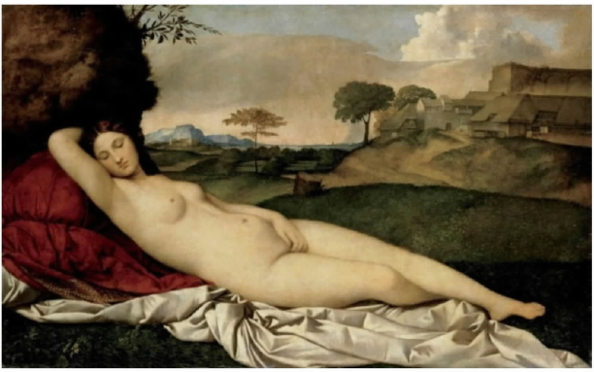​
Giorgione, Sleeping Venus, c. 1510, oil on canvas

But things were destined not to end there. One of Giorgione's pupils was Titian, and the former student undertook to riff on his master. The resulting Venus of Urbino is a prototypical example of Renaissance imitatio—the creation of an original work from an existing model. See id., at 8; 1 G. Vasari, Lives of the Artists 31, 444 (G. Bull transl. 1965). You can see the resemblance—but also the difference:
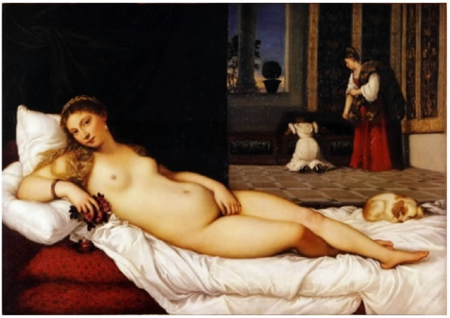​
Titian, Venus of Urbino, 1538, oil on canvas

The majority would presumably describe these Renaissance canvases as just “two portraits of reclining nudes painted to sell to patrons.” Cf. ante, at 1272 – 1273, 1278 – 1279. But wouldn't that miss something—indeed, everything—about how an artist engaged with a prior work to create new expression and add new value?

And the reuse of past images was far from done. For here is Édouard Manet's Olympia, now considered a foundational work of artistic modernism, but referring in obvious ways to Titian's (and back a step, to Giorgione's) Venus:

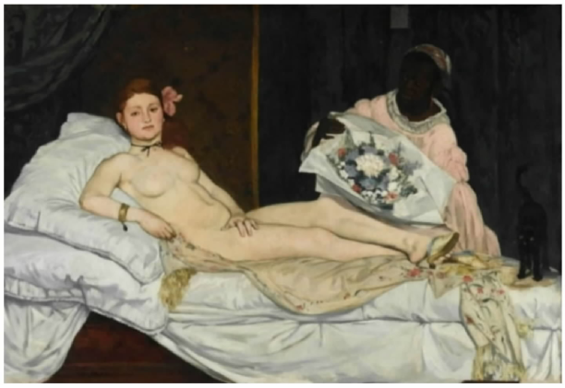​
Manet, Olympia, 1863, oil on canvas

Here again consider the account of the Rauschenberg, Lichtenstein, and Mitchell Foundations: “The revolutionary shock of the painting depends on how traditional imagery remains the painting's recognizable foundation, even as that imagery is transformed and wrenched into the present.” Brief as Amici Curiae 9. It is an especially striking example of a recurrent phenomenon—of how the development of visual art works across time and place, constantly building on what came earlier. In fact, the Manet has itself spawned further transformative paintings, from Cézanne to a raft of contemporary artists across the globe. See id., at 10–11. But the majority, as to these matters, is uninterested and unconcerned.

Take a look at one last example, from a modern master very different from Warhol, but availing himself of the same appropriative traditions. On the left (below) is Velázquez's portrait of Pope Innocent X; on the right is Francis Bacon's Study After Velázquez's Portrait.

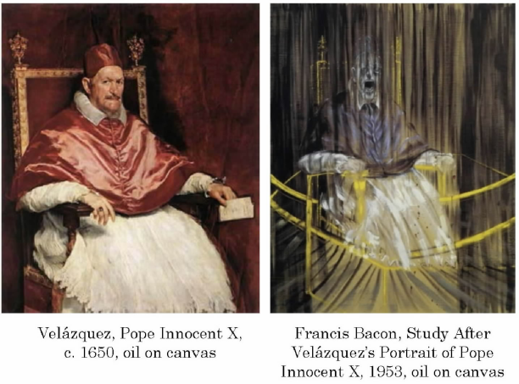​
To begin with, note the word “after” in Bacon's title. Copying is so deeply rooted in the visual arts that there is a naming convention for it, with “after” denoting that a painting is some kind of “imitation of a known work.” M. Clarke, The Concise Oxford Dictionary of Art Terms 5 (2d ed. 2010). Bacon made frequent use of that convention. He was especially taken by Velázquez's portrait of Innocent X, referring to it in tens of paintings. In the one shown above, Bacon retained the subject, scale, and composition of the Velázquez original. Look at one, look at the other, and you know Bacon copied. But he also transformed. He invested his portrait with new “expression, meaning, [and] message,” converting Velázquez's study of magisterial power into one of mortal dread. Campbell, 510 U.S. at 579.

But the majority, from all it says, would find the change immaterial. Both paintings, after all, are “portraits of [Pope Innocent X] used to depict [Pope Innocent X]” for hanging in some interior space, ante, at 1273; so on the majority's reasoning, someone in the market for a papal portrait could use either one, see ante, at 1278 – 1279. Velázquez's portrait, although Bacon's model, is not “the object of [his] commentary.” Ante, at 1281; see A. Zweite, Bacon's Scream, in Francis Bacon: The Violence of the Real 71 (A. Zweite ed. 2006) (Bacon “was not seeking to expose Velázquez's masterpiece,” but instead to “adapt it” and “give it a new meaning”). And absent that “target[ing],” the majority thinks the portraits’ distinct messages make no difference. Ante, at 1281. Recall how the majority deems irrelevant the District Court's view that the Goldsmith Prince is vulnerable, the Warhol Prince iconic. Too small a “degree of difference,” according to the majority. Ante, at 1284 – 1285; see supra, at 1300 – 1301. So too here, presumably: the stolid Pope, the disturbed Pope—it just doesn't matter. But that once again misses what a copier accomplished: the making of a wholly new piece of art from an existing one.

The majority thus treats creativity as a trifling part of the fair-use inquiry, in disregard of settled copyright principles and what they reflect about the artistic process. On the majority's view, an artist had best not attempt to market even a transformative follow-on work—one that adds significant new expression, meaning, or message. That added value (unless it comes from critiquing the original) will no longer receive credit under factor 1. And so it can never hope to outweigh factor 4's assessment of the copyright holder's interests. The result will be what this Court has often warned against: suppression of “the very creativity which [copyright] law is designed to foster.” Stewart, 495 U.S. at 236; see supra, at 1297 – 1298. And not just on the margins. Creative progress unfolds through use and reuse, framing and reframing: One work builds on what has gone before; and later works build on that one; and so on through time. Congress grasped the idea when it directed courts to attend to the “purpose and character” of artistic borrowing—to what the borrower has made out of existing materials. That inquiry recognizes the value in using existing materials to fashion something new. And so too, this Court—from Justice Story's time to two Terms ago—has known that it is through such iterative processes that knowledge accumulates and art flourishes. But not anymore. The majority's decision is no “continuation” of “existing copyright law.” Ante, at 1287. In declining to acknowledge the importance of transformative copying, the Court today, and for the first time, turns its back on how creativity works.

III
And the workings of creativity bring us back to Andy Warhol. For Warhol, as this Court noted in Google, is the very embodiment of transformative copying. He is proof of concept—that an artist working from a model can create important new expression. Or said more strongly, that appropriations can help bring great art into being. Warhol is a towering figure in modern art not despite but because of his use of source materials. His work—whether Soup Cans and Brillo Boxes or Marilyn and Prince—turned something not his into something all his own. Except that it also became all of ours, because his work today occupies a significant place not only in our museums but in our wider artistic culture. And if the majority somehow cannot see it—well, that's what evidentiary records are for. The one in this case contained undisputed testimony, and lots of it, that Warhol's Prince series conveyed a fundamentally different idea, in a fundamentally different artistic style, than the photo he started from. That is not the end of the fair-use inquiry. The test, recall, has four parts, with one focusing squarely on Goldsmith's interests. But factor 1 is supposed to measure what Warhol has done. Did his “new work” “add[ ] something new, with a further purpose or different character”? Campbell, 510 U.S. at 579. Did it “alter[ ] the first with new expression, meaning, or message”? Ibid. It did, and it did. In failing to give Warhol credit for that transformation, the majority distorts ultimate resolution of the fair-use question.

Still more troubling are the consequences of today's ruling for other artists. If Warhol does not get credit for transformative copying, who will? And when artists less famous than Warhol cannot benefit from fair use, it will matter even more. Goldsmith would probably have granted Warhol a license with few conditions, and for a price well within his budget. But as our precedents show, licensors sometimes place stringent limits on follow-on uses, especially to prevent kinds of expression they disapprove. And licensors may charge fees that prevent many or most artists from gaining access to original works. Of course, that is all well and good if an artist wants merely to copy the original and market it as his own. Preventing those uses—and thus incentivizing the creation of original works—is what copyrights are for. But when the artist wants to make a transformative use, a different issue is presented. By now, the reason why should be obvious. “Inhibit[ing] subsequent writers” and artists from “improv[ing] upon prior works”—as the majority does today—will “frustrate the very ends sought to be attained” by copyright law. Harper & Row, 471 U.S. at 549. It will stifle creativity of every sort. It will impede new art and music and literature. It will thwart the expression of new ideas and the attainment of new knowledge. It will make our world poorer.

A silkscreen is a fine mesh fabric used in screen printing. Warhol's practice was to deliver a photograph to a professional silkscreen printer with instructions for alterations, such as cropping and high contrasting. 1 App. 160, 163. The latter alteration would “flatten” the image. Once Warhol approved, the printer would “reproduc[e]” the altered image “like a photographic negative onto the screen.” Id., at 164. For canvas prints, Warhol “would then place the screen face down on the canvas, pour ink onto the back of the mesh, and use a squeegee to pull the ink through the weave and onto the canvas.” Ibid. The resulting “high-contrast half-tone impressions” served as an “ ‘under-drawing,’ ” over which Warhol painted colors by hand. Id., at 165.
AWF sold 12 of the works to collectors and galleries, and it transferred custody of the remaining four works to the Andy Warhol Museum in Pittsburgh.
The Court of Appeals considered not only the possibility of market harm caused by the actions of AWF but also “whether ‘unrestricted and widespread conduct of the sort engaged in by [AWF] would result in a substantially adverse impact on the potential market’ ” for the photograph, including the market for derivative works. 11 F.4th 26, 49–50 (C.A.2 2021) (quoting Campbell v. Acuff-Rose Music, Inc., 510 U.S. 569, 590 (1994)); see also Harper & Row, Publishers, Inc. v. Nation Enterprises, 471 U.S. 539, 568 (1985).
Take a critical book review, for example. Not only does the review, as a whole, serve a different purpose than the book; each quoted passage within the review likely serves a different purpose (as an object of criticism) than it does in the book. That may not always be so, however, and a court must consider each use within the whole to determine whether the copying is fair. W. Patry, Fair Use § 3:1, pp. 129–130 (2022).
In theory, the question of transformative use or transformative purpose can be separated from the question whether there has been transformation of a work. In practice, however, the two may overlap. Compare, e.g., Núñez v. Caribbean Int'l News Corp., 235 F.3d 18, 21–23 (C.A.1 2000) (newspaper's reproduction, without alteration, of photograph of beauty pageant winner to explain controversy over whether her title should be withdrawn had transformative purpose because “ ‘the pictures were the story’ ”), with Leibovitz v. Paramount Pictures Corp., 137 F.3d 109, 114–115 (C.A.2 1998) (film advertisement's alteration of well-known photograph by superimposing actor's face on actress’ body had transformative purpose of parody).
The authors of the Copyright Act of 1976 included the language, “ ‘whether such use is of a commercial nature or is for non-profit educational purposes,’ ” in the first fair use factor “to state explicitly” that, “as under the present law, the commercial or non-profit character of an activity, while not conclusive with respect to fair use, can and should be weighed along with other factors.” H. R. Rep. No. 94–1476, p. 66 (1976).
Return to the example of a book review. The review's use of quoted material may be justified in both the broad and the narrower senses. First, the use is likely to serve a different purpose than the material itself. See n. 4, supra. Second, there may be compelling reason to borrow from the original to achieve that purpose because the review targets the material for comment or criticism. But again, the question of justification will depend on the individual use or uses. See Patry, Fair Use § 3:1, at 129–130. Even book reviews are not entitled to a presumption of fairness. Campbell, 510 U.S. at 581.
Consider, for example, this Court's analysis of the first factor in Google LLC v. Oracle America, Inc., 593 U. S. –––, 141 S.Ct. 1183 (2021). Google stressed that “[t]he fact that computer programs are primarily functional makes it difficult to apply traditional copyright concepts in that technological world.” Id., at –––, 141 S.Ct. at 1208. Still, in evaluating the purpose and character of Google's use of Sun Microsystems’ code, the Court looked, first, to whether the purpose of the use was significantly different from that of the original; and, second, to the strength of other justifications for the use. Although Google's use was commercial in nature, it copied Sun's code, which was “created for use in desktop and laptop computers,” “only insofar as needed to include tasks that would be useful in smartphone[s].” Id., at –––, 141 S.Ct. at 1203. That is, Google put Sun's code to use in the “distinct and different computing environment” of its own Android platform, a new system created for new products. Ibid. Moreover, the use was justified in that context because “shared interfaces are necessary for different programs to speak to each other” and because “reimplementation of interfaces is necessary if programmers are to be able to use their acquired skills.” Ibid.; see also id., at –––, 141 S.Ct. at 1193-1194.
AWF sought a declaratory judgment that would cover the original Prince Series works, but Goldsmith has abandoned all claims to relief other than her claim as to the 2016 Condé Nast license and her request for prospective relief as to similar commercial licensing. Brief for Respondents 3, 17–18; Tr. of Oral Arg. 80–82.
The dissent, however, focuses on a case that is not before the Court. No, not whether Francis Bacon would have made fair use of Velásquez's painting, had American copyright law applied in Europe with a term of 300 years post mortem auctoris. But cf. post, at 1309 – 1311 (opinion of KAGAN, J.). Rather, Congress has directed courts to examine the purpose and character of the challenged “use.” 17 U.S.C. § 107(1). Yet the dissent assumes that any and all uses of an original work entail the same first-factor analysis based solely on the content of a secondary work. This assumption contradicts the fair use statute and this Court's precedents. See supra, at 1277 – 1278. Had AWF's use been solely for teaching purposes, that clearly would affect the analysis, and the statute permits no other conclusion. Preferring not to focus on the specific use alleged to infringe Goldsmith's copyright, the dissent begins with a sleight of hand, see post, at 1292, n. 1, and continues with a false equivalence between AWF's commercial licensing and Warhol's original creation. The result is a series of misstatements and exaggerations, from the dissent's very first sentence, post, at 1291 (“Today, the Court declares that Andy Warhol's eye-popping silkscreen of Prince ... is (in copyright lingo) not ‘transformative’ ”), to its very last, post, at 1312 (“[The majority opinion] will make our world poorer”).
The Court of Appeals observed that the “purpose and function of the two works at issue here is identical, not merely in the broad sense that they are created as works of visual art, but also in the narrow but essential sense that they are portraits of the same person.” 11 F.4th at 42 (footnote omitted). This Court goes somewhat “further and examine[s] the copying's more specifically described ‘purpose[s]’ ” in the context of the particular use at issue (here, in a magazine about Prince). Google, 593 U. S., at –––, 141 S.Ct. at 1203. The Court does not define the purpose as simply “commercial” or “commercial licensing.” Post, at 1301, 1302 – 1303, n. 7, 1305, n. 8 (KAGAN, J., dissenting). Nor does the Court view Goldsmith's photograph and Warhol's illustration as “fungible products in the magazine market.” Post, at 1301; see post, at 1296 – 1297. Rather, the Court finds significant the degree of similarity between the specific purposes of the original work and the secondary use at issue. According to the dissent, the fact that a magazine editor might prefer one image to the other must mean the secondary use is transformative, either because it has a different aesthetic or conveys a different message. Post, at 1296 – 1297. The Court, because it fails to understand the difference, does not have “much of a future in magazine publishing,” the dissent chides. Ibid. While the dissent is probably correct about the Court's business prospects, the editors of People, Rolling Stone, and Time chose a variety of different photos of Prince for their memorial issues. See fig. 5, supra. Portrait photos, in fact. Some black and white; some depicting Prince's “ ‘corporeality’ ”; some “realistic” or “humanistic.” Post, at 1296, 1300 (KAGAN, J., dissenting). These variations in aesthetics did not stop the photos from serving the same essential purpose of depicting Prince in a magazine commemorating his life and career. Fortunately, the dissent's “magazine editor” test does not have much of a future in fair use doctrine. The flaw in the dissent's logic is simple: If all that mattered under the first factor were whether a buyer was “drawn aesthetically” to a secondary work (instead of the pre-existing work it adapted) or whether the buyer preferred “to convey the message of” the secondary work, post, at 1297, then every derivative work would qualify. The New Yorker might prefer an unauthorized sequel to a short story, rather than the original, but that does not mean the purpose and character of the use would weigh in its favor. Similarly, a rap label might prefer 2 Live Crew's song, rather than Orbison's original, based on the new sound and lyrics (i.e., new aesthetic and message), but that was not enough in Campbell, and it is not enough here.
In this way, the first factor relates to the fourth, market effect. See Campbell, 510 U.S. at 591; cf. also Harper & Row, 471 U.S. at 568 (“The excerpts were employed as featured episodes in a story about the Nixon pardon—precisely the use petitioners had licensed to Time”). While the first factor considers whether and to what extent an original work and secondary use have substitutable purposes, the fourth factor focuses on actual or potential market substitution. Under both factors, the analysis here might be different if Orange Prince appeared in an art magazine alongside an article about Warhol. Brief for United States as Amicus Curiae 33. While keenly grasping the relationship between The Two Lolitas, the dissent fumbles the relationship between the first and fourth fair use factors. Under today's decision, as before, the first factor does not ask whether a secondary use causes a copyright owner economic harm. Cf. post, at 1303 (opinion of KAGAN, J.). There is, however, a positive association between the two factors: A secondary use that is more different in purpose and character is less likely to usurp demand for the original work or its derivatives, as the Court has explained, see Campbell, 510 U.S. at 591. This relationship should be fairly obvious. But see post, at 1303 – 1304 (KAGAN, J., dissenting) (suggesting that the first factor can favor only the user and the fourth factor only the copyright owner). Still, the relationship is not absolute. For example, copies for classroom use might fulfill demand for an original work. The first factor may still favor the copyist, even if the fourth factor is shown not to. At the same time, other forms of straight copying may be fair if a strong showing on the fourth factor outweighs a weak showing on the first.
The dissent misconstrues the role of commercialism in this analysis. The Court does not hold that “[a]ll that matters is that [AWF] and the publisher entered into a licensing transaction”; or that the first-factor inquiry “should disregard Warhol's creative contributions because he licensed his work”; or that an artist may not “market even a transformative follow-on work.” Post, at 1292, 1302, 1311 (opinion of KAGAN, J.). Instead, consistent with the statute, “whether [a] use is of a commercial nature or is for nonprofit educational purposes” is one element of the first factor, § 107(1); it does not dispose of that factor, much less the fair use inquiry. As this opinion makes clear, the commercial character of a secondary use should be weighed against the extent to which the use is transformative or otherwise justified. Supra, at 1276 (citing Campbell, 510 U.S. at 579–580, 585); see also supra, at 1272 – 1273, 1276 – 1277, and n. 8, 1280; infra, at 1285 – 1286.
The dissent contends that the Court gives “little role” to “the key term ‘character.’ ” Post, at 1302 (opinion of KAGAN, J.). This is somewhat puzzling, as the Court has previously employed “character” to encompass exactly what the dissent downplays: “ ‘the commercial or nonprofit character of an activity.’ ” Sony Corp. of America v. Universal City Studios, Inc., 464 U.S. 417, 448–449 (1984) (quoting H. R. Rep. No. 94–1476, at 66); see also Campbell, 510 U.S. at 572, 584–585 (repeatedly referring to “commercial character”). Rather than looking to this case law, the dissent looks up the word “character” in a dictionary. See post, at 1298 – 1299. But the dissent's preferred definition—“a thing's ‘main or essential nature[,] esp[ecially] as strongly marked and serving to distinguish,’ ” post, at 1302 (quoting Webster's Third New International Dictionary 376 (1976))—helps Goldsmith, not AWF. Even this definition does not support the implication that “character” is determined by any aesthetic distinctiveness, such as the addition of any new expression. Instead, it is the “main or essential nature” that must be “strongly marked and serv[e] to distinguish.” So return to Orange Prince on the cover of the Condé Nast issue commemorating Prince, see fig. 5, supra, and ask, what is the main or essential nature of the secondary use of Goldsmith's photograph in that context?
The situation might be different if AWF licensed Warhol's Soup Cans to a soup business to serve as its logo. That use would share much the same purpose of Campbell's logo, even though Soup Cans has some new meaning or message. This hypothetical, though fanciful, is parallel to the situation here: Both Goldsmith and AWF sold images of Prince (AWF's copying Goldsmith's) to magazines to illustrate stories about the celebrity, which is the typical use made of Goldsmith's photographs.
The dissent either does not follow, or chooses to ignore, this analysis. The point is not simply that the Soup Cans series comments on consumer culture, similar to how Warhol's celebrity images comment on celebrity culture. Post, at 1299 – 1300 (opinion of KAGAN, J.). Rather, as the discussion makes clear, the degree of difference in purpose and character between Campbell's soup label and Warhol's painting is nearly absolute. Plus, Warhol's use targets Campbell's logo, at least in part. These features (which are absent in this case) strengthen Warhol's claim to fairness in copying that logo in a painting.
The dissent is stumped. Buried in a conclusory footnote, it suggests that the fourth fair use factor alone takes care of derivative works like book-to-film adaptations. Post, at 1298, n. 5. This idea appears to come from a Hail Mary lobbed by AWF when it got caught in the same bind. See Tr. of Oral Arg. 15–16. The Court is aware of no authority for the proposition that the first factor favors such uses (on the dissent's view, the first factor must, because the use modifies the expressive content of an original work), leaving it to the fourth factor to ensure that § 106(2) is not a dead letter. Certainly Google, which merely noted in passing that “[m]aking a film of an author's book may ... mean potential or presumed losses to the copyright owner,” did not hold as much. 593 U. S., at –––, 141 S.Ct. at 1206; see id., at ––– – –––, ––– – –––, 141 S.Ct. at 1202-1205, 1205-1209.
The dissent makes a similar mistake with Google: It fails to read the decision as a whole. So while the dissent claims that the “[Google] Court would have told this one to go back to school,” it might be easier just to go back and read Google. Post, at 1292 (opinion of KAGAN, J.). The Court did not hold that any secondary use that is innovative, in some sense, or that a judge or Justice considers to be creative progress consistent with the constitutional objective of copyright, is thereby transformative. The Court instead emphasized that Google used Sun's code in a “distinct and different” context, and “only insofar as needed” or “necessary” to achieve Google's new purpose. Google, 593 U. S., at –––, 141 S.Ct. at 1203; see also n. 8, supra. In other words, the same concepts of use and justification that the Court relied on in Google are the ones that it applies today.
The dissent demonstrates the danger of this approach. On its view, the first fair use factor favors AWF's use of Goldsmith's photograph simply because Warhol created worthy art. Goldsmith's original work, by contrast, is just an “old photo,” one of Warhol's “templates.” Post, at 1292, 1300 – 1301 (opinion of KAGAN, J.). In other words, the dissent (much like the District Court) treats the first factor as determined by a single fact: “It's a Warhol.” This Court agrees with the Court of Appeals that such logic would create a kind of privilege that has no basis in copyright law. See 11 F.4th at 43. Again, the Court does not deny that Warhol was a major figure in American art. But it leaves the worth of his works to the critics. Compare, e.g., D. Antin, Warhol: The Silver Tenement, in Pop Art: A Critical History 287 (S. Madoff ed. 1997), with R. Hughes, The Shock of the New 346–351 (2d ed. 1991). Whatever the contribution of Orange Prince, Goldsmith's photograph is part of that contribution. A court need not, indeed should not, assess the relative worth of two works to decide a claim of fair use. Otherwise, “some works of genius would be sure to miss appreciation,” and, “[a]t the other end, copyright would be denied to [works] which appealed to a public less educated than the judge.” Bleistein, 188 U.S. at 251–252 (Holmes, J.). That Goldsmith's photograph “had [its] worth and [its] success is sufficiently shown by the desire to reproduce [it] without regard to [her] rights.” Id., at 252.
At no point in this litigation has AWF maintained that any of the Prince Series works, let alone Orange Prince on the cover of the 2016 Condé Nast special edition, comment on, criticize, or otherwise target Goldsmith's photograph. That makes sense, given that the photograph was unpublished when Goldsmith licensed it to Vanity Fair, and that neither Warhol nor Vanity Fair selected the photograph, which was instead provided by Goldsmith's agency.
The dissent wonders: Why does targeting matter? See post, at 1304 – 1305 (opinion of KAGAN, J.). The reason, as this opinion explains, is the first factor's attention to justification. Supra, at 1275 – 1277, and nn. 7–8, 1282 – 1283, and n. 18 (citing Campbell, 510 U.S. at 580–581; Google, 593 U. S., at –––, 141 S.Ct. at 1203-1204). Compare, for example, a film adaptation of Gone With the Wind with a novel, The Wind Done Gone, that “inverts” the original's “portrait of race relations” to expose its “romantic, idealized” portrayal of the antebellum South. SunTrust Bank v. Houghton Mifflin Co., 268 F.3d 1257, 1270 (C.A.11 2001); id., at 1280 (Marcus, J., specially concurring). Or, to build from one of the artistic works the dissent chooses to feature, consider a secondary use that borrows from Manet's Olympia to shed light on the original's depiction of race and sex. See R. Storr & C. Armstrong, Lunch With Olympia (2016). Although targeting is not always required, fair use is an affirmative defense, and AWF bears the burden to justify its taking of Goldsmith's work with some reason other than, “I can make it better.”
The dissent oddly suggests that under the Court's opinion, the first fair use factor favors such uses. See post, at 1298, n. 5. This ignores, well, pretty much the entire opinion. See supra, at 1273 – 1276, 1278 – 1280, 1280 – 1281, 1281 – 1283, 1284 – 1285 (degree of difference in purpose and character); supra, at 276, 1279 – 1280 (commercial nature); supra, at 1275 – 1277, 1281, 1283, 1285 – 1286 (justification). In particular, the Court does not hold that the first factor favors any user who “wants to reach different buyers, in different markets, consuming different products.” Post, at 1298, n. 5 (opinion of KAGAN, J.). The dissent apparently deduces this proposition from its inverse, which is a common logical fallacy.
1 By the time of the licensing, Warhol had died and the Warhol Foundation had stepped into his shoes. But for ease of exposition, I will refer to both the artist and his successor-in-interest as Warhol.
2 One preliminary note before beginning in earnest. As readers are by now aware, the majority opinion is trained on this dissent in a way majority opinions seldom are. Maybe that makes the majority opinion self-refuting? After all, a dissent with “no theory” and “[n]o reason” is not one usually thought to merit pages of commentary and fistfuls of comeback footnotes. Ante, at 1286. In any event, I'll not attempt to rebut point for point the majority's varied accusations; instead, I'll mainly rest on my original submission. I'll just make two suggestions about reading what follows. First, when you see that my description of a precedent differs from the majority's, go take a look at the decision. Second, when you come across an argument that you recall the majority took issue with, go back to its response and ask yourself about the ratio of reasoning to ipse dixit. With those two recommendations, I'll take my chances on readers’ good judgment.
3 The majority attempts to minimize the visual dissimilarities between Warhol's silkscreen and Goldsmith's photograph by rotating the former image and then superimposing it on the latter one. See ante, at 1271 (fig. 6); see also Brief for Goldsmith 17 (doing the same thing). But the majority is trying too hard: Its manipulated picture in fact reveals the significance of the cropping and facial reorientation that went into Warhol's image. And the majority's WarGold combo of course cannot obscure the other differences, of color and presentation, between the two works.
4 In the spirit of this opinion, I might have quoted that line without further ascription. But lawyers believe in citations, so I will tell you that the Rodgers lyric (which is, of course, from the Sound of Music) is used—to make the same point I do—in Rob Kapilow's Listening for America: Inside the Great American Songbook From Gershwin to Sondheim (2019). One of that book's themes is that even the most “radically new” music builds on existing works—or as Irving Berlin put the point, “songs make history, and history makes songs.” Id., at xv, 2. And so too for every other form of art. See infra, at 1305 – 1311 (making this point at greater length—and with pictures!).
5 The fourth factor has, to use the majority's repeated example, forced many a filmmaker to pay for adapting books into movies—as we noted two Terms ago. See Google LLC v. Oracle America, Inc., 593 U. S. –––, –––, 141 S.Ct. 1183, 1206 (2021) (explaining that film adaptations may founder on “[t]he fourth statutory factor” because “[m]aking a film of an author's book” may result in “potential or presumed losses to the copyright owner”). The majority asserts that it is “aware of no authority for the proposition” that the fourth factor can thus protect against unlicensed film adaptations, insisting that the first factor must do (or at least share in) the work. Ante, at 1282, n. 17; see ante, at 1275, 1281 – 1283, 1286. But Google is the “authority for the proposition”: That's just what it said, in so many words. And anyway, the majority's own first-factor test, applied consistently, would favor, not stop, the freeloading filmmaker. As you've seen (and I'll discuss below), that test boils down to whether a follow-on work serves substantially the same commercial purpose as the original—here, “depict[ing] Prince in magazine stories about Prince.” Ante, at 1273; see ante, at 1278 – 1279, and n. 11, 1281, n. 15, 1284 – 1285, 1285 – 1286. A film adaptation doesn't fit that mold: The filmmaker (unlike Warhol, in the majority's view) wants to reach different buyers, in different markets, consuming different products. The majority at one point suggests it might have some different factor 1 test in its back pocket to deal with this problem. See ante, at 1286, n. 22. But assuming the majority's approach, as stated repeatedly in its opinion, is truly the majority's approach, factor 1 won't help the author in the book-to-film situation. Under that approach, it is the fourth factor, not the first, which has to “take[ ] care of derivative works like book-to-film adaptations.” Ante, at 1282, n. 17. It's a good thing the majority errs in believing that the fourth factor isn't up to the job.
6 I have to admit, I stole that last phrase from Michael Lewis's The New New Thing: A Silicon Valley Story (2014). I read the book some time ago, and the phrase stuck with me (as phrases often do). I wouldn't have thought of it on my own.
7 The majority seeks some statutory backing in what it describes as § 107’s reference to the “specific ‘use’ ” of a work “alleged to be ‘an infringement.’ ” Ante, at 1277; see also ante, at 1289, 1290 (GORSUCH, J., concurring). Because the challenged use here is a licensing (so says the majority), all that matters is that Goldsmith engaged in similar commercial transactions. But the majority is both rewriting and splicing the statute. The key part of the statute simply asks whether the “use made of a [copyrighted] work” is fair. (The term “alleged infringement,” which the majority banks on, nowhere exists in the text; indeed, all the statute says about infringement, and in a separate sentence, is that a fair use doesn't count as one.) The statute—that is, the actual one—thus focuses attention on what the copier does with the underlying work. So when the statute more particularly asks (in factor 1) about the “purpose and character of the use”—meaning again, the “use made of [the copyrighted] work”—it is asking to what end, and with what result, the copier made use of the original. And that necessarily involves the issue of transformation—more specifically here, how Warhol's silkscreen transformed Goldsmith's photo.
8 No worries, the majority says: Today's decision is only about the commercial licensing of artistic works, not about their “creation” or their other uses. See ante, at 1277 – 1278, and n. 10. So, for example, if Warhol had used his Prince silkscreen “for teaching purposes” or sought to “display [it] in a nonprofit museum,” the first factor could have gone the other way. Ante, at 1278, n. 10; ante, at 1291 (GORSUCH, J., concurring). But recall what Samuel Johnson said about “blockheads”: Unless an artist is one, he makes art for money. See supra, at 1303. So when the majority denies follow-on artists the full reward of their creativity, it diminishes their incentive to create. And as should go without saying, works not created will not appear in classrooms and museums.
9 OK, one last one: T. S. Eliot made the same point more, shall we say, poetically. We often harp, he wrote, on “the poet's difference from his predecessors.” The Sacred Wood 43 (1921). “[But] we shall often find that not only the best, but the most individual parts of his work may be those in which the dead poets, his ancestors, assert their immortality most vigorously.... No poet, no artist of any art, has his complete meaning alone.” Id., at 43–44.
10 He is, though, also one of modern music's most bounteous sources. His work has been copied so often that Rolling Stone (whose name was partly inspired by—OK, you guessed it—Bob Dylan) recently published a list of the 80 greatest Dylan covers. See J. Wenner, A Letter from the Editor, Rolling Stone, Nov. 9, 1967, p. 2; J. Dolan et al., The 80 Greatest Dylan Covers of All Time, Rolling Stone, May 24, 2021 (online source archived at https://www.supremecourt.gov). (The list's collators noted that Dylan so “loved the ide[a] of other people doing his songs” that they struggled to settle on 80. Ibid.) To see how important all that copying was, consider Mr. Tambourine Man. When the Byrds first heard Dylan's demo of the song, they weren't sure they could use it. (David Crosby thought it was way too long.) But Roger McGuinn decided he could “save” the tune. Ibid. Add a Bach-inspired guitar lick (truly, J. S. Bach) and a Beatles-inspired beat, and the “pound of Dylan's acoustic guitars” was “transformed” into a “danceable” and “uplifting” megahit. R. Unterberger, Turn! Turn! Turn! 137 (2002). And that rendition (not Dylan's own) launched a thousand ships. Among other things, it “spawned an entirely new style” of music—what soon came to be known as “folk-rock.” Id., at 108, 132–133.

