CAVALIER v. RANDOM HOUSE, INC.
____________________________

United States Court of Appeals for the Ninth Circuit, 2002

297 F.3d 815
W. FLETCHER, Circuit Judge:

Wanda and Christopher Cavalier (the "Cavaliers") appeal the district court's summary judgment and dismissal in favor of defendants Random House, Inc. ("Random House"), the Children's Television Workshop Inc., and CTW Publishing Co. (collectively, "CTW"). In an action for copyright and trademark infringement, false designation of origin, and unfair competition, the Cavaliers alleged that defendants published books containing art work, text, and characters virtually identical to materials previously submitted to Random House and CTW by the Cavaliers. We find that the "moon night light" cover and the "relaxing stars on clouds "illustration raise triable issues of fact as to substantial similarity. We therefore reverse in part the grant of summary judgment, limited to the Cavaliers' copyright infringement claim as to the cover and illustration. We otherwise affirm.

I

A. Background

The Cavaliers created copyrighted works involving several characters who are featured in children's stories. Their main character, Nicky Moonbeam, an anthropomorphic moon, teaches children to overcome their fears (including fear of the dark) and encourages children to follow their dreams. The Cavaliers copyrighted these works in the period from 1992 to 1995.

From 1995 through 1998, the Cavaliers submitted more than 280 pages, including their copyrighted works, to Random House and CTW. The first submission consisted of two stories--Nicky Moonbeam: The Man in the Moon and Nicky Moonbeam Saves Christmas--and the design for a "moon night light" to be built directly into the back cover of a "board book." A "board book" is a book with sturdy, thick pages, designed for use by young children. Later submissions in 1996 and 1998 consisted of "pitch materials," which included detailed illustrations, ideas for general story lines and television programs, specific traits of the Nicky Moonbeam characters, and goals for the Nicky Moonbeam stories.

After face-to-face meetings with the Cavaliers regarding their submissions, Random House and CTW rejected their works. Soon thereafter, in February 1999, Random House and CTW jointly published the books Good Night, Ernie and Good Night, Elmo, and, in September 1999, CTW aired the animated television series Dragon Tales.

B. Description of the Works

1. The Cavaliers' Works

Nicky Moonbeam: The Man in the Moon is an approximately 3500-word story. Its main characters are Nicky Moonbeam and Daisy, a five-year-old child. Nicky is a child-like figure drawn with a full moon head, sometimes with and sometimes without a full body. He has egg-shaped eyes, a human-like nose, and a mouth, with moon rocks or craters on his face. Nicky has star friends who have faces drawn in the upper point of the stars, with small, lidded eyes and no nose. In the latest version of the story, Nicky is sad and lonely because he cannot stop dreaming about meeting a child. Nicky sails the Dream Weaver, a sailboat propelled by moonbeams, to Earth where he meets Daisy. After explaining what it is like to be the man-in-the-moon and all the jobs he has, Nicky takes Daisy for a ride in the night sky on his boat. They play in the clouds. Daisy floats on a cloud that looks like a dragon while Nicky balances on an airplane-shaped cloud. After playing all night in the clouds, Nicky and Daisy return to Earth where they play at the beach, building sand castles, playing with crabs, and listening to the waves. Because he is having so much fun, Nicky does not want to return to the sky. But after Daisy explains that disaster would befall the Earth if Nicky did not go back, Nicky returns to the sky and continues to do his "man in the moon" job, comforting and encouraging children. Nicky is happier than he has ever been. He resolves to continue to surround the children with his "moonbeam love," stretching his moonbeam arms to hug the world.

Plaintiffs' second story, Nicky Moonbeam Saves Christmas, is told in 1700-2500 words (depending on the version). In this story, the reindeer Rudolph is sick and cannot guide Santa on his rounds. Nicky is summoned to the North Pole by the chief elf, where he learns about Santa's dilemma. Daisy, who has traveled with Nicky to the North Pole on the Dream Weaver boat, suggests that Nicky lead Santa's sleigh using his moonbeams to light the way. Nicky is unsure whether he can do it, but Daisy convinces him he must try. Nicky saves the day, using his moonbeams to lead the sleigh while Rudolph, who has been bolstered with cough syrup and Mrs. Claus' chicken soup, guides them with a map. They complete Santa's rounds just as Nicky's moonbeams are exhausted. A celebration occurs at the North Pole. Nicky is proud because he believed in himself and completed the job.

The Cavaliers' "night light in the sky" idea was that the back cover of a board book featuring Nicky Moonbeam would extend some distance beyond the front cover and the pages, so that a portion of the inside of the back cover would be visible on the right-hand side, both when the book was closed and when it was being read. On the extended (visible) portion of the inside back cover would be a night light in the shape of a pearly white moon with black eyes and pink cheeks. Stars would surround the moon night light. The "on" button for the moon night light would be a small circle with a star on it, positioned below and to the right of the night light. See Appendix, Fig. 1. As the Cavaliers described it in their submission materials, "The moon night light would be positioned to the right free of the pages. . . . An interactive button in the shape of a circle . . ., star placed inside. As a child pushes the button in the circle the light shines and stays on for a full minute."

The Cavaliers' proposed art work includes the following illustrations, related to the stories: (1) stars wearing woolen and top hats while relaxing and playing on clouds, see Appendix, Fig. 2; (2) a star being polished with cloths by other stars, see Appendix, Fig. 3; (3) a smiling moon sending light blue "moonbeams" down to earth, with star dust trail and suggested text, "Nicky . . . shines his long beams to earth for a child to walk up, hop on"; and (4) Nicky, as the moon, hanging just outside of a child's bedroom window and sending stars to float around a child's room and glow while the child falls asleep.

The Cavaliers also suggested a "Just Imagine" book series featuring Nicky Moonbeam; proposed the use of "Nicky Badges" and "Glow Stars"; described and illustrated the concept of a "star tree," from which characters could pluck a star; illustrated a small girl floating on a dragon-shaped cloud; introduced Nicky's "school in the sky"; and created a "fear of the dark" checklist to be packaged with its first story or television episode on that theme.

2. Random House and CTW's Works

Good Night, Ernie and Good Night, Elmo are both five-page board books featuring Sesame Street Muppet characters. In Good Night, Ernie, told in 74 words, Ernie wonders about the stars and takes an imaginary journey in the night sky. He wonders how many stars there are, and counts them as he sits on a crescent moon. He wonders where the stars go during the day and he visits them. He wonders how the stars stay bright, and he thinks about helping them shine. All of this "wondering" makes Ernie tired. Ernie returns to his bed which is floating in the sky surrounded by stars. He and the stars wish each other good night. The stars have ping-pong ball-shaped eyes touching a round bulbous nose.

In Good Night, Elmo, told in 119 words, Elmo notices the moon shining on his pillow. The moon invites him to "hop on" its moonbeam and "take a ride" through the night sky, where Elmo races a shooting star, sees the cow jumping over the moon, and begins jumping like the cow. All of that jumping tires Elmo, and he rides a moonbeam back to his bed, where he begins to fall asleep as the moon shines through his window. The moon on the cover has ping-pong ball-shaped eyes touching a round bulbous nose.

A star night light, surrounded by stars, is built into the extended inside back cover to the right of the free pages of Good Night, Ernie. A comparable moon night light is built into the extended inside back cover of Good Night, Elmo. The instructions for the night light are identical for both books: "To turn on Ernie's [Elmo's] night light, press the star button. It turns off by itself."

The Dragon Tales series features friendly talking dragons that take children on adventures to teach them how to "face their fears, and to find ways of coping with everyday problems, like making friends and learning new skills." When Emmy, a six-year-old, and Max, her four-year-old brother, move into a new home, they discover a magical dragon scale. When they chant a poem, the scale transports them to Dragon Land, a brightly colored fantasy world in which the children discover talking trees, a rainbow river, gnomes, giants, and other fanciful creatures and geography. One of the dragon characters is a wise old teacher who teaches at the "School in the Sky." In the "Forest of Darkness" episode, a character who is afraid of the dark is sent on a mission to find the "Star Tree" and return with one of its "Star Seeds." In conjunction with that episode, CTW marketed a "fear of the dark" checklist.

C. Trial Court Proceedings

The Cavaliers filed in district court their first amended complaint, containing claims for copyright infringement under 17 U.S.C. § 101 et seq.; trademark infringement under 15 U.S.C. § 1051 et seq.; and false designation of origin under 15 U.S.C. § 1125 et seq. The Cavaliers alleged that Random House and CTW had copied and appropriated their works, including the Nicky Moonbeam characters, illustrations, text, and night light.

The trial court granted Random House and CTW's motion for summary judgment on the following grounds: (1) The Cavaliers' general story lines in which anthropomorphic moon and stars ease children's fears of sleeping in the dark, and the depiction of related scenes and stock characters ("scenes-a-faire"), are not protectible by copyright; (2) Good Night, Ernie, Good Night, Elmo, and Dragon Tales were not substantially similar to the copyright-protectible material in the Cavaliers' works; and (3) given the lack of substantial similarity, the Cavaliers' Lanham Act claims also failed. The Cavaliers timely appealed.

II

The grant of summary judgment is reviewed de novo.

Clicks Billiards, Inc. v. Sixshooters, Inc., 251 F.3d 1252, 1257 (9th Cir. 2001) (Lanham Act issues); Smith v. Jackson, 84 F.3d 1213, 1218 (9th Cir. 1996) (copyright infringement claims). Whether a particular work is subject to copyright protection is a mixed question of fact and law subject to de novo review. Ets-Hokin v. Skyy Spirits, Inc., 225 F.3d 1068, 1073 (9th Cir. 2000). "Although summary judgment is not highly favored on questions of substantial similarity in copyright cases, summary judgment is appropriate if the court can conclude, after viewing the evidence and drawing inferences in a manner most favorable to the non-moving party, that no reasonable juror could find substantial similarity of ideas and expression . . . . Where reasonable minds could differ on the issue of substantial similarity, however, summary judgment is improper." Shaw v. Lindheim, 919 F.2d 1353, 1355 (9th Cir. 1990) (quotation marks and citations omitted).

III

To establish a successful copyright infringement claim, a plaintiff must show that he or she owns the copyright and that defendant copied protected elements of the work. Shaw, 919 F.2d at 1356. Copying may be established by showing that the infringer had access to plaintiff's copyrighted work and that the works at issue are substantially similar in their protected elements. Id. For purposes of their summary judgment motion, Random House and CTW did not contest ownership or access. The sole issue before us is whether any of Random House's or CTW's works were substantially similar to the Cavaliers' submissions.

We employ a two-part analysis in this circuit--an extrinsic test and an intrinsic test--to determine whether two works are substantially similar. Id. The "extrinsic test" is an objective comparison of specific expressive elements. "The test focuses on articulable similarities between the plot, themes, dialogue, mood, setting, pace, characters, and sequence of events in two works." Kouf v. Walt Disney Pictures & Television, 16 F.3d 1042, 1045 (9th Cir. 1994) (quotation marks and citation omitted). Although originally cast as a "test for similarity of ideas," Sid & Marty Krofft Television Prods., Inc. v. McDonald's Corp., 562 F.2d 1157, 1164 (9th Cir. 1977), the extrinsic test, now encompassing all objective manifestations of expression, no longer fits that description. Shaw, 919 F.2d at 1357. The "intrinsic test" is a subjective comparison that focuses on "whether the ordinary, reasonable audience" would find the works substantially similar in the "total concept and feel of the works." Kouf, 16 F.3d at 1045 (quotation marks and citation omitted).

A court "must take care to inquire only whether 'the protectible elements, standing alone, are substantially similar.'" Williams v. Crichton, 84 F.3d 581, 588 (2d Cir. 1996) (emphasis in original) (citation omitted); accord Apple Computer, Inc. v. Microsoft Corp., 35 F.3d 1435, 1442-43 (9th Cir. 1994). Therefore, when applying the extrinsic test, a court must filter out and disregard the non-protectible elements in making its substantial similarity determination. See Shaw, 919 F.2d at 1361 (applying the extrinsic test to determine "whether there is substantial similarity between the protected expression of ideas in two literary works") (emphasis added); Berkic v. Crichton, 761 F.2d 1289, 1293-94 (9th Cir. 1985) (rejecting consideration of general ideas as well as scenes-a-faire in determining substantial similarity under the extrinsic test).

Copyright law only protects expression of ideas, not the ideas themselves. 17 U.S.C. § 102(b). For example, in Kouf we found no substantial similarity even though the works at issue both "involved a life struggle of kids fighting insurmountable dangers, because 'general plot ideas are not protected by copyright law . . . .'" Kouf, 16 F.3d at 1045 (quoting Berkic, 761 F.2d at 1293). "It is well established that, as a matter of law, certain forms of literary expression are not protected against copying." Berkic, 761 F.2d at 1293. Familiar stock scenes and themes that are staples of literature are not protected. Berkic, 761 F.2d at 1294. In Berkic, we rejected finding substantial similarity based on scenes such as "depictions of the small miseries of domestic life, romantic frolics at the beach, and conflicts between ambitious young people on one hand, and conservative or evil bureaucracies on the other." Id. Scenes-a-faire, or situations and incidents that flow necessarily or naturally from a basic plot premise, cannot sustain a finding of infringement. Id. In Williams, for example, we found no infringement because the common elements of electrified fences, automated tours, dinosaur nurseries, and uniformed workers were scenes-a-faire that flowed from the concept of a dinosaur zoo. Williams, 84 F.3d at 589.

A. Good Night, Ernie and Good Night, Elmo

The Cavaliers allege that the following elements of Good Night, Ernie were copied by Random House and CTW from their submissions:

(1) A built-in night light with an "on" button on the inside back cover of a board book, with the light appearing as a moon with eyes, nose, and smiling benevolent expression;

(2) A character looking into the sky, wondering who and what the stars are;

(3) A character interacting with smiling, rosy-faced, bright yellow, five-pointed stars;

(4) A character sitting on a crescent moon;

(5) Smiling, bright yellow, rosy-cheeked, five-pointed stars playing and lounging on the clouds during the day and wearing colorful woolen hats;

(6) A character polishing a star with a cloth;

(7) Smiling, bright yellow, rosy-cheeked, five-pointed stars floating in a child's bedroom, glowing and comforting the child;

(8) Stars trailed by a distinctive "moondust."

The Cavaliers allege that the following elements of Good Night, Elmo were copied:

(1) A built-in night light comparable to that in Good Night, Ernie;

(2) Moonbeams shining through a window;

(3) A character saying "hop on a moonbeam and take a ride";

(4) A character interacting with smiling, yellow, rosy-cheeked, five-pointed stars trailing sparkling dust and surrounded by other stars.

We first compare the Good Night books to the Nicky Moonbeam stories as literary works, taken as a whole. We then compare individual art work from the Good Night books to that in the Cavaliers' submissions.

1. Comparison of Literary Works as a Whole

On summary judgment, only the extrinsic test matters for comparison of literary works. If the Cavaliers can show that there is a triable issue of fact under the extrinsic test, the intrinsic test's subjective inquiry must be left to the jury and Random House and CTW's motion for summary judgment must be denied. Smith, 84 F.3d at 1218; Kouf, 16 F.3d at 1045; Shaw, 919 F.2d at 1361.

Conversely, if the Cavaliers cannot show a triable issue of fact under the extrinsic test, Random House and CTW necessarily prevail on summary judgment. A jury could not find copyright infringement because there can be no substantial similarity without evidence under both the extrinsic and intrinsic tests. Kouf, 16 F.3d at 1045. We now apply the objective factors of the extrinsic test, considering only the protectible material, to determine whether Good Night, Ernie and/or Good Night, Elmo, taken as a whole, are sufficiently similar to the Cavaliers' works to raise a triable issue of fact.

The Cavaliers' Nicky Moonbeam stories and Good Night, Elmo share the general premise of a child, invited by a moon-type character, who takes a journey through the night sky and returns safely to bed to fall asleep. But basic plot ideas, such as this one, are not protected by copyright law. See Berkic, 761 F.2d at 1293 ("Both deal with criminal organizations that murder healthy young people, then remove and sell their vital organs to wealthy people in need of organ transplants. To some extent, both works take their general story from the adventures of a young professional who courageously investigates, and finally exposes, the criminal organization. But this degree of similarity between the basic plots of two works cannot sustain a plaintiff's claim that the works are 'substantially similar.'").

Otherwise, the actual narratives in Good Night, Ernie and Good Night, Elmo do not share much in common with the Nicky Moonbeam stories. The Nicky Moonbeam stories (2000-4000 words each) involve relatively elaborate story lines, while the text in the Good Night books (roughly 100 words each) describes a simple, discrete group of scenes. The stories do not share any detailed sequence of events. Moreover, although some of the Cavaliers' illustrations appear to depict events in the Nicky Moonbeam stories, the allegedly copied illustrations appear in a different context in the Good Night books.

The principal setting in the Good Night books is the night sky, which is also prevalent in the Nicky Moonbeam stories. However, this setting naturally and necessarily flows from the basic plot premise of a child's journey through the night sky; therefore, the night sky setting constitutes scenes-a-faire and cannot support a finding of substantial similarity. Furthermore, neither of the Good Night stories involves the beach or the North Pole, the venues for significant parts of the Nicky Moonbeam stories.

The pace, dialogue, mood, and theme of the Good Night stories differ markedly from those of the Nicky Moonbeam stories. In the Good Night stories, the entire night journey is completed in five simple pages. There is no dialogue in Good Night, Ernie, and the dialogue in Good Night, Elmo is limited to two simple exchanges. The district court correctly characterized their mood as "fun" and "very lighthearted." There is no focused theme or message in either story.

In contrast, the Nicky Moonbeam stories progress more deliberately, with several contemplative scenes developing thematic details. There is extensive dialogue, especially in Nicky Moonbeam: Man in the Moon, where most of the story is based on dialogue between Nicky Moonbeam and Daisy. Although also written for children, the mood in the Nicky Moonbeam stories is more serious and instructional. They contain explicit messages for children, teaching them not to be afraid of the dark, to discover and share their special gifts with the world, and to believe in themselves.

As the Cavaliers acknowledge, the main characters in the Good Night stories are different--Sesame Street Muppets (Ernie and Elmo) rather than Nicky Moonbeam. Although Good Night, Elmo features Mr. Moon, he does not share any of the anthropomorphic characteristics of Nicky Moonbeam, except the ability to talk. Moreover, a moon character can be considered a stock character for children's literature, and directly flows from the idea of a journey in the night sky. None of the other characters in the Nicky Moonbeam stories are found in the Good Night stories.

Random House and CTW contend that even if their Good Night stories contain some protectible elements, such commonalities would not justify a finding of substantial similarity of the works under Litchfield v. Spielberg, 736 F.2d 1352 (9th Cir. 1984). We agree. In Litchfield, we held that a compilation of "random similarities scattered throughout the works" is "inherently subjective and unreliable." Id. at 1356; see also Kouf, 16 F.3d at 1045-46. The Litchfield argument is especially strong here since the alleged similarities are selected from over 280 pages of submissions. Further, "consideration of the total concept and feel of a work, rather than specific inquiry into plot and character development, is especially appropriate in an infringement action involving children's works[.]" Williams, 84 F.3d at 589. Since the "total concept and feel" of the Cavaliers' stories are, as discussed above, more serious and instructional than defendants' books, a finding of infringement is disfavored in this case. In sum, there is no triable issue of fact on the issue of whether either Good Night, Ernie or Good Night, Elmo is a substantially similar literary work to the Nicky Moonbeam stories under the extrinsic test.

2. Comparison of Individual Illustrations

Even though we hold that the Good Night stories, taken as a whole, do not infringe the Cavaliers' copyright, the question remains whether protected parts of the Cavaliers' works have been copied. See Universal Pictures Co. v. Harold Lloyd Corp., 162 F.2d 354, 361 (9th Cir. 1947) ("The whole picture need not be copied to constitute infringement. The mere copying of a major sequence is sufficient."). We therefore consider whether there exists a triable issue of substantial similarity between any of the isolated art work, as freestanding work divorced from the stories. Indeed, almost all of the allegedly copied elements are found in the Cavaliers' art work rather than in the narratives. Three of the art works present a close question of substantial similarity for summary judgment purposes: (1) the moon night light design on the extended inside back cover; (2) the illustration of stars relaxing on clouds; and (3) the illustration of stars being polished. See Appendix, Fig. 1-3.

The basic mode of analysis for comparison of the literary elements applies to comparison of the art work. As with literary works, unprotectible elements should not be considered when applying the extrinsic test to art work. "This does not mean that at the end of the day, when the works are considered under the intrinsic test, they should not be compared as a whole. Nor does it mean that infringement cannot be based on original selection and arrangement of unprotected elements. However, the unprotectable elements have to be identified, or filtered, before the works can be considered as a whole." Apple Computer, 35 F.3d at 1446 (citations omitted). The precise factors evaluated for literary works do not readily apply to art works. Rather, a court looks to the similarity of the objective details in appearance. See McCulloch v. Albert E. Price, Inc., 823 F.2d 316, 319 (9th Cir. 1987) (citing Litchfield, 736 F.2d at 1356) ("In Litchfield, we stated that the similarity of ideas prong may be shown by focusing on the similarities in the objective details of the works. Concluding that the plates are 'confusingly similar in appearance' is tantamount to finding substantial similarities in the objective details of the plates."). Although we do not attempt here to provide an exhaustive list of relevant factors for evaluating art work, the subject matter, shapes, colors, materials, and arrangement of the representations may be considered in determining objective similarity in appearance.

It is not clear whether the rule in Shaw, 919 F.2d at 1361--that when comparison of literary works under the extrinsic test presents a triable issue of fact, the question of substantial similarity necessarily survives summary judgment and must go to the jury--applies to art work. Compare Smith, 84 F.3d at 1218 (applying Shaw's rule to musical motives) and Kouf, 16 F.3d at 1045-46 (applying Shaw's rule to motion picture screenplay and holding that plaintiff failed to satisfy extrinsic test) and Brown Bag Software v. Symantec Corp., 960 F.2d 1465, 1476-77 (9th Cir. 1992) (declining to limit Shaw as a matter of law because at least some computer programs are similar to literary works), with Apple Computer, 35 F.3d at 1447 (leaving open the question whether the Shaw rule applies to audiovisual works such as graphical user interfaces) and Pasillas v. McDonald's Corp., 927 F.2d 440, 442-43 (9th Cir. 1991) (limiting Shaw to literary works and affirming summary judgment on competing "Man in the Moon" masks for lack of substantial similarity of protectible expression). The underlying rationale in Shaw, 919 F.2d at 1361--that subjective assessments of similarity in expression are best suited to the trier of fact--appears to favor application of that rule in this case. But we need not decide the issue because we find that a juror could reasonably determine that the first two works at issue--the "moon night light" and "stars relaxing on clouds" (which we find objectively similar under the extrinsic test as discussed below)--were subjectively similar to the Cavaliers' illustrations in "total concept and feel" under the intrinsic test as well.

A comparison of the night light designs, see Appendix, Fig. 1, reveals obvious similarities. The basic idea--a night light built into the inside back cover of a board book--is the same. In Good Night, Elmo, the night light is in the shape of a smiling moon face with pinkish cheeks and black eyes. In Good Night, Ernie, the exterior outline of the face on the night light is a star rather than a moon, but the features are the same. Both the moon and star faces in the Good Night stories share these characteristics with the moon face in the Cavaliers' stories. In both of the Good Night stories, the stars surround the night light faces in much the same as in the Cavaliers' stories. Both lights are positioned in the upper portion of the projecting inside back cover, as they are in the Cavaliers' design. The shape (a star enclosed in a circle) and positioning of the "on" button to the lower-right is the same. Although the concept of a built-in night light is not protectible under copyright law, the choice of a smiling moon or star face with pinkish cheeks surrounded by stars in a specific configuration, and situated above an encircled star "on" button, constitutes protectible expression. The differences--mainly that the facial features of Random House and CTW's moon and star lights have ping-pong ball-shaped eyes and bulbous nose, compared to plaintiffs' black circles and no nose--are relatively minor and do not support a grant of summary judgment for the defendant on the issue of substantial similarity.

A comparison of the two depictions of stars relaxing on clouds, see Appendix, Fig. 2, also reveals obvious similarities.

The basic concept--stars situated on clouds--is the same. As expressed in their accompanying texts, both illustrations share the theme of exploring the stars' activities during daytime: The Cavaliers' drawing aims "to give you an idea of what stars do during the day when they are 'off work' dressing up or involved in any activity until night"; the text in Good Night, Ernie reads "Ernie wonders what the stars do during the day. He thinks about visiting them." Several of the stars in both illustrations are resting on clouds, appearing ready to fall asleep. Most strikingly, several of the stars in both illustrations are wearing red and green woolen (striped and solid) winter or sleeping caps. On the other hand, some of the other details differ. The stars in the Cavaliers' drawing are engaged in various activities--one is wearing a costume, one is dancing in a top hat, one is lounging, and one is yawning. In contrast, none of Random House and CTW's stars are dressed up, and all have sleepy gazes (eyelids drooping). Furthermore, the main characters in each illustration are different (Nicky Moonbeams vs. Ernie) and are doing different things (reading vs. flying). Finally, as stated above, the facial features and curves of the stars are different. Despite these differences, the striking similarities in the details of the subject matter, and arrangement of the stars and the clouds, dress of the stars, and accompanying text are sufficient to survive summary judgment on the question of substantial similarity.

Finally, we compare the two depictions of stars being polished, see Appendix, Fig. 3. Obvious similarities again appear. The subject matter--a star being polished--is the same. Furthermore, the stars being polished are both five-pointed, yellowish, and smiling. But the basic idea of polishing a star and the depiction of the common features of stars are unprotectible, and the two works differ significantly in the protectible details. Ernie polishes the entire star in Good Night, Ernie, while four smaller stars simultaneously polish the points of the star in the Cavaliers' illustration. The curves and facial details of the stars differ, as the Good Night, Ernie stars are rounder and have ping-pong ball-shaped eyes and red bulbous noses; moreover, there is a long line of "dirty" stars, as indicated by their brownish tint, waiting to be polished. Ernie also uses sun rays to help him polish. These significant elements are absent from the Cavaliers' work. Thus, we do not find a triable issue of substantial similarity as to this illustration.

B. Dragon Tales

The Cavaliers allege the following similarities between CTW's television series Dragon Tales and their submissions:

(1) A young girl riding on a dragon;

(2) the names of characters "Cassie" and "Emmy";

(3) the slogan "Just Imagine";

(4) a "fear of the dark" checklist;

(5) a "star tree";

(6) characters wearing "glow badges" and the power of "glow";

(7) themes employing magical adventures to teach children to overcome their fears and to try new things;

(8) a "school in the sky."

We find no triable issue of fact for substantial similarity between Dragon Tales and the Cavaliers' submissions, either as stories or as freestanding art work. The themes of teaching children to have confidence, to overcome their fears, and to try are not only too general to be protected but are also standard topics in children's literature. Nor is the use of "magical adventures," a stock plot device, protectible. Although depictions or descriptions of a child riding a dragon, glowing badges, star trees, checklists, and schools in the sky could be protected, these elements are not protectible as abstract ideas. Plaintiffs have no depiction (graphical or textual) of the glowing badges, and their written description of the" lunarium" is quite different from that of the Dragon Tales "School in the Sky." Although the Cavaliers submitted artistic representations of Nicky's star tree and a child riding a dragon, the Cavaliers' depictions do not share any common details with the depictions in Dragon Tales. The "fear of the dark" checklists share some of the underlying established techniques of combating such fear, but neither the techniques nor the checklist idea are protectible; moreover, the checklists are arranged and formatted differently. Use of the same names does not sufficiently support infringement, especially when attached to such different characters--a grandmother and Dream Beamie (the Cavaliers) versus a six-year-old girl and a dragon (Dragon Tales). See Hogan v. DC Comics, 48 F. Supp. 2d 298, 311 (S.D.N.Y. 1999). Therefore, the district court correctly determined that there was no triable issue of fact as to substantial similarity for Dragon Tales.

IV

The district court was correct in granting summary judgment to Random House and CTW on the Cavaliers' Lanham Act claims. The Cavaliers' trademark infringement claims fail because they have not raised a triable issue of fact that Random House and CTW have used any of their trademarks, namely "The Man in the Moon," "Don't Be Afraid of the Dark," or any "Nicky Moonbeam"-related marks. Moreover, the Cavaliers have not submitted any proof of likelihood of confusion. The Cavaliers' false designation of origin claim is essentially a "reverse passing off" claim, alleging that Random House and CTW falsely depicted themselves as having written and drawn materials copyrighted by the Cavaliers. However, "without substantial similarity there can be no claim for reverse passing off" under the Lanham Act. Litchfield, 736 F.2d at 1358. If substantial similarity exists, then the court must further consider whether the defendant has copied "substantially the entire item" to support a "reverse passing off" claim. Cleary v. News Corp., 30 F.3d 1255, 1261 (9th Cir. 1994). Although we find that plaintiffs have raised a triable issue of substantial similarity for the night light cover and one of the illustrations, we do not find that defendants have copied sufficient material to support a "reverse passing off" claim, especially because the Good Night books prominently feature Sesame Street characters. Because Elmo and Ernie are strongly associated with sources other than the Cavaliers, the Cavaliers' false designation of origin claim fails.

CONCLUSION

For the foregoing reasons, we AFFIRM the district court's grant of summary judgment on substantial similarity as to the literary works as a whole, AFFIRM the district court's grant of summary judgment on all the Lanham Act claims, but REVERSE its grant of summary judgment against plaintiffs' copyright claim with respect to the "moon night light" cover and the "relaxing stars on clouds" illustration. No costs allowed.

AFFIRMED in part, REVERSED in part, and REMANDED.

APPENDIX

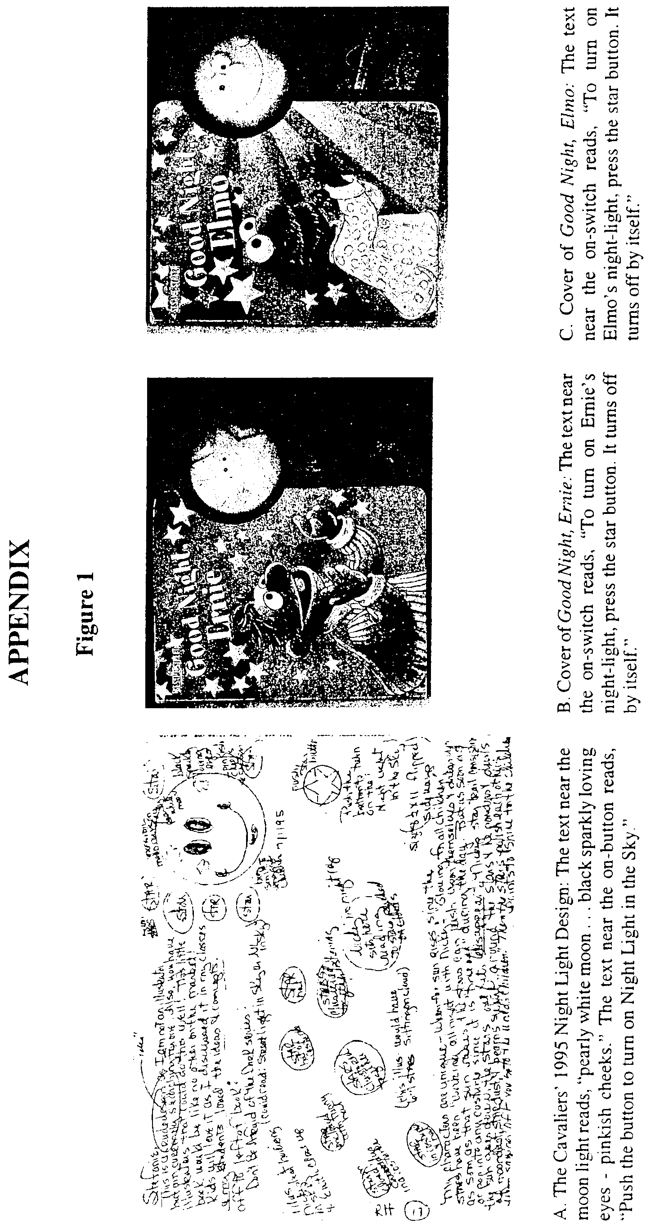
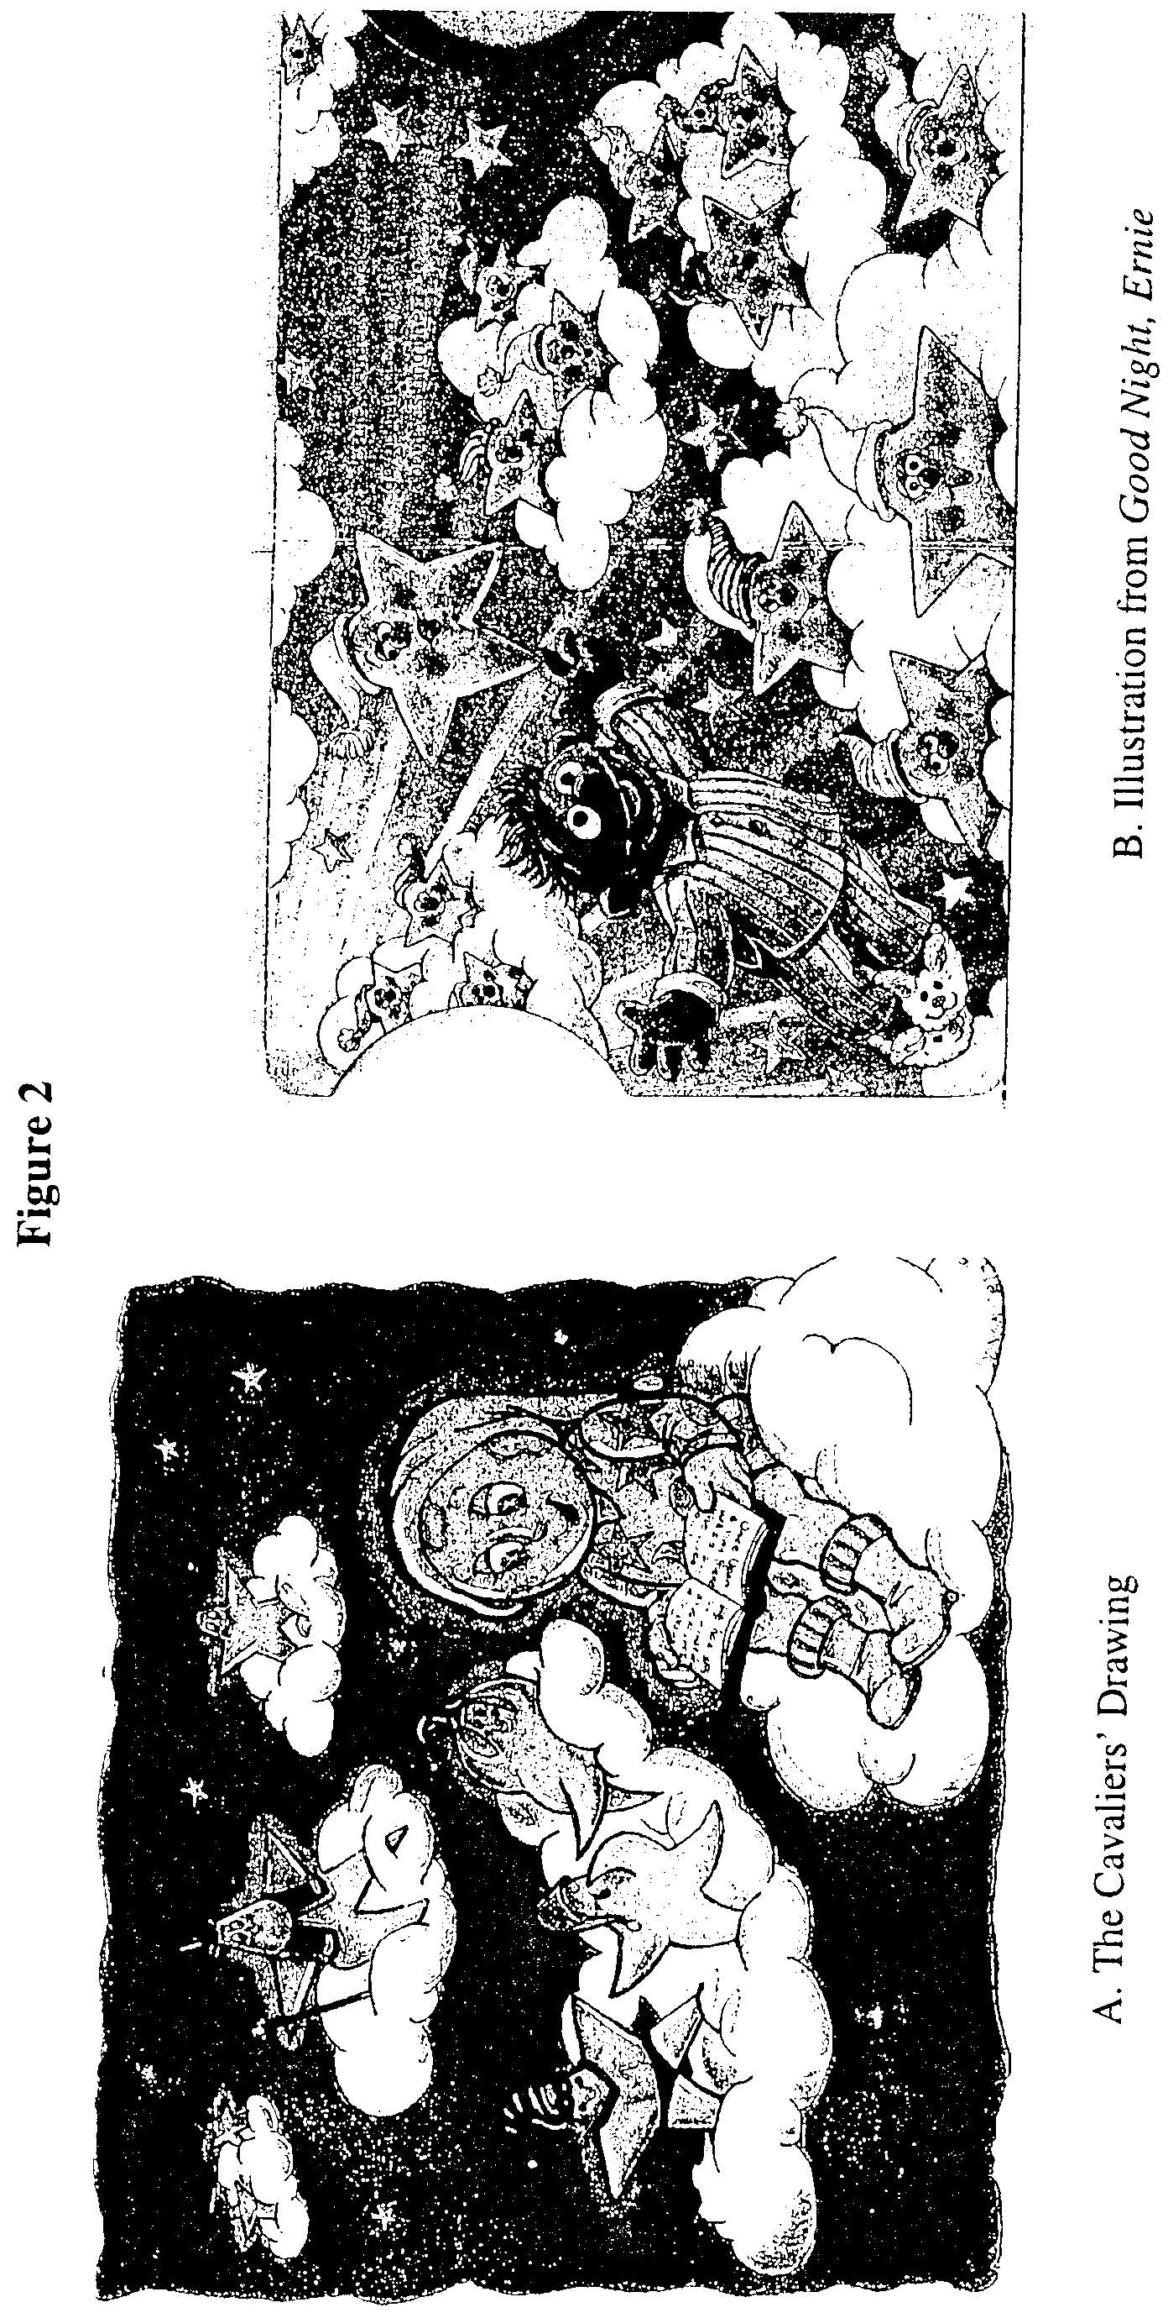
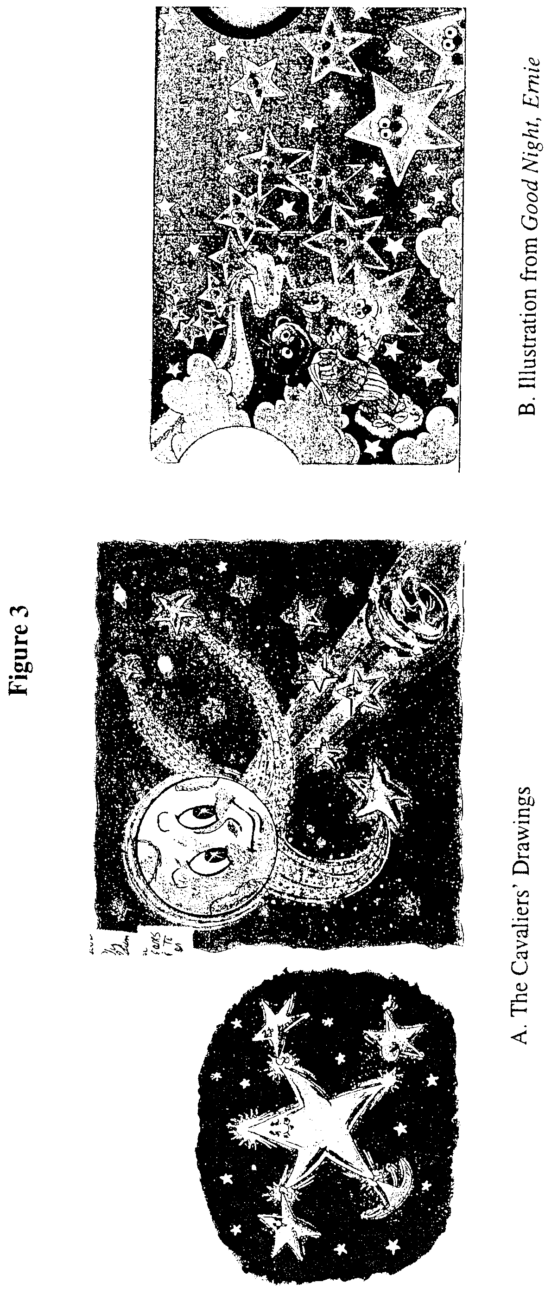

The district court did not address on the merits the complaint's fourth claim of unfair competition under federal law, and the Cavaliers do not discuss the issue on appeal. We thus consider that issue waived. The complaint also alleged state law claims for relief, which the district court dismissed without prejudice and are not the subject of this appeal.
In their second set of submissions, the Cavaliers provided a more detailed illustration (dated January 1996) of the face of its moon night light, which included a nose and more developed eyes more closely resembling Nicky Moonbeam's face.

