STAR ATHLETICA, L.L.C. v. VARSITY BRANDS, INC.
____________________________

Supreme Court of the United States, 2017
137 S. Ct. 1002

THOMAS, J., delivered the opinion of the Court, in which ROBERTS, C.J., and ALITO, SOTOMAYOR, and KAGAN, JJ., joined. GINSBURG, J., filed an opinion concurring in the judgment. BREYER, J., filed a dissenting opinion, in which KENNEDY, J., joined.

Congress has provided copyright protection for original works of art, but not for industrial designs. The line between art and industrial design, however, is often difficult to draw. This is particularly true when an industrial design incorporates artistic elements. Congress has afforded limited protection for these artistic elements by providing that “pictorial, graphic, or sculptural features” of the “design of a useful article” are eligible for copyright protection as artistic works if those features “can be identified separately from, and are capable of existing independently of, the utilitarian aspects of the article.” 17 U.S.C. § 101.

We granted certiorari to resolve widespread disagreement over the proper test for implementing § 101’s separate-identification and independent-existence requirements. We hold that a feature incorporated into the design of a useful article is eligible for copyright protection only if the feature (1) can be perceived as a two- or three-dimensional work of art separate from the useful article and (2) would qualify as a protectable pictorial, graphic, or sculptural work—either on its own or fixed in some other tangible medium of expression—if it were imagined separately from the useful article into which it is incorporated. Because that test is satisfied in this case, we affirm.

I

Respondents Varsity Brands, Inc., Varsity Spirit Corporation, and Varsity Spirit Fashions & Supplies, Inc., design, make, and sell cheerleading uniforms. Respondents have obtained or acquired more than 200 U.S. copyright registrations for two-dimensional designs appearing on the surface of their uniforms and other garments. These designs are primarily “combinations, positionings, and arrangements of elements” that include “chevrons ..., lines, curves, stripes, angles, diagonals, inverted [chevrons], coloring, and shapes.” At issue in this case are Designs 299A, 299B, 074, 078, and 0815. See Appendix, infra.

Petitioner Star Athletica, L.L.C., also markets and sells cheerleading uniforms. Respondents sued petitioner for infringing their copyrights in the five designs. The District Court entered summary judgment for petitioner on respondents’ copyright claims on the ground that the designs did not qualify as protectable pictorial, graphic, or sculptural works. It reasoned that the designs served the useful, or “utilitarian,” function of identifying the garments as “cheerleading uniforms” and therefore could not be “physically or conceptually” separated under § 101 “from the utilitarian function” of the uniform.

The Court of Appeals for the Sixth Circuit reversed. 799 F.3d 468 (6th Cir. 2015). In its view, the “graphic designs” were “separately identifiable” because the designs “and a blank cheerleading uniform can appear ‘side by side’—one as a graphic design, and one as a cheerleading uniform.” Id., at 491 (quoting Compendium of U.S. Copyright Office Practices § 924.2(B) (3d ed. 2014) (Compendium)). And it determined that the designs were “‘capable of existing independently’” because they could be incorporated onto the surface of different types of garments, or hung on the wall and framed as art.

Judge McKeague dissented. He would have held that, because “identifying the wearer as a cheerleader” is a utilitarian function of a cheerleading uniform and the surface designs were “integral to” achieving that function, the designs were inseparable from the uniforms. Id., at 495–496.

II

* * *

The Copyright Act … establishes a special rule for copyrighting a pictorial, graphic, or sculptural work incorporated into a “useful article,” which is defined as “an article having an intrinsic utilitarian function that is not merely to portray the appearance of the article or to convey information.” The statute does not protect useful articles as such. Rather, “the design of a useful article” is “considered a pictorial, graphical, or sculptural work only if, and only to the extent that, such design incorporates pictorial, graphic, or sculptural features that can be identified separately from, and are capable of existing independently of, the utilitarian aspects of the article.”

Courts, the Copyright Office, and commentators have described the analysis undertaken to determine whether a feature can be separately identified from, and exist independently of, a useful article as “separability.” In this case, our task is to determine whether the arrangements of lines, chevrons, and colorful shapes appearing on the surface of respondents’ cheerleading uniforms are eligible for copyright protection as separable features of the design of those cheerleading uniforms.

A

As an initial matter, we must address whether separability analysis is necessary in this case.
1

Respondents argue that “[s]eparability is only implicated when a [pictorial, graphic, or sculptural] work is the ‘design of a useful article.’” They contend that the surface decorations in this case are “two-dimensional graphic designs that appear on useful articles,” but are not themselves designs of useful articles. Consequently, the surface decorations are protected two-dimensional works of graphic art without regard to any separability analysis under § 101. Under this theory, two-dimensional artistic features on the surface of useful articles are “inherently separable.”

This argument is inconsistent with the text of § 101. The statute requires separability analysis for any “pictorial, graphic, or sculptural features” incorporated into the “design of a useful article.” “Design” refers here to “the combination” of “details” or “features” that “go to make up” the useful article. 3 Oxford English Dictionary 244 (def. 7, first listing) (1933) (OED). Furthermore, the words “pictorial” and “graphic” include, in this context, two-dimensional features such as pictures, paintings, or drawings. See 4 id., at 359 (defining “[g]raphic” to mean “[o]f or pertaining to drawing or painting”); 7 id., at 830 (defining “[p]ictorial” to mean “of or pertaining to painting or drawing”). And the statute expressly defines “[p]ictorial, graphical, and sculptural works” to include “two-dimensional ... works of ... art.” § 101. The statute thus provides that the “design of a useful article” can include two-dimensional “pictorial” and “graphic” features, and separability analysis applies to those features just as it does to three-dimensional “sculptural” features.

* * *

B

We must now decide when a feature incorporated into a useful article “can be identified separately from” and is “capable of existing independently of” “the utilitarian aspects” of the article. This is not a free-ranging search for the best copyright policy, but rather “depends solely on statutory interpretation.” Mazer v. Stein, 347 U.S. 201, 214 (1954). … We thus begin and end our inquiry with the text, giving each word its “ordinary, contemporary, common meaning.” Walters v. Metropolitan Ed. Enterprises, Inc., 519 U.S. 202, 207 (1997). We do not, however, limit this inquiry to the text of § 101 in isolation. “[I]nterpretation of a phrase of uncertain reach is not confined to a single sentence when the text of the whole statute gives instruction as to its meaning.” Maracich v. Spears, 570 U.S. ––––, ––––, 133 S. Ct. 2191, 2203 (2013). We thus “look to the provisions of the whole law” to determine § 101’s meaning. United States v. Heirs of Boisdore, 8 How. 113, 122, 12 L. Ed. 1009 (1849).

1

The statute provides that a “pictorial, graphic, or sculptural featur [e]” incorporated into the “design of a useful article” is eligible for copyright protection if it (1) “can be identified separately from,” and (2) is “capable of existing independently of, the utilitarian aspects of the article.” § 101. The first requirement—separate identification—is not onerous. The decisionmaker need only be able to look at the useful article and spot some two- or three-dimensional element that appears to have pictorial, graphic, or sculptural qualities.

The independent-existence requirement is ordinarily more difficult to satisfy. The decisionmaker must determine that the separately identified feature has the capacity to exist apart from the utilitarian aspects of the article. See 2 OED 88 (def. 5) (defining “[c]apable” of as “[h]aving the needful capacity, power, or fitness for”). In other words, the feature must be able to exist as its own pictorial, graphic, or sculptural work as defined in § 101 once it is imagined apart from the useful article. If the feature is not capable of existing as a pictorial, graphic, or sculptural work once separated from the useful article, then it was not a pictorial, graphic, or sculptural feature of that article, but rather one of its utilitarian aspects.

Of course, to qualify as a pictorial, graphic, or sculptural work on its own, the feature cannot itself be a useful article or “[a]n article that is normally a part of a useful article” (which is itself considered a useful article). § 101. Nor could someone claim a copyright in a useful article merely by creating a replica of that article in some other medium—for example, a cardboard model of a car. Although the replica could itself be copyrightable, it would not give rise to any rights in the useful article that inspired it.

* * *

C

In sum, a feature of the design of a useful article is eligible for copyright if, when identified and imagined apart from the useful article, it would qualify as a pictorial, graphic, or sculptural work either on its own or when fixed in some other tangible medium.

Applying this test to the surface decorations on the cheerleading uniforms is straightforward. First, one can identify the decorations as features having pictorial, graphic, or sculptural qualities. Second, if the arrangement of colors, shapes, stripes, and chevrons on the surface of the cheerleading uniforms were separated from the uniform and applied in another medium—for example, on a painter’s canvas—they would qualify as “two-dimensional ... works of ... art,” § 101. And imaginatively removing the surface decorations from the uniforms and applying them in another medium would not replicate the uniform itself. Indeed, respondents have applied the designs in this case to other media of expression—different types of clothing—without replicating the uniform. The decorations are therefore separable from the uniforms and eligible for copyright protection.

The dissent argues that the designs are not separable because imaginatively removing them from the uniforms and placing them in some other medium of expression—a canvas, for example—would create “pictures of cheerleader uniforms.” (opinion of BREYER, J.). Petitioner similarly argues that the decorations cannot be copyrighted because, even when extracted from the useful article, they retain the outline of a cheerleading uniform.

This is not a bar to copyright. Just as two-dimensional fine art corresponds to the shape of the canvas on which it is painted, two-dimensional applied art correlates to the contours of the article on which it is applied. A fresco painted on a wall, ceiling panel, or dome would not lose copyright protection, for example, simply because it was designed to track the dimensions of the surface on which it was painted. Or consider, for example, a design etched or painted on the surface of a guitar. If that entire design is imaginatively removed from the guitar’s surface and placed on an album cover, it would still resemble the shape of a guitar. But the image on the cover does not “replicate” the guitar as a useful article. Rather, the design is a two-dimensional work of art that corresponds to the shape of the useful article to which it was applied. The statute protects that work of art whether it is first drawn on the album cover and then applied to the guitar’s surface, or vice versa. Failing to protect that art would create an anomaly: It would extend protection to two-dimensional designs that cover a part of a useful article but would not protect the same design if it covered the entire article. The statute does not support that distinction, nor can it be reconciled with the dissent’s recognition that “artwork printed on a t-shirt” could be protected. Post (internal quotation marks omitted).

To be clear, the only feature of the cheerleading uniform eligible for a copyright in this case is the two-dimensional work of art fixed in the tangible medium of the uniform fabric. Even if respondents ultimately succeed in establishing a valid copyright in the surface decorations at issue here, respondents have no right to prohibit any person from manufacturing a cheerleading uniform of identical shape, cut, and dimensions to the ones on which the decorations in this case appear. They may prohibit only the reproduction of the surface designs in any tangible medium of expression—a uniform or otherwise.

* * *

[Petitioner and the United States argued that “separability” requires that the useful article retain its utility once the PGS work is removed.] The debate over the relative utility of a plain white cheerleading uniform is unnecessary. The focus of the separability inquiry is on the extracted feature and not on any aspects of the useful article that remain after the imaginary extraction. The statute does not require the decisionmaker to imagine a fully functioning useful article without the artistic feature. Instead, it requires that the separated feature qualify as a nonuseful pictorial, graphic, or sculptural work on its own.

* * *

Because we reject the view that a useful article must remain after the artistic feature has been imaginatively separated from the article, we necessarily abandon the distinction between “physical” and “conceptual” separability, which some courts and commentators have adopted based on the Copyright Act’s legislative history. See H.R. Rep. No. 94–1476, p. 55 (1976). According to this view, a feature is physically separable from the underlying useful article if it can “be physically separated from the article by ordinary means while leaving the utilitarian aspects of the article completely intact.” Compendium § 924.2(A).. Conceptual separability applies if the feature physically could not be removed from the useful article by ordinary means. See Compendium § 924.2(B).

The statutory text indicates that separability is a conceptual undertaking. Because separability does not require the underlying useful article to remain, the physical-conceptual distinction is unnecessary.

* * *

III

We hold that an artistic feature of the design of a useful article is eligible for copyright protection if the feature (1) can be perceived as a two- or three-dimensional work of art separate from the useful article and (2) would qualify as a protectable pictorial, graphic, or sculptural work either on its own or in some other medium if imagined separately from the useful article. Because the designs on the surface of respondents’ cheerleading uniforms in this case satisfy these requirements, the judgment of the Court of Appeals is affirmed.

It is so ordered.

APPENDIX TO OPINION OF THE COURT
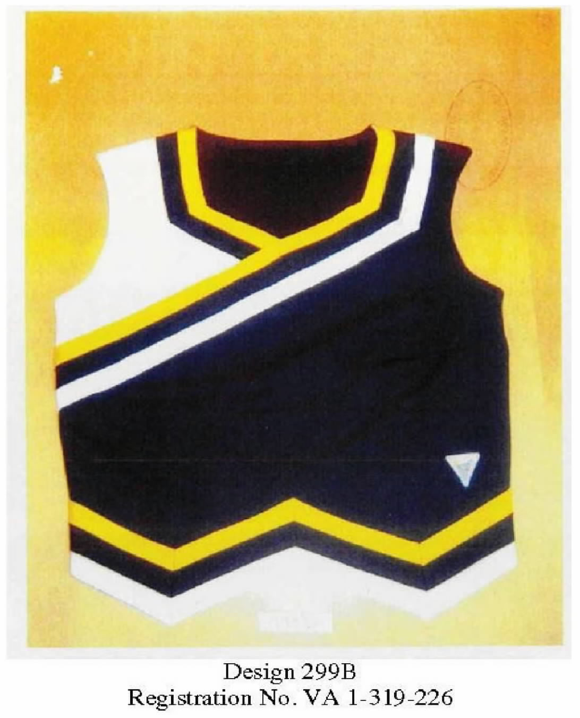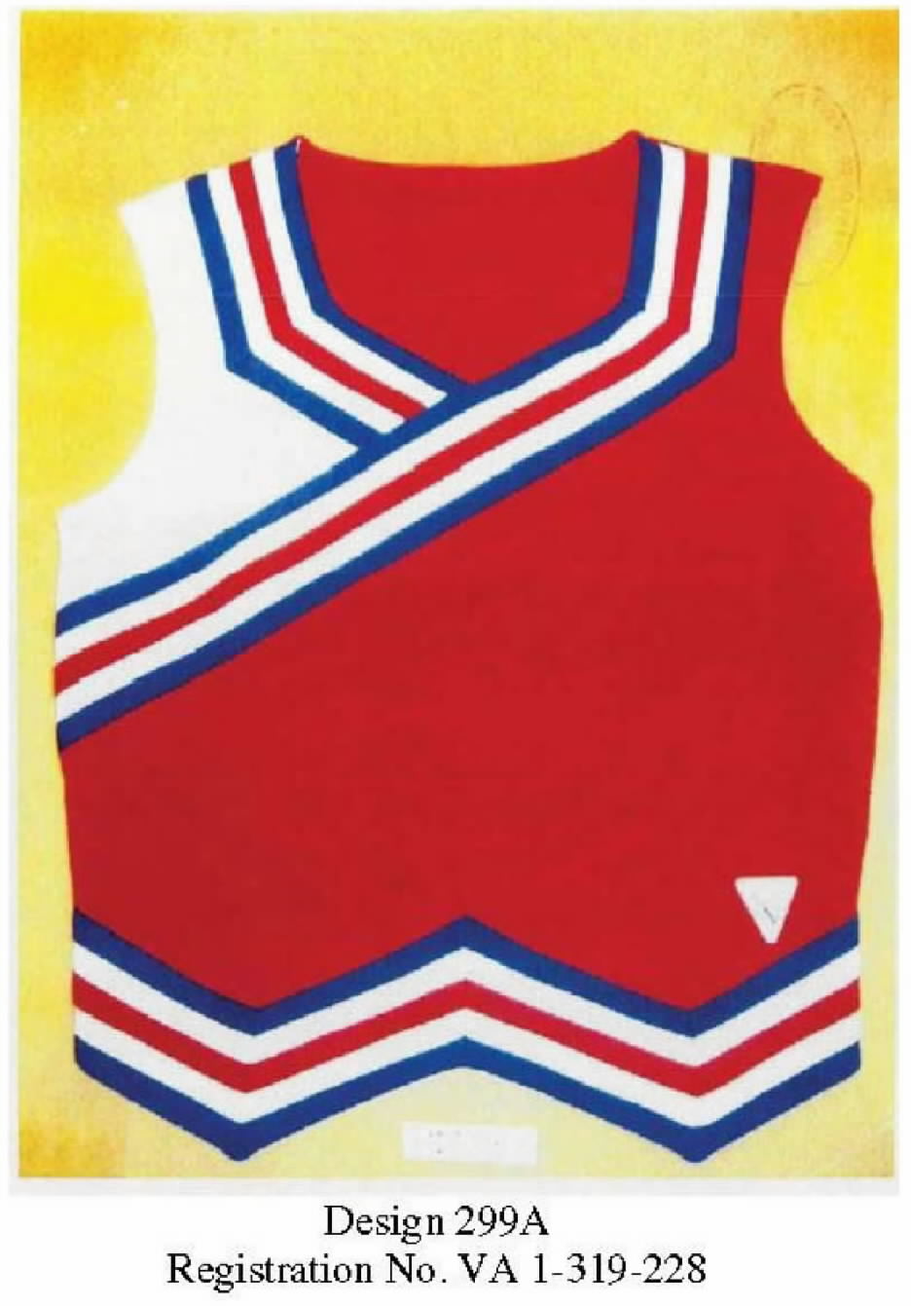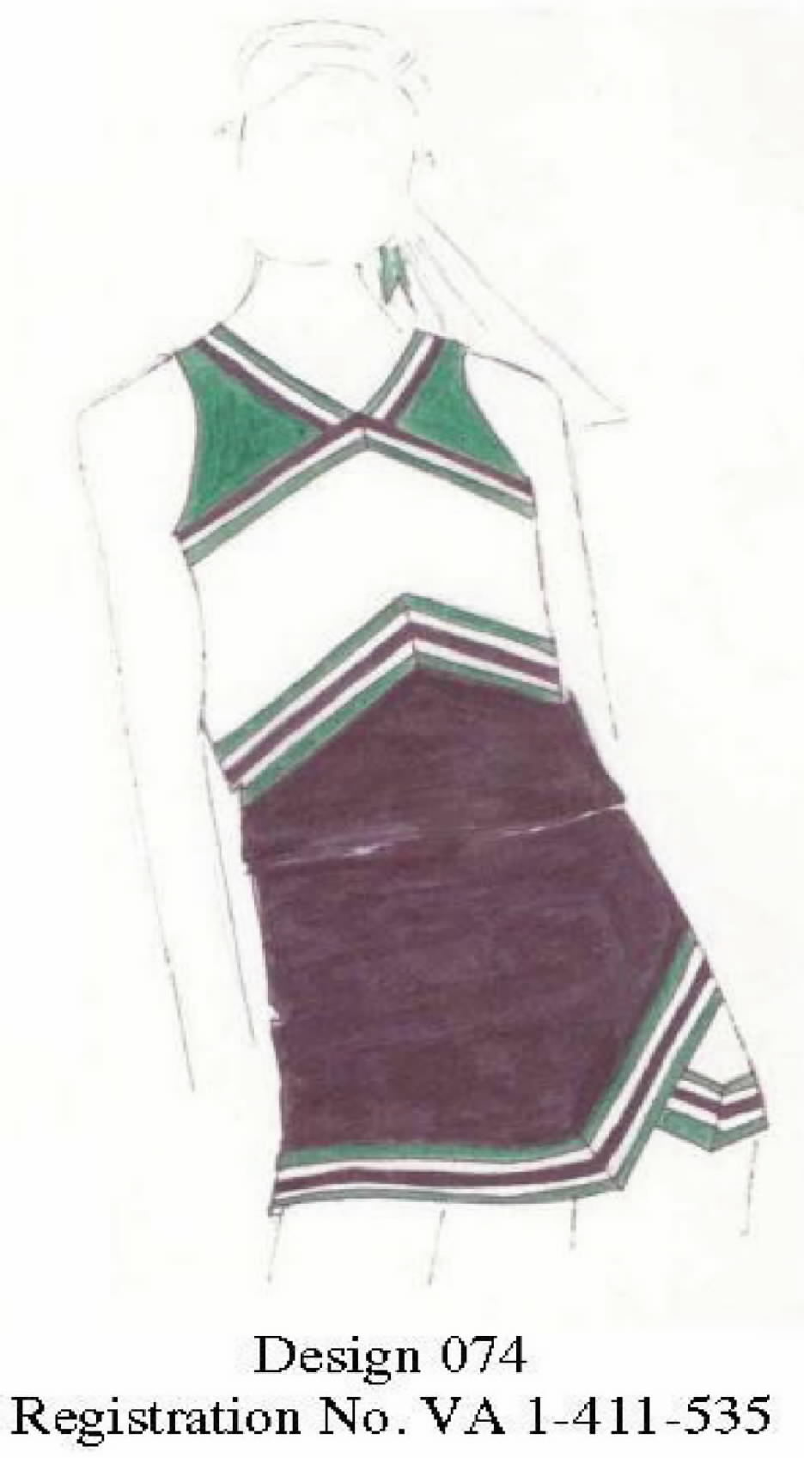
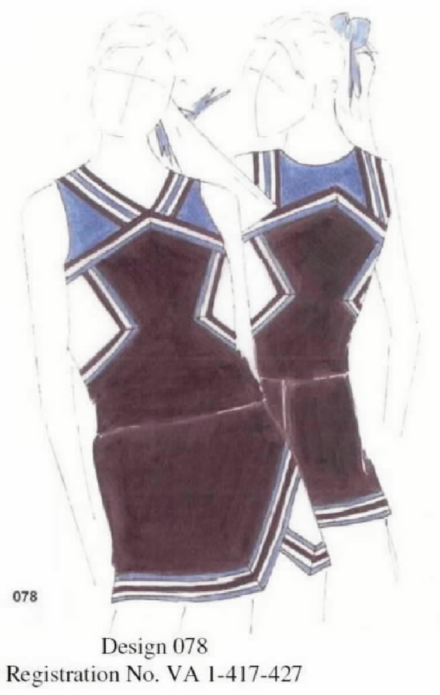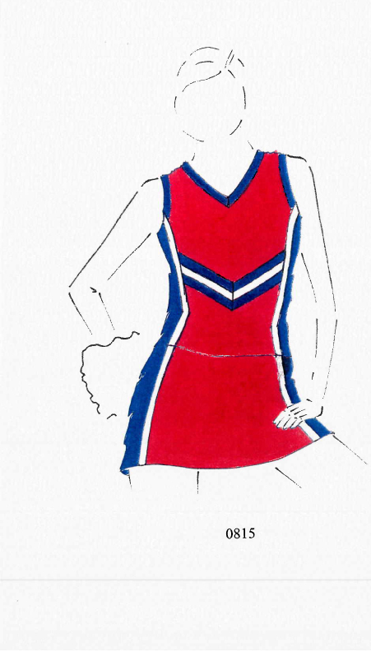

​Justice GINSBURG, concurring in the judgment.

I concur in the Court’s judgment but not in its opinion. Unlike the majority, I would not take up in this case the separability test appropriate under 17 U.S.C. § 101. Consideration of that test is unwarranted because the designs at issue are not designs of useful articles. Instead, the designs are themselves copyrightable pictorial or graphic works reproduced on useful articles.

A pictorial, graphic, or sculptural work (PGS work) is copyrightable. § 102(a)(5). PGS works include “two-dimensional and three-dimensional works of fine, graphic, and applied art.” § 101. Key to this case, a copyright in a standalone PGS work “includes the right to reproduce the work in or on any kind of article, whether useful or otherwise.” § 113(a). Because the owner of a copyright in a pre-existing PGS work may exclude a would-be infringer from reproducing that work on a useful article, there is no need to engage in any separability inquiry to resolve the instant petition.

The designs here in controversy are standalone pictorial and graphic works that respondents Varsity Brands, Inc., et al. (Varsity) reproduce on cheerleading uniforms. Varsity’s designs first appeared as pictorial and graphic works that Varsity’s design team sketched on paper. Varsity then sought copyright protection for those two-dimensional designs, not for cheerleading costumes; its registration statements claimed “2–Dimensional artwork” and “fabric design (artwork).” Varsity next reproduced its two-dimensional graphic designs on cheerleading uniforms, also on other garments, including T-shirts and jackets.3

In short, Varsity’s designs are not themselves useful articles meet for separability determination under § 101; they are standalone PGS works that may gain copyright protection as such, including the exclusive right to reproduce the designs on useful articles.

APPENDIX

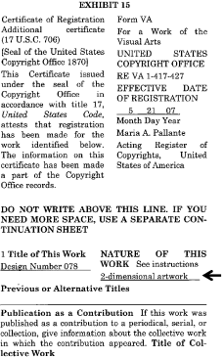
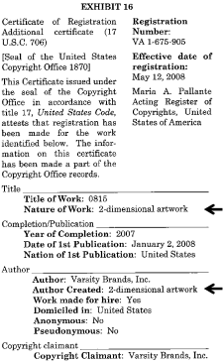 | 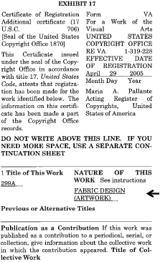
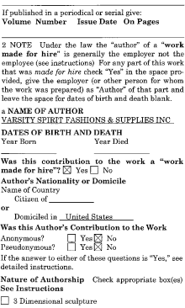
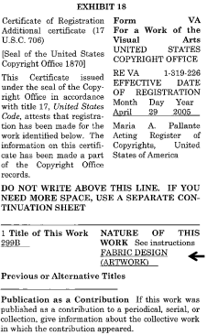 | 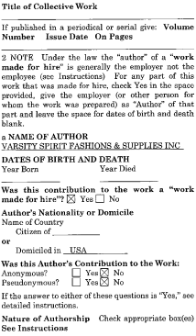
 | 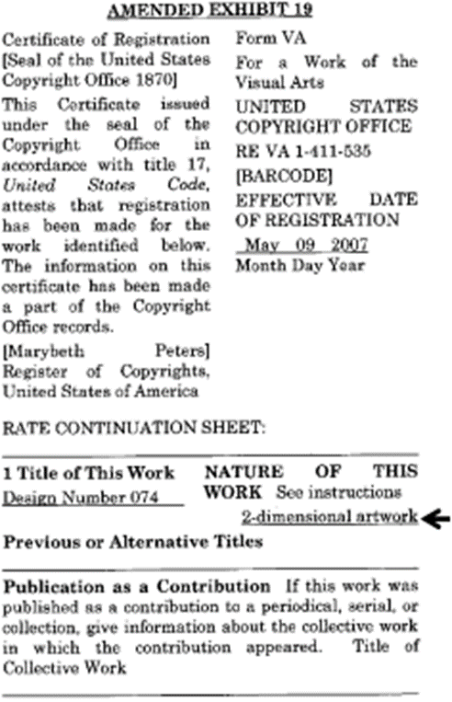

​​
​​​Justice BREYER, with whom Justice KENNEDY joins, dissenting.

I agree with much in the Court’s opinion. But I do not agree that the designs that Varsity Brands, Inc., submitted to the Copyright Office are eligible for copyright protection. Even applying the majority’s test, the designs cannot “be perceived as ... two- or three-dimensional work[s] of art separate from the useful article.” Ante.

Look at the designs that Varsity submitted to the Copyright Office. See Appendix to opinion of the Court, ante. You will see only pictures of cheerleader uniforms. And cheerleader uniforms are useful articles. A picture of the relevant design features, whether separately “perceived” on paper or in the imagination, is a picture of, and thereby “replicate[s],” the underlying useful article of which they are a part. Ante. Hence the design features that Varsity seeks to protect are not “capable of existing independently o[f] the utilitarian aspects of the article.” 17 U.S.C. § 101.
I
The relevant statutory provision says that the “design of a useful article” is copyrightable “only if, and only to the extent that, such design incorporates pictorial, graphic, or sculptural features that can be identified separately from, and are capable of existing independently of, the utilitarian aspects of the article.” But what, we must ask, do the words “identified separately” mean? Just when is a design separate from the “utilitarian aspect of the [useful] article?” The most direct, helpful aspect of the Court’s opinion answers this question by stating:
“Nor could someone claim a copyright in a useful article merely by creating a replica of that article in some other medium—for example, a cardboard model of a car. Although the replica could itself be copyrightable, it would not give rise to any rights in the useful article that inspired it.” Ante.
Exactly so. These words help explain the Court’s statement that a copyrightable work of art must be “perceived as a two- or three-dimensional work of art separate from the useful article.” Ante. They help clarify the concept of separateness. They are consistent with Congress’ own expressed intent. 17 U.S.C. § 101; H.R. Rep. No. 94–1476, pp. 55, 105 (1976) (H.R. Rep.). And they reflect long held views of the Copyright Office. See Compendium of U.S. Copyright Office Practices § 924.2(B) (3d ed. 2014), online at http://www.copyright.gov/comp3/docs/compendium.pdf (as last visited Mar. 7, 2017) (Compendium).

Consider, for example, the explanation that the House Report for the Copyright Act of 1976 provides. It says:
“Unless the shape of an automobile, airplane, ladies’ dress, food processor, television set, or any other industrial product contains some element that, physically or conceptually, can be identified as separable from the utilitarian aspects of that article, the design would not be copyrighted....” H.R. Rep., at 55 (emphasis added).
These words suggest two exercises, one physical, one mental. Can the design features (the picture, the graphic, the sculpture) be physically removed from the article (and considered separately), all the while leaving the fully functioning utilitarian object in place? If not, can one nonetheless conceive of the design features separately without replicating a picture of the utilitarian object? If the answer to either of these questions is “yes,” then the design is eligible for copyright protection. Otherwise, it is not. The abstract nature of these questions makes them sound difficult to apply. But with the Court’s words in mind, the difficulty tends to disappear.

An example will help. Imagine a lamp with a circular marble base, a vertical 10–inch tall brass rod (containing wires) inserted off center on the base, a light bulb fixture emerging from the top of the brass rod, and a lampshade sitting on top. In front of the brass rod a porcelain Siamese cat sits on the base facing outward. Obviously, the Siamese cat is physically separate from the lamp, as it could be easily removed while leaving both cat and lamp intact. And, assuming it otherwise qualifies, the designed cat is eligible for copyright protection.

Now suppose there is no long brass rod; instead the cat sits in the middle of the base and the wires run up through the cat to the bulbs. The cat is not physically separate from the lamp, as the reality of the lamp’s construction is such that an effort to physically separate the cat and lamp will destroy both cat and lamp. The two are integrated into a single functional object, like the similar configuration of the ballet dancer statuettes that formed the lamp bases at issue in Mazer v. Stein, 347 U.S. 201 (1954). But we can easily imagine the cat on its own, as did Congress when conceptualizing the ballet dancer. See H.R. Rep., at 55 (the statuette in Mazer was “incorporated into a product without losing its ability to exist independently as a work of art”). In doing so, we do not create a mental picture of a lamp (or, in the Court’s words, a “replica” of the lamp), which is a useful article. We simply perceive the cat separately, as a small cat figurine that could be a copyrightable design work standing alone that does not replicate the lamp. Hence the cat is conceptually separate from the utilitarian article that is the lamp. The pair of lamps pictured at Figures 1 and 2 in the Appendix to this opinion illustrate this principle.

* * *

… A separable design feature must be “capable of existing independently” of the useful article as a separate artistic work that is not itself the useful article. If the claimed feature could be extracted without replicating the useful article of which it is a part, and the result would be a copyrightable artistic work standing alone, then there is a separable design. But if extracting the claimed features would necessarily bring along the underlying useful article, the design is not separable from the useful article. In many or most cases, to decide whether a design or artistic feature of a useful article is conceptually separate from the article itself, it is enough to imagine the feature on its own and ask, “Have I created a picture of a (useful part of a) useful article?” If so, the design is not separable from the useful article. If not, it is.

In referring to imagined pictures and the like, I am not speaking technically. I am simply trying to explain an intuitive idea of what separation is about, as well as how I understand the majority’s opinion. So understood, the opinion puts design copyrights in their rightful place. The law has long recognized that drawings or photographs of real world objects are copyrightable as drawings or photographs, but the copyright does not give protection against others making the underlying useful objects. That is why a copyright on Van Gogh’s painting would prevent others from reproducing that painting, but it would not prevent others from reproducing and selling the comfortable old shoes that the painting depicts. Indeed, the purpose of § 113(b) was to ensure that “‘copyright in a pictorial, graphic, or sculptural work, portraying a useful article as such, does not extend to the manufacture of the useful article itself.’” H.R. Rep., at 105.

II

To ask this kind of simple question—does the design picture the useful article?—will not provide an answer in every case, for there will be cases where it is difficult to say whether a picture of the design is, or is not, also a picture of the useful article. But the question will avoid courts focusing primarily upon what I believe is an unhelpful feature of the inquiry, namely, whether the design can be imagined as a “two- or three-dimensional work of art.” Ante. That is because virtually any industrial design can be thought of separately as a “work of art”: Just imagine a frame surrounding the design, or its being placed in a gallery. Consider Marcel Duchamp’s “readymades” series, the functional mass-produced objects he designated as art. See Appendix, fig. 4, infra. What is there in the world that, viewed through an esthetic lens, cannot be seen as a good, bad, or indifferent work of art? What design features could not be imaginatively reproduced on a painter’s canvas? Indeed, great industrial design may well include design that is inseparable from the useful article—where, as Frank Lloyd Wright put it, “form and function are one.” F. Wright, An Autobiography 146 (1943) (reprint 2005). Where they are one, the designer may be able to obtain 15 years of protection through a design patent. 35 U.S.C. §§ 171, 173. But, if they are one, Congress did not intend a century or more of copyright protection.
III
The conceptual approach that I have described reflects Congress’ answer to a problem that is primarily practical and economic. Years ago Lord Macaulay drew attention to the problem when he described copyright in books as a “tax on readers for the purpose of giving a bounty to writers.” 56 Parl. Deb. (3d Ser.) (1841) 341, 350. He called attention to the main benefit of copyright protection, which is to provide an incentive to produce copyrightable works and thereby “promote the Progress of Science and useful Arts.” U.S. Const. Art. I, § 8, cl. 8. But Macaulay also made clear that copyright protection imposes costs. Those costs include the higher prices that can accompany the grant of a copyright monopoly. They also can include (for those wishing to display, sell, or perform a design, film, work of art, or piece of music, for example) the costs of discovering whether there are previous copyrights, of contacting copyright holders, and of securing permission to copy. Sometimes, as Thomas Jefferson wrote to James Madison, costs can outweigh “the benefit even of limited monopolies.” Letter from Thomas Jefferson to James Madison (July 31, 1788), in 13 Papers of Thomas Jefferson 443 (J. Boyd ed. 1956) (Jefferson Letter). And that is particularly true in light of the fact that Congress has extended the “limited Times” of protection, U.S. Const. Art. I, § 8, cl. 8, from the “14 years” of Jefferson’s day to potentially more than a century today.

The Constitution grants Congress primary responsibility for assessing comparative costs and benefits and drawing copyright’s statutory lines. Courts must respect those lines and not grant copyright protection where Congress has decided not to do so. And it is clear that Congress has not extended broad copyright protection to the fashion design industry.

Congress’ decision not to grant full copyright protection to the fashion industry has not left the industry without protection. Patent design protection is available. 35 U.S.C. §§ 171, 173. A maker of clothing can obtain trademark protection under the Lanham Act for signature features of the clothing. 15 U.S.C. § 1051 et seq. And a designer who creates an original textile design can receive copyright protection for that pattern as placed, for example, on a bolt of cloth, or anything made with that cloth. E.g., Compendium § 924.3(A)(1). “[T]his [type of] claim ... is generally made by the fabric producer rather than the garment or costume designer,” and is “ordinarily made when the two-dimensional design is applied to the textile fabric and before the garment is cut from the fabric.” 56 Fed. Reg. 56531 (1991).

The fashion industry has thrived against this backdrop, and designers have contributed immeasurably to artistic and personal self-expression through clothing. But a decision by this Court to grant protection to the design of a garment would grant the designer protection that Congress refused to provide. It would risk increased prices and unforeseeable disruption in the clothing industry, which in the United States alone encompasses nearly $370 billion in annual spending and 1.8 million jobs. Brief for Council of Fashion Designers of America, Inc., as Amicus Curiae 3–4 (citing U.S. Congress, Joint Economic Committee, The New Economy of Fashion 1 (2016)). That is why I believe it important to emphasize those parts of the Court’s opinion that limit the scope of its interpretation. That language, as I have said, makes clear that one may not “claim a copyright in a useful article merely by creating a replica of that article in some other medium,” which “would not give rise to any rights in the useful article that inspired it.” Ante.
IV
If we ask the “separateness” question correctly, the answer here is not difficult to find. The majority’s opinion, in its appendix, depicts the cheerleader dress designs that Varsity submitted to the Copyright Office. Can the design features in Varsity’s pictures exist separately from the utilitarian aspects of a dress? Can we extract those features as copyrightable design works standing alone, without bringing along, via picture or design, the dresses of which they constitute a part?

Consider designs 074, 078, and 0815. They certainly look like cheerleader uniforms. That is to say, they look like pictures of cheerleader uniforms, just like Van Gogh’s old shoes look like shoes. I do not see how one could see them otherwise. Designs 299A and 2999B present slightly closer questions. They omit some of the dresslike context that the other designs possess. But the necklines, the sleeves, and the cut of the skirt suggest that they too are pictures of dresses. Looking at all five of Varsity’s pictures, I do not see how one could conceptualize the design features in a way that does not picture, not just artistic designs, but dresses as well.

Were I to accept the majority’s invitation to “imaginatively remov[e]” the chevrons and stripes as they are arranged on the neckline, waistline, sleeves, and skirt of each uniform, and apply them on a “painter’s canvas,” ante, that painting would be of a cheerleader’s dress. The esthetic elements on which Varsity seeks protection exist only as part of the uniform design—there is nothing to separate out but for dress-shaped lines that replicate the cut and style of the uniforms. Hence, each design is not physically separate, nor is it conceptually separate, from the useful article it depicts, namely, a cheerleader’s dress. They cannot be copyrighted.

Varsity, of course, could have sought a design patent for its designs. Or, it could have sought a copyright on a textile design, even one with a similar theme of chevrons and lines.

But that is not the nature of Varsity’s copyright claim. It has instead claimed ownership of the particular “‘treatment and arrangement’” of the chevrons and lines of the design as they appear at the neckline, waist, skirt, sleeves, and overall cut of each uniform. Brief for Respondents 50. The majority imagines that Varsity submitted something different—that is, only the surface decorations of chevrons and stripes, as in a textile design. As the majority sees it, Varsity’s copyright claim would be the same had it submitted a plain rectangular space depicting chevrons and stripes, like swaths from a bolt of fabric. But considered on their own, the simple stripes are plainly unoriginal. Varsity, then, seeks to do indirectly what it cannot do directly: bring along the design and cut of the dresses by seeking to protect surface decorations whose “treatment and arrangement” are coextensive with that design and cut. As Varsity would have it, it would prevent its competitors from making useful three-dimensional cheerleader uniforms by submitting plainly unoriginal chevrons and stripes as cut and arranged on a useful article. But with that cut and arrangement, the resulting pictures on which Varsity seeks protection do not simply depict designs. They depict clothing. They depict the useful articles of which the designs are inextricable parts. And Varsity cannot obtain copyright protection that would give them the power to prevent others from making those useful uniforms, any more than Van Gogh can copyright comfortable old shoes by painting their likeness.

I fear that, in looking past the three-dimensional design inherent in Varsity’s claim by treating it as if it were no more than a design for a bolt of cloth, the majority has lost sight of its own important limiting principle. One may not “claim a copyright in a useful article merely by creating a replica of that article in some other medium,” such as in a picture. Ante. That is to say, one cannot obtain a copyright that would give its holder “any rights in the useful article that inspired it.” Ante.

With respect, I dissent.

APPENDIX

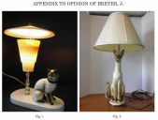​

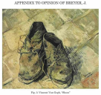​

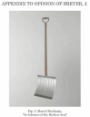​

Comments

1. The law prior to Star Athletica. As a matter of legal doctrine and statutory interpretation, the majority opinion in Varsity Brands purports to clarify and standardize legal standards that had become unwieldy in the wake of a trio of cases decided 30 years ago by the Court of Appeals for the Second Circuit. The doctrinal question concerns copyright status for expressive dimensions of two- and three-dimensional things that have both “creative” and “functional” attributes. The law directs that those expressive attributes can be protected by copyright if they are “separate” from the “functional”’ attributes. Courts have wrestled to come up with a useful and coherent approach to the “separateness” issue. On the whole, guided by the legislative history of the Copyright Act, courts looked to either “physical” separability (such a painting that could added to a blank, white dinner plate) or to “conceptual” separability. In that latter category, in Kieselstein-Cord v. Accessories by Pearl, Inc., 632 F.2d 989 (2d Cir. 1980), the court approved copyright protection for silver belt buckles that adopted the abstract forms of modern sculpture; the court noted that the “conceptual” separability of the aesthetic elements of the buckles was supported, among other ways, by the fact that the buckles had been accepted into the permanent collection of the Metropolitan Museum of Art. In Carol Barnhart Inc. v. Economy Cover Corp., 773 F.2d 411 (2d Cir. 1985), the court rejected the notion that mannequins used for clothing displays could be copyrighted, noting that any “expressive” dimension to the mannequins at issue could not be distinguished from their function. In Brandir Int’l, Inc. v. Cascade Pac. Lumber Co., 834 F.2d 1142, 1145 (2d Cir. 1987), the court rejected copyright protection for the “Ribbon Rack” bicycle rack designed using sculpted steel tubes. Conceptual separability was absent because the sculptor’s design process for the rack emphasized functional rather than aesthetic considerations.

Via Star Athletica, the Supreme Court has now clarified that any differences between physical separability and conceptual separability are now irrelevant.

2. Seeing things. There is little doubt in Star Athletica that the cheerleader uniforms embody “pictorial, graphic, and sculptural works,” and that the uniforms are also “useful articles.” (Note that Justice Ginsburg, concurring, does not agree that the uniforms are akin to any other physical medium in which a creator may fix a creative work. Do you agree?) Both definitions must be satisfied in order for the Supreme Court to confront the issue that divides the majority and dissent: whether the utilitarian features of the article can be separated from its pictorial, graphic, and sculptural (that is, artistic) features. The Court divides sharply not over the analytic approach to this question, which all justices agree should focus on the possibility of conceptual separability, but over its application to the facts of the case, and particularly over a type of characterization question that is common in copyright cases generally: What is the object that is at hand in the case? What do the justices “see” when they look at the subject matter of the case? According to the majority, a cheerleader uniform need not have any graphic designs at all; if all colors and shapes were removed from these dresses, they would still be dresses and, more important, the colors and shapes themselves could be analyzed to determine whether they meet Feist’s minimal creativity threshold. Justice Ginsburg would take this approach to its extreme, not by examining the uniforms themselves but instead by giving great weight to how the Respondent (the original plaintiff), Varsity Brands, described its works in its copyright registrations. The dissent “sees” only cheerleader uniforms; the colors and shapes in question define their very status as uniforms, presumably because the colors and shapes signal their role, and the roles played by the people who wear them, to relevant audiences. Advocates and judges are rarely called on to make explicit these seemingly metaphysical premises of their arguments. Cases involving PGS works often question them and rely on them implicitly. Are these differences in perspective capable of definitive resolution? If so, how?

3. Is it a useful article? If a PGS work does not constitute a “useful article,” then there is no need to perform a separability analysis; the work is entitled to copyright so long as it otherwise meets the default standards of originality and fixation. The statute defines a useful article as “an article having an intrinsic utilitarian function that is not merely to portray the appearance of the article or to convey information.” Maps and globes, for example, are “articles” that are not “useful” within the meaning of this definition. Though they have an intrinsic utilitarian function, their purpose is to convey information. The issue of “usefulness” has led courts to some improbable distinctions. Though ordinary mannequins of humans are useful articles, animal mannequins used for taxidermy are not. See Superior Form Builders, Inc. v. Dan Chase Taxidermy Supply Co., Inc., 74 F.3d 488 (4th Cir. 1996). Halloween costumes are ordinarily useful articles, see Whimsicality, Inc. v. Rubie’s Costume Co., Inc., 891 F.2d 452 (2d Cir. 1989), though the Court of Appeals for the Second Circuit held that a complaint that alleged that “plush, sculpted animal costumes are not useful articles” should have survived a pretrial motion to dismiss. See Chosun Int’l, Inc. v. Chrisha Creations, Ltd., 413 F.3d 324 (2d Cir. 2005). Halloween masks, standing alone, are not “useful articles.” See Masquerade Novelty v. Unique Industries, 912 F.2d 663 (3d Cir. 1990). And in Poe v. Missing Persons, 745 F.2d 1238 (9th Cir. 1984), the court confronted whether what appeared to be a woman’s swimsuit made of triangles of opaque plastic was in fact a work of conceptual art or truly a swimsuit, and therefore a useful article. It remanded the case for fact-finding by the trial court.

4. Evidence and proof. The cases decided by the Second Circuit in the 1980s considered evidence from markets for selling and advertising the articles in question, evidence from consumers and users of the articles, evidence from the creators and designers of the articles, and evidence from expert witnesses. Some “useful articles” are best understood as intended for or consumed by industry, some by the mass market, and some by elite markets for fine art, for example. Articles designed or intended for one purpose (furniture for the home, for example) may later be characterized by another purpose (as items in a collection of a museum devoted to modern design, for example). As the results in those cases show, the opinions differ with respect to the weight to be given each type of evidence. No matter what form of evidence is given prominence, there is a considerable risk of idiosyncrasy and error. Under the standard announced by the Supreme Court, it is clear that much of the evidence made relevant by those older cases, such as evidence related to the creator’s artistic intentions or related to the artistic marketability of the works in question, is now irrelevant. Under the Court’s standard, what evidence is relevant?

5. Overlapping IP systems and the nondiscrimination principle. Recall Justice Holmes’s statement in Bleistein of the “nondiscrimination” principle in copyright law. In what respects is that principle consistent with copyright protection for PGS works, and in what respects is it in tensions with copyright for PGS works? Distinctive and decorative attributes of functional objects can be protected not only by copyright law but also, in different respects by patent law (particularly design patent law, as Justice Breyer points out in dissent in Star Athletica) and also by trademark law, via the law of trade dress. To what extent should producers of creative, innovative, or distinctive objects be limited to one form of IP protection, and to what extent should those objects be eligible for as many forms of IP protection as might apply, according to their respective standards? Boundaries among different IP regimes are often murky. The argument for limiting multiple forms of IP protection for a single object relies on the principle that each system of IP carries is own set of limiting policies, principles, and rules (the idea/expression distinction copyright, for example). Permitting a creator or developer to opt into a different form of IP means possibly avoiding some relevant, meaningful limitations.

Is admitting PGS works into copyright an all-or-nothing proposition? If not, how should courts and Congress draw the line between what is copyrightable and what is not with respect to so-called applied art? As the issue was framed by the Supreme Court in Mazer v. Stein, the question was “an artist’s right to copyright a work of art intended to be reproduced for lamp bases.” Mazer, 347 U.S. at 205. The Court concluded there that if the work was copyrightable in the first place, the fact that it was subsequently adapted as a lamp would not change its copyrightable status.

6. Copyright and fashion design. Fashion design and clothing manufacture is a major worldwide industry. Though designers are often highly creative, their designs are often not subject to copyright protection in the US. (Designers and designs may be protected legally by trademark law.) Fabric designs and patterns may be protected by copyright, but the design of a dress, jacket, or suit may not be, by virtue of the widely-shared understanding that these items are “useful articles” and that any expressive attributes could not be identified separately. As Justice Breyer’s dissent indicates, the fashion industry watched the Star Athletica litigation with great interest, hoping that the Court would announce a legal standard that would create greater opportunities for the copyright protection of fashion design. Did it?

We do not today hold that the surface decorations are copyrightable. We express no opinion on whether these works are sufficiently original to qualify for copyright protection, or on whether any other prerequisite of a valid copyright has been satisfied.
The dissent suggests that our test would lead to the copyrighting of shovels. Post. But a shovel, like a cheerleading uniform, even if displayed in an art gallery, is “an article having an intrinsic utilitarian function that is not merely to portray the appearance of the article or to convey information.” 17 U.S.C. § 101. It therefore cannot be copyrighted. A drawing of a shovel could, of course, be copyrighted. And, if the shovel included any artistic features that could be perceived as art apart from the shovel, and which would qualify as protectable pictorial, graphic, or sculptural works on their own or in another medium, they too could be copyrighted. But a shovel as a shovel cannot.
3 That Varsity’s designs can be placed on jackets or T-shirts without replicating a cheerleader’s uniform supports their qualification as fabric designs. The dissent acknowledges that fabric designs are copyrightable, but maintains that Varsity’s designs do not count because Varsity’s submissions depict clothing, not fabric designs. Post. But registrants claiming copyrightable designs may submit drawings or photos of those designs as they appear on useful articles. See Compendium of U.S. Copyright Office Practices § 1506 (3d ed. 2014) (“To register a copyrightable design that has been applied to the back of a useful article, such as a chair, the applicant may submit drawings of the design as it appears on the chair[.]”), online at https://www.copyright.gov/comp3/docs/compendium.pdf (as last visited Mar. 8, 2017). And, as noted in text, Varsity’s registration statements claimed “2–Dimensional artwork” and “fabric design (artwork).”. The dissent also acknowledges that artwork printed on a T-shirt is copyrightable. Post. Varsity’s colored shapes and patterns can be, and indeed are, printed on T-shirts. Assuming Varsity’s designs meet the other requirements for copyrightable subject matter, they would fit comfortably within the Copyright Office guidance featured by the dissent. See post (citing Compendium of U.S. Copyright Office Practices, supra, § 924.2(B)).

