DC COMICS v. TOWLE
________________________________________________________
Court of Appeals for the Ninth Circuit, 2015
802 F.3d 1012
OPINION
IKUTA, Circuit Judge:
We are asked to decide whether defendant Mark Towle infringed DC Comics’ exclusive rights under a copyright when he built and sold replicas of the Batmobile, as it appeared in the 1966 television show Batman and the 1989 film BATMAN. Holy copyright law, Batman!
I
DC Comics (DC) is the publisher and copyright owner of comic books featuring the story of the world-famous character, Batman. Since his first comic book appearance in 1939, the Caped Crusader has protected Gotham City from villains with the help of his sidekick Robin the Boy Wonder, his utility belt, and of course, the Batmobile.

Originally introduced in the Batman comic books in 1941, the Batmobile is a fictional, high-tech automobile that Batman employs as his primary mode of transportation. The Batmobile has varied in appearance over the years, but its name and key characteristics as Batman’s personal crime-fighting vehicle have remained consistent. Over the past eight decades, the comic books have continually depicted the Batmobile as possessing bat-like external features, ready to leap into action to assist Batman in his fight against Gotham’s most dangerous villains, and equipped with futuristic weaponry and technology that is “years ahead of anything else on wheels.”

Since its creation in the comic books, the Batmobile has also been depicted in numerous television programs and motion pictures. Two of these depictions are relevant to this case: the 1966 television series Batman, starring Adam West, and the 1989 motion picture BATMAN, starring Michael Keaton.

The 1966 Batman television series was the product of a licensing agreement between DC’s predecessor, National Periodical Publications, Inc. (National Periodical) and the American Broadcasting Company (ABC). In 1965, National Periodical entered into a licensing agreement with ABC (the 1965 ABC Agreement) in which it granted ABC “an exclusive license to produce a series of half-hour television programs ... based upon the literary property consisting of the comic book and comic strip stories entitled ‘Batman’ ... including the characters therein.” This exclusive right included the right to “translate, adapt, [or] arrange” the Batman literary property “to such extent as ABC may desire” in the making of the television programs, and the right to secure copyrights in the television programs produced. The agreement also provided that “[a]ll rights in the property not specifically granted to ABC are hereby reserved to and may be exercised by National at all times during the term of this agreement” except as otherwise expressly stated in the agreement. National Periodical’s reserved rights included “[a]ll rights of publication,” and the exclusive merchandising rights to all products manufactured or distributed under the name of any character in the Batman comic books.

Under this agreement, ABC (through a series of sub-licensing agreements) produced the 1966 television show starring Adam West as Batman. In addition to Batman, Robin, and the use of visual onomatopoeia that flashed on screen during fight scenes—Pow! Boff! Thwack!—the television series featured the Batmobile. The design of the Batmobile did not directly copy any iterations of the Batmobile as it appeared in the comic books. As in the comic books, however, the Batmobile in the 1966 television show maintained a bat-like appearance and was equipped with state-of-the-art weaponry and technology.

In 1979, DC again licensed its rights in the Batman literary property, this time to Batman Productions, Inc. (BPI). In the agreement (the 1979 BPI Agreement), DC granted BPI the exclusive right to create a motion picture based on the “Property,” which was defined to include “[t]he names, titles, fictional locations and fictional conveyances ... as depicted and contained in the comic magazines [published by DC], which are identifiable with or associated with the fictional character known as ‘Batman,’ such as ... that certain conveyance known as the ‘Batmobile.’ ” The 1979 BPI Agreement also granted BPI the right to “adapt, use, ... modify, [or] alter ... the Property” for the purpose of producing the motion picture. Like the 1965 ABC Agreement, the 1979 BPI Agreement provided that “[a]ll rights in the Property not specifically granted to” BPI under the agreement “are reserved to DC and may be exercised by DC at all times without any limitation or restriction whatsover except as specifically set forth herein.” These reserved rights included “[a]ll rights of publication in and to the Property,” as well as “[a]ll ‘merchandising rights’ ” in “products manufactured or distributed under the name of or using a representation of ‘Batman’ or any other character or thing included in the Property ... or under a name which incorporates any phrase, clause or expression used in DC’s comic strips or comic magazines....”

BPI subsequently sub-licensed its rights to Warner Bros., Inc., who eventually (through a number of additional sub-licensing agreements) produced the 1989 motion picture BATMAN, starring Michael Keaton as Batman. Like the 1966 television series, the 1989 motion picture featured a Batmobile that was physically distinct from the Batmobile portrayed in the comic books and the 1966 television series. Nonetheless, the Batmobile as portrayed in the motion picture retained a bat-like physical appearance and was again equipped with futuristic technology and crime-fighting weaponry.

Defendant Mark Towle produces replicas of the Batmobile as it appeared in both the 1966 television show and 1989 motion picture as part of his business at Gotham Garage, where he manufactures and sells replicas of automobiles featured in motion pictures or television programs. Towle concedes that these replicas copy the designs of the Batmobile as depicted on television and in the motion picture, though they do not copy every feature. Towle then sells these vehicles for approximately $90,000 to “avid car collectors” who “know the entire history of the Batmobile.” Towle also sells kits that allow customers to modify their cars to look like the Batmobile, as it appeared in the 1966 television show and the 1989 motion picture.

Before DC brought this lawsuit, Towle advertised each replica as the “Batmobile,” and used the domain name batmobilereplicas.com to market his business. He also advertised that the replicas included such features as “custom bat insignias, wheel bats, [and a] bat steering wheel,” and would attract attention due to the fame of the Batmobile. By his own admission, Towle is not authorized by DC to manufacture or sell any products bearing DC’s copyright or trademark.

In May 2011, DC filed this action against Towle, alleging, among other things, causes of action for copyright infringement, trademark infringement, and unfair competition arising from Towle’s manufacture and sale of the Batmobile replicas. Towle denied that he had infringed upon DC’s copyright. He claimed that the Batmobile as it appeared in the 1966 television show and 1989 motion picture was not subject to copyright protection. Alternatively, Towle argued that DC did not own the copyright in the Batmobile as it appeared in either production. Towle also asserted the affirmative defense of laches. The parties subsequently filed cross motions for partial summary judgment as to DC’s trademark, copyright, and unfair competition claims, and as to Towle’s laches defense.

In a published order, the district court granted in part and denied in part DC’s motion for summary judgment, and denied Towle’s cross motion for summary judgment. DC Comics v. Towle, 989 F.Supp.2d 948 (C.D.Cal.2013). First, the district court held that the Batmobile was a character entitled to copyright protection. In reaching this conclusion, the district court made a number of findings. Among other things, it found that the Batmobile “is known by one consistent name that identifies it as Batman’s personal vehicle,” and, although some of its physical traits have changed over time, several have remained consistent, including its “high-tech gadgets and weaponry,” “bat-like motifs,” and its jet black color. Additionally, the district court found that the Batmobile is always “depicted as being swift, cunning, strong and elusive,” and is even portrayed as a “superhero” and “Batman’s sidekick, if not an extension of Batman’s own persona.”

Second, the district court held that DC maintained a copyright in the Batmobile as it appeared in both the 1966 television show and the 1989 motion picture based on its ownership of the merchandising rights. Alternatively, the district court concluded that DC owns a copyright in the Batmobile as it appeared in each production because the appearance of the Batmobile in each production was derived from the Batmobile depicted in DC’s comic books. Finally, the district court concluded that Towle infringed upon DC’s copyright because he copied the Batmobile as it appeared in the 1966 and 1989 productions in his replicas. Accordingly, the district court granted summary judgment on the copyright infringement claim to DC.

….

Finally, the court denied DC’s summary judgment motion on Towle’s laches defense to the copyright infringement claim because it determined that there was a genuine dispute of fact as to whether Towle was aware that copying the Batmobile as it appeared in the 1966 television show and 1989 motion picture constituted copyright infringement.

After the district court issued its decision, the parties entered into a joint stipulation in which they agreed that the district court would enter a judgment against Towle on DC’s copyright infringement and other claims. They also agreed that, except as provided in the stipulation, all claims were to be dismissed with prejudice. The district court entered a judgment consistent with this stipulation on February 22, 2013, and Towle timely appealed.

Because the parties entered into a stipulation that finalized the district court order, we have jurisdiction over this appeal under 28 U.S.C. § 1291.
II
In order to prevail on its claim for copyright infringement, DC must prove that it owns a copyright in the Batmobile as it appeared in the 1966 television series and 1989 movie, and that Towle infringed that copyright by creating unauthorized replicas. See Entm’t Research Grp., Inc. v. Genesis Creative Grp., Inc., 122 F.3d 1211, 1217 (9th Cir.1997).

To the Batmobile!
A
We begin with the question whether the Batmobile, as it appears in the comic books, television series, and motion picture, is entitled to copyright protection. In the context of copyright law, where, as here, “the question requires us to consider legal concepts in the mix of fact and law and to exercise judgment about the values that animate legal principles, ... the question should be classified as one of law and reviewed de novo.” Harper House, Inc. v. Thomas Nelson, Inc., 889 F.2d 197, 201 (9th Cir.1989).

Courts have recognized that copyright protection extends not only to an original work as a whole, but also to “sufficiently distinctive” elements, like comic book characters, contained within the work. Halicki Films, LLC v. Sanderson Sales & Mktg., 547 F.3d 1213, 1224 (9th Cir.2008). Although comic book characters are not listed in the Copyright Act, we have long held that such characters are afforded copyright protection. See Walt Disney Productions v. Air Pirates, 581 F.2d 751 (9th Cir.1978). In Air Pirates, for instance, we considered a number of subversive comic books that portrayed well-known Disney characters as being active participants in “a free thinking, promiscuous, drug ingesting counterculture.” Id. at 753. In holding that the Disney characters were copyrightable (and that Disney’s copyright in those characters had been infringed), we distinguished a prior decision suggesting that literary “characters ordinarily are not copyrightable,” id. at 755 (citing Warner Bros. Pictures, Inc. v. Columbia Broad. Sys., Inc., 216 F.2d 945 (9th Cir.1954)), on the grounds that a comic book character “has physical as well as conceptual qualities” and “is more likely to contain some unique elements of expression” than a purely literary character. Id. (citing Detective Comics, Inc. v. Bruns Publications Inc., 111 F.2d 432 (2d Cir.1940) (holding that comic book characters are copyrightable); Fleischer Studios v. Freundlich, 73 F.2d 276 (2d Cir.1934) (same); King Features Syndicate v. Fleischer, 299 F. 533 (2d Cir.1924) (same)). We subsequently held that characters in a television series or a motion picture may also be entitled to copyright protection. See Olson v. National Broadcasting Co., 855 F.2d 1446 (9th Cir.1988).

Not every comic book, television, or motion picture character is entitled to copyright protection. We have held that copyright protection is available only “for characters that are especially distinctive.” Halicki, 547 F.3d at 1224. To meet this standard, a character must be “sufficiently delineated” and display “consistent, widely identifiable traits.” Rice v. Fox Broadcasting Co., 330 F.3d 1170 (9th Cir.2003) (citing Toho Co., Ltd. v. William Morrow & Co., Inc., 33 F.Supp.2d 1206, 1215 (C.D.Cal.1998) (Godzilla)). A masked magician “dressed in standard magician garb” whose role “is limited to performing and revealing the magic tricks,” for example, is not “an ‘especially distinct’ character differing from an ordinary magician in a manner that warrants copyright protection.” Id. Further, characters that have been “lightly sketched” and lack descriptions may not merit copyright protection. Olson, 855 F.2d at 1452–53.

We have previously determined that an automotive character can be copyrightable. See Halicki, 547 F.3d at 1224. In Halicki, we considered whether “Eleanor,” a car that appeared in both the original 1971 and 2000 remake motion picture Gone in 60 Seconds, could be entitled to copyright protection as a character. Id. at 1224–25. Considering Eleanor’s persistent attributes in both the original and remake of Gone in 60 Seconds, we concluded that Eleanor met some of the key factors necessary to qualify for copyright protection. Id. at 1225. We first noted that Eleanor was more like a comic book character than a literary character given Eleanor’s “physical as well as conceptual qualities.” Id. We also stated that Eleanor “displays consistent, widely identifiable traits and is especially distinctive.” Id. (alteration, citation, and internal quotation marks omitted). We gave several examples of these traits. First, we noted that “[i]n both films, the thefts of the other cars go largely as planned, but whenever the main human character tries to steal Eleanor, circumstances invariably become complicated.” Id. Second, we noted that in the original, “the main character says ‘I’m getting tired of stealing this Eleanor car,’ ” and in the remake “the main character refers to his history with Eleanor.” Id. Despite this evidence of distinctive traits, we were sensitive to the fact that the district court had implied that Eleanor was deserving of copyright protection, but had not directly examined this “fact-intensive issue.” Id. Therefore, we remanded the issue to the district court to decide in the first instance. Id.

As indicated in Halicki, a character may be protectable if it has distinctive character traits and attributes, even if the character does not maintain the same physical appearance in every context. As the Eighth Circuit has recognized, “the presence of distinctive qualities apart from visual appearance can diminish or even negate the need for consistent visual appearance.” Warner Bros. Entm’t, Inc. v. X One X Prods., 644 F.3d 584, 599 n. 8 (8th Cir.2011). For example, in Halicki, Eleanor’s ability to consistently disrupt heists by her presence was more pertinent to our analysis of whether the car should qualify as a sufficiently distinctive character than Eleanor’s make and model. 547 F.3d at 1225. Indeed, Halicki put no weight on the fact that Eleanor was a customized yellow 1971 Fastback Ford Mustang in one film, and a silver 1967 Shelby GT–500 in another.

Similarly, district courts have determined that James Bond, Batman, and Godzilla are characters protected by copyright, despite their changes in appearance. See Metro–Goldwyn–Mayer, Inc. v. Am. Honda Motor Co., 900 F.Supp. 1287, 1295–96 (C.D.Cal.1995) (James Bond) (cited with approval in Rice ); Toho Co. v. William Morrow & Co., 33 F.Supp.2d 1206, 1216 (C.D.Cal.1998) (Godzilla) (cited with approval in Rice ); Sapon v. DC Comics, No. 00 CIV. 8992(WHP), 2002 WL 485730, at *3–4 (S.D.N.Y. Mar. 29, 2002) (Batman). In each instance, courts have deemed the persistence of a character’s traits and attributes to be key to determining whether the character qualifies for copyright protection. The character “James Bond” qualifies for copyright protection because, no matter what the actor who portrays this character looks like, James Bond always maintains his “cold-bloodedness; his overt sexuality; his love of martinis ‘shaken, not stirred;’ his marksmanship; his ‘license to kill’ and use of guns; his physical strength; [and] his sophistication.” Metro–Goldwyn–Mayer, 900 F.Supp. at 1296. Similarly, while the character “Godzilla” may have a different appearance from time to time, it is entitled to copyright protection because it “is always a pre-historic, fire-breathing, gigantic dinosaur alive and well in the modern world.” Toho Co., 33 F.Supp.2d at 1216. In short, although James Bond’s, Godzilla’s, and Batman’s “costume and character have evolved over the years, [they have] retained unique, protectable characteristics” and are therefore entitled to copyright protection as characters. Sapon, 2002 WL 485730, at *3–4.

We read these precedents as establishing a three-part test for determining whether a character in a comic book, television program, or motion picture is entitled to copyright protection. First, the character must generally have “physical as well as conceptual qualities.” Air Pirates, 581 F.2d at 755. Second, the character must be “sufficiently delineated” to be recognizable as the same character whenever it appears. See Rice, 330 F.3d at 1175. Considering the character as it has appeared in different productions, it must display consistent, identifiable character traits and attributes, although the character need not have a consistent appearance. See Halicki, 547 F.3d at 1224. Third, the character must be “especially distinctive” and “contain some unique elements of expression.” Halicki, 547 F.3d at 1224. It cannot be a stock character such as a magician in standard magician garb. Rice, 330 F.3d at 1175. Even when a character lacks sentient attributes and does not speak (like a car), it can be a protectable character if it meets this standard. Halicki, 547 F.3d at 1224.

We now apply this framework to this case. Because (unlike in Halicki ) the district court here addressed this question in detail, we consider its factual findings in analyzing this issue. Cf. Halicki, 547 F.3d at 1225. First, because the Batmobile has appeared graphically in comic books, and as a three-dimensional car in television series and motion pictures, it has “physical as well as conceptual qualities,” and is thus not a mere literary character. Air Pirates, 581 F.2d at 755.

Second, the Batmobile is “sufficiently delineated” to be recognizable as the same character whenever it appears. See Rice, 330 F.3d at 1175. As the district court determined, the Batmobile has maintained distinct physical and conceptual qualities since its first appearance in the comic books in 1941. In addition to its status as “a highly-interactive vehicle, equipped with high-tech gadgets and weaponry used to aid Batman in fighting crime,” the Batmobile is almost always bat-like in appearance, with a bat-themed front end, bat wings extending from the top or back of the car, exaggerated fenders, a curved windshield, and bat emblems on the vehicle. This bat-like appearance has been a consistent theme throughout the comic books, television series, and motion picture, even though the precise nature of the bat-like characteristics have changed from time to time.

The Batmobile also has consistent character traits and attributes. No matter its specific physical appearance, the Batmobile is a “crime-fighting” car with sleek and powerful characteristics that allow Batman to maneuver quickly while he fights villains. In the comic books, the Batmobile is described as waiting “[l]ike an impatient steed straining at the reins ... shiver[ing] as its super-charged motor throbs with energy” before it “tears after the fleeing hoodlums” an instant later. Elsewhere, the Batmobile “leaps away and tears up the street like a cyclone,” and at one point “twin jets of flame flash out with thunderclap force, and the miracle car of the dynamic duo literally flies through the air!”6⁶ Like its comic book counterpart, the Batmobile depicted in both the 1966 television series and the 1989 motion picture possesses “jet engine[s]” and flame-shooting tubes that undoubtedly give the Batmobile far more power than an ordinary car. Furthermore, the Batmobile has an ability to maneuver that far exceeds that of an ordinary car. In the 1966 television series, the Batmobile can perform an “emergency bat turn” via reverse thrust rockets. Likewise, in the 1989 motion picture, the Batmobile can enter “Batmissile” mode, in which the Batmobile sheds “all material outside [the] central fuselage” and reconfigures its “wheels and axles to fit through narrow openings.”7

Equally important, the Batmobile always contains the most up-to-date weaponry and technology. At various points in the comic book, the Batmobile contains a “hot-line phone ... directly to Commissioner Gordon’s office” maintained within the dashboard compartment, a “special alarm” that foils the Joker’s attempt to steal the Batmobile, and even a complete “mobile crime lab” within the vehicle. Likewise, the Batmobile in the 1966 television series possesses a “Bing–Bong warning bell,” a mobile Bat-phone, a “Batscope, complete with [a] TV-like viewing screen on the dash,” and a “Bat-ray.” Similarly, the Batmobile in the 1989 motion picture is equipped with a “pair of forward-facing Browning machine guns,” “spherical bombs,” “chassis-mounted shinbreakers,” and “side-mounted disc launchers.”

Because the Batmobile, as it appears in the comic books as well as in the 1966 television show and 1989 motion picture, displays “consistent, identifiable character traits and attributes,” the second prong of the character analysis is met here.

Third, the Batmobile is “especially distinctive” and contains unique elements of expression. In addition to its status as Batman’s loyal bat-themed sidekick complete with the character traits and physical characteristics described above, the Batmobile also has its unique and highly recognizable name. It is not merely a stock character.

Accordingly, applying our three-part test, we conclude that the Batmobile is a character that qualifies for copyright protection.

Towle raises two arguments against this conclusion. First, he points out that the Batmobile has at times appeared without its signature sleek “bat-like” features. He notes that in a 1988 comic book rendition, the Batmobile appears as a heavily armored tank with large tires and a rocket launcher. The Batmobile portrayed in the 1989 motion picture could also transform into a Batmissile. As we have noted, however, a consistent appearance is not as significant in our analysis as consistent character traits and attributes. The changes in appearance cited by Towle resemble costume changes that do not alter the Batmobile’s innate characteristics, any more than James Bond’s change from blue swimming trunks (in Casino Royale ) to his classic tuxedo affects his iconic character. In context, the depictions of the Batmobile as a tank or missile promote its character as Batman’s crime-fighting super car that can adapt to new situations as may be necessary to help Batman vanquish Gotham City’s most notorious evildoers. See Halicki, 547 F.3d at 1224–25.

Second, Towle argues that a jury should decide the question whether the Batmobile displayed unique elements of expression and consistent, widely identifiable traits. We disagree. We have previously recognized that “[w]hether a particular work is subject to copyright protection is a mixed question of fact and law subject to de novo review.” Societe Civile Succession Guino v. Renoir, 549 F.3d 1182, 1185 (9th Cir.2008). Neither party disputes the relevant facts regarding the Batmobile here. Accordingly, we are well-equipped to determine whether, as a matter of law, these undisputed facts establish that the Batmobile is an “especially distinctive” character entitled to copyright protection.

B

Having concluded that the Batmobile is a copyrightable character, we next consider whether Towle’s copies of the Batmobile as it appeared in the 1966 and 1989 productions infringed on DC’s copyright. Here, Towle does not contest that his replicas copy the Batmobile as it appeared in the 1966 and 1989 productions, even if they do not copy every feature. Rather, Towle’s main argument is that DC does not own any copyright interest in the 1966 and 1989 productions and therefore lacks standing to pursue its copyright infringement claim against Towle.

To analyze Towle’s argument, we begin with the applicable legal framework. Under the Copyright Act, “copyright ownership ‘vests initially in the author or authors of the work,’ which is generally the creator of the copyrighted work.” U.S. Auto Parts Network, Inc. v. Parts Geek, LLC, 692 F.3d 1009, 1015 (9th Cir.2012) (quoting 17 U.S.C. § 201(a)). The owner of a copyright has a number of exclusive rights, including the right “to prepare derivative works” based on its original work of authorship, 17 U.S.C. § 106. A derivative work is a “work based upon one or more preexisting works that recasts, transforms, or adapts the preexisting work,” Parts Geek, 692 F.3d at 1015–16 (alterations omitted) (quoting 17 U.S.C. § 101), such as a motion picture that is based on a literary work, see, e.g., Stewart v. Abend, 495 U.S. 207, 212–14 (1990), a three-dimensional costume based upon two-dimensional cartoon characters, see Entm’t Research Grp., 122 F.3d at 1218, or three-dimensional figurines based on cartoon characters, Durham Indus., Inc. v. Tomy Corp., 630 F.2d 905, 909 (2nd Cir.1980). If an unauthorized third party prepares a derivative work, the copyright owner of the underlying work can sue for infringement. See Silvers v. Sony Pictures Entm’t, Inc., 402 F.3d 881, 885 (9th Cir.2005) (en banc) (citing 17 U.S.C. § 501(b)); see also, e.g., Air Pirates, 581 F.2d at 754–55; Durham Indus., 630 F.2d at 909.

A copyright owner also has the exclusive right to “authorize others to prepare derivative works based on their copyrighted works.” Lewis Galoob Toys, Inc. v. Nintendo of Am., Inc., 964 F.2d 965, 967 (9th Cir.1992). When a copyright owner authorizes a third party to prepare a derivative work, the owner of the underlying work retains a copyright in that derivative work with respect to all of the elements that the derivative creator drew from the underlying work and employed in the derivative work. See Stewart, 495 U.S. at 223. By contrast, the creator of the derivative work has a copyright only as to those original aspects of the work that the derivative creator contributed, and only to the extent the derivative creator’s contributions are “more than trivial.” Parts Geek, 692 F.3d at 1016; see also Stewart, 495 U.S. at 223. Moreover, a copyright in a derivative work “must not in any way affect the scope of any copyright protection in that preexisting material.” Id.; see 17 U.S.C. § 103(a) (“The copyright in a ... derivative work ... is independent of, and does not affect or enlarge the scope, duration, ownership, or subsistence of, any copyright protection in the preexisting material.”). Logically, therefore, if a third party copies a derivative work without authorization, it infringes the original copyright owner’s copyright in the underlying work to the extent the unauthorized copy of the derivative work also copies the underlying work.

….

In sum, as a leading copyright commentator explained, “if the material copied was derived from a copyrighted underlying work, this will constitute an infringement of such work regardless of whether the defendant copied directly from the underlying work, or indirectly via the derivative work.” 1 Melville B. Nimmer & David Nimmer, Nimmer on Copyright § 3.05, at 3–34.31 (Matthew Bender, Rev. Ed.) (hereafter Nimmer on Copyright ). This conclusion is consistent with our determination that a copyright in an authorized derivative work “must not in any way affect the scope of any copyright protection in” the underlying work. Parts Geek, 692 F.3d at 1016 (quoting Entm’t Research Grp., 122 F.3d at 1220 (quoting Durham Indus., 630 F.2d at 909)). Accordingly, the author of an underlying work is entitled to sue a third party who makes an unauthorized copy of an authorized derivative work to the extent that the material copied derived from the underlying work.

Applying these principles, we conclude that DC owns a copyright interest in the Batmobile character, as it is depicted in the 1966 and 1989 productions. There is no dispute that DC is the original creator of the Batmobile character. While DC licensed rights to produce derivative works of this character in the 1965 ABC Agreement and the 1979 BPI Agreement, DC did not transfer its underlying rights to the Batmobile character.8 DC therefore owns the copyright in the Batmobile character, as expressed in the 1966 and 1989 productions, at least to the extent these productions drew on DC’s underlying work. Stewart, 495 U.S. at 223. Accordingly, it is irrelevant that Towle’s replica Batmobiles were an indirect copy of the Batmobile character, because DC is entitled to sue for infringement of its underlying work. See Apple Computer, 35 F.3d at 1447–48; Gamma Audio & Video, 11 F.3d at 1111–12.

Towle argues that his replicas of the Batmobile as it appeared in the 1966 and 1989 productions do not infringe on DC’s underlying work because those versions of the Batmobile look substantially different from any particular depiction of the Batmobile in the comic books. We reject this argument. As a copyrightable character, the Batmobile need not have a consistent appearance in every context, so long as the character has distinctive character traits and attributes. See, e.g., Warner Bros. Entm’t, Inc., 644 F.3d at 599 n. 8. For instance, as we explained above, an automotive character may be copyrightable even if it appears as a yellow Fastback Ford Mustang in one film, and a silver 1967 Shelby GT–500 in another. Halicki, 547 F.3d at 1218, 1224. Here, DC retained its copyright in the Batmobile character even though its appearance in the 1966 and 1989 productions did not directly copy any comic book depiction. Because Towle produced a three-dimensional expression of the entire Batmobile character as it appeared in the 1966 and 1989 productions, and the Batmobile character in each of those productions was derived from DC’s underlying work, we conclude that Towle’s replicas necessarily copied some aspects of DC’s underlying works. See e.g., Durham Indus., 630 F.2d at 909 (noting that three-dimensional “small, plastic, wind-up toys” of Disney characters Mickey, Donald, and Pluto were derivative works of these characters). Therefore, while we question whether a derivative work based on a character could ever have any independently copyrightable elements that would not “affect the scope of any copyright protection in that preexisting material,” Parts Geek, 692 F.3d at 1016, we need not address that issue here.

For the same reason, we reject Towle’s argument that his replicas of the Batmobile as it appeared in the 1966 television series and 1989 movie did not infringe DC’s underlying work because the series and movies were produced by third parties, pursuant to sub-licensing agreements with ABC and BPI. Towle argues that while DC had an agreement with ABC and BPI to retain certain rights, DC failed to show that the agreements between ABC and BPI and the sublicensees also protected DC’s interests. This argument fails because DC retained its rights to the underlying Batmobile character, and the creation of derivative works by sublicensees cannot deprive DC of such rights. DC may sue any third party who infringes on that work, even if the third party copies “indirectly via the derivative work.” Nimmer on Copyright § 3.05.
C
Having established that the Batmobile character is entitled to copyright protection, and that DC owns a copyright to this character as it appears in the 1966 television series and 1989 motion picture, we conclude that Towle infringed upon these copyrights when he produced replicas of the Batmobile. While we ordinarily apply a two-part “substantial similarity” test to determine whether a plaintiff has established “copying of constituent elements of the work that are original,” Funky Films, Inc. v. Time Warner Entm’t Co., L.P., 462 F.3d 1072, 1076–77 (9th Cir.2006) (internal quotation marks omitted), we need not do so where, as here, “the copying of the substance of the entire work” is admitted, Narell v. Freeman, 872 F.2d 907, 910 (9th Cir.1989). Based on the undisputed facts, Towle’s production and sale of replicas of the Batmobile, as it appeared in the 1966 and 1989 productions, infringed DC’s exclusive right to produce derivative works of this character. Therefore, there is no genuine issue of material fact as to whether he infringed DC’s copyrighted material. DC is entitled to judgment, and we affirm.
….
IV
As Batman so sagely told Robin, “In our well-ordered society, protection of private property is essential.” Batman: The Penguin Goes Straight, (Greenway Productions television broadcast March 23, 1966). Here, we conclude that the Batmobile character is the property of DC, and Towle infringed upon DC’s property rights when he produced unauthorized derivative works of the Batmobile as it appeared in the 1966 television show and the 1989 motion picture. Accordingly, we affirm the district court.

AFFIRMED.

APPENDIX A
Batmobile Depicted in the 1966 Television Series

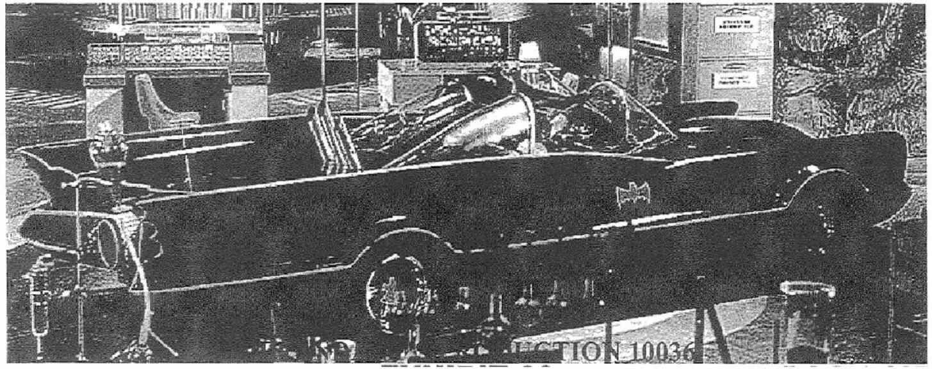​
Towle Replica
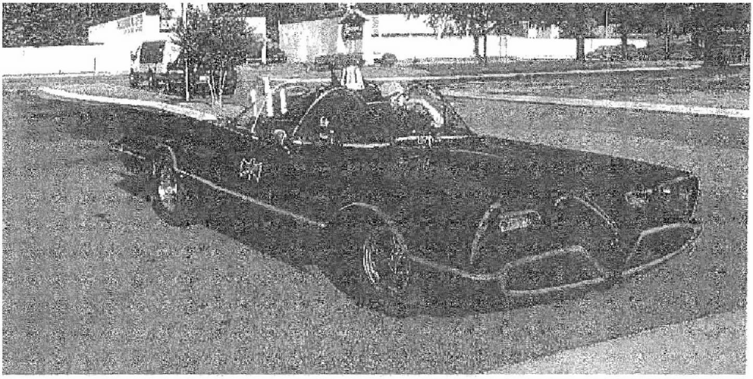​

APPENDIX B
Batmobile Depicted in the 1989 Motion Picture
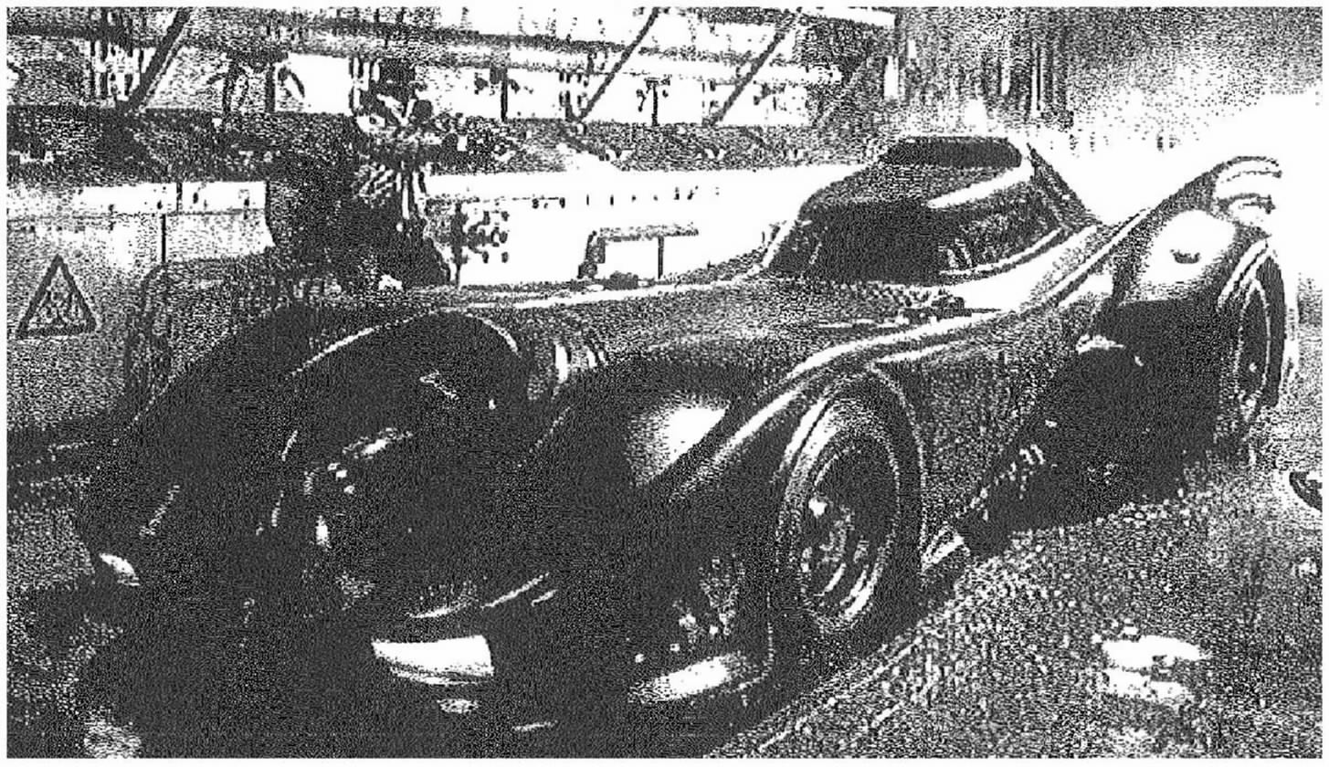​
Towle Replica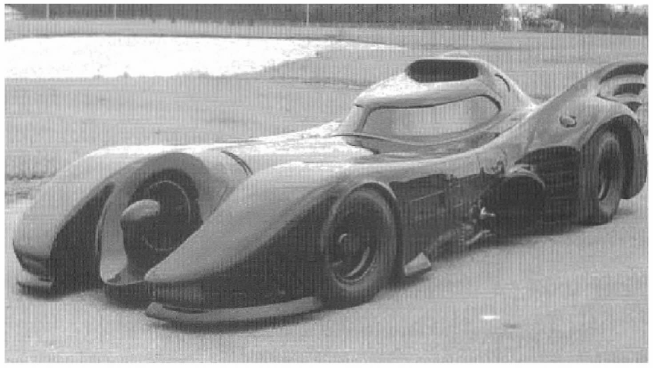

A photo of the Batmobile depicted in the 1966 television series, as well as a photo of Towle’s replica of this Batmobile, can be found in Appendix A.
A photo of the Batmobile depicted in the 1989 motion picture, as well as a photo of Towle’s replica of this Batmobile, can be found in Appendix B.
DC clearly asserted in both its original and amended complaint that the Batmobile in all of its forms, including the 1966 television program and 1989 motion picture, is copyrightable subject matter owned by DC. We thus reject Towle’s argument that DC has failed to identify the copyrights at issue in this case.
The district court also concluded, in the alternative, that the 1966 and 1989 Batmobiles were entitled to copyright protection as a sculptural work under 17 U.S.C. § 102(a)(5). Because we agree that the Batmobile is a character entitled to copyright protection, we need not reach this issue.
6 This episode causes Robin to exclaim “Whee! The Batplane couldn’t do better!”
7 Towle submitted a chart to the district court setting forth these features.
8 Indeed, DC expressly retained all rights not specifically granted to the licensees, including the merchandising rights to all of if its characters in both the 1965 ABC Agreement and the 1979 BPI Agreement. See supra, at 1016, 1016–17. As a result, DC retained the exclusive right to produce three-dimensional expressions of the Batmobile character. See Durham Indus., 630 F.2d at 909; see also Halicki, 547 F.3d at 1218, 1223–24 (concluding that because a party retained the exclusive merchandising rights in a derivative work, she could assert a claim for copyright infringement against a party producing “vehicles resembling the 1967 Shelby GT–500 ‘Eleanor’ character that appeared in the Remake” Gone in Sixty Seconds ).

